  - gih.uq.edu.au

Genome Innovation Hub Standard Operating Procedure (SOP)

SOP Title: | High Molecular Weight (HMW) Total DNA Extraction from Non-model Species
SOP Number: | GIH_SOP204-02
Effective Date: | 19 June 2023
Current Review Date: | 19 June 2025
Replaces SOP Number: | SOP204-01
Current version:
 | Name | Date
First Issue written by: | Subash Rai | 20/10/2022
Latest update by: | Subash Rai | 19/06/2023
Authorised by: | Stacey Andersen | 19/06/2023

Document revisions:

- Proteinase K is replaced with Pronase in Step A.13.
- Centrifuge speed is changed from 13,000xg to 3,000xg while pelleting the CTAB-DNA complex (Step A.26).
- Addition of alternative quick bead capturing method – using SparQ Pure Mag Beads which require 5 min incubation instead of 1 h incubation (Step C Option B).

Previous versions:
SOP Number | Authored/Revised by | Date Originated or Revised
SOP204-01 | Subash Rai | 20/10/2021

Contents

A Purpose and Application 3
B Brief Summary of Method 3
C Untested Suggested Modifications 3
D Experimental Design Considerations 3
E Requisite Prior Knowledge 3
F Definitions and Abbreviations 4
G Occupational Health and Safety 4
H Cautions 4
I Personnel Qualifications, Training and Responsibilities 5
J Equipment and Materials 5
K Procedure 7
L Next Steps 13
M Worked Example 14
N SOP Validation Details 16
O Troubleshooting 17
P Waste Management and Disposal 18
Q Data Records Management 18
R Reference Documents 18
S Quality Control (QC) & Quality Assurance (QA) Section 18

A Purpose and Application
This SOP describes a method for extracting high-quality, high molecular weight DNA from non-model organisms, suitable for long-read sequencing. It covers required equipment, materials, consumables, procedures, and anticipated results along with worked examples in diverse non-model species including the DNA quality tested by NanoDrop, Qubit, TapeStation, and long-read sequencing, particularly Oxford Nanopore Technologies and PacBio platform. The method described in this SOP does not work well if the tissue materials have generic divalent ions, are sensitive to heat or for metaorganisms for metagenomics studies e.g. coral (for such sample type see GIH_ SOP205-02).

B Brief Summary of Method
The method described herein is an optimised version of the protocol published in protocols.io and the previous version of GIH SOP (GIH_SOP204-01). This method is quicker than the previous version and offers the two best approaches for capturing intact HMW DNA using magnetic beads. The first beads capturing approach (Step C (Option A) – Beads purification of HMW DNA) is longer (55 min) but retains a higher size of DNA than the second approach (Step C (Option B) – Beads purification of HMW DNA). Using this protocol, high-quality High Molecular Weight (HMW) total DNA >50kb was successfully extracted from various non-model organism’s tissues such as custard apple, Eidothea hardeniana (IUCN listed as an Endangered species), blueberry, sea slug and conesnail.

C Untested Suggested Modifications
Not applicable now.

D Experimental Design Considerations
Grinding of tissue is key to achieving successful tissue lysis and thus better DNA yield. Therefore, if the test sample is limited, the user should do grinding practice with abundantly available closely related tissues. To get HMW DNA, tissue should be collected freshly or equivalent e.g., snap frozen. The amount of the starting tissue depends on the tissue types and genome size, but 500mg ground tissue powder is a good starting point. If the tissue sample is less than 750mg (wet weight), add 500μl lysis buffer (without β-mercaptoethanol) to increase wet mass of the starting sample and ease the grinding process. When using ground-tissue powder from alternative approaches, the lysis process starts from Step 9.

E Requisite Prior Knowledge
The user should have knowledge of sample quality and the reagent’s age. The sample quality indicates whether the sample is fresh or young tissues or mature tissues, and whether they were snap frozen or collected at normal temperature and frozen later or preserved in any preserving reagents, as well as how it was transported from the collection site. In addition, the user should be aware of the source and site of collections e.g. from a controlled environment like a greenhouse or from a natural environment (stressed or relaxed) and the estimated genome size of the sample species.

F Definitions and Abbreviations
CTAB: Cetyltrimethylammonium bromide
EDTA: Ethylenediaminetetraacetic acid
PEG: Polyethylene Glycol
NaCl: Sodium Chloride
PVP: Polyvinylpyrrolidone
HMW DNA: High Molecular Weight DNA
RT: Room Temperature
kb: Kilobases
LN2: Liquid nitrogen

G Occupational Health and Safety
The user should work under the fume hood while working with β-mercaptoethanol and Chloroform:Isoamyl alcohol and read the MSDS of each reagent before their handling. Appropriate PPE such as lab coat/apron, closed shoes, safety glasses or faceshield and thermal shielding gloves (must be long cuffed to prevent pooling in glove) should be worn while handling LN2. For more detail, the user should carefully read and complete the following risk assessments (RA ID is based on WebDB at Institute for Molecular Bioscience) before performing the experiment.

- Risk assessment #1379 (RM Liquid Nitrogen handling and storage DAH) before handling and transporting LN2.
- Risk assessment #2823 (IMB - Handling, transport, storage and disposal of dry ice) before handling and transporting dry ice.
- Risk assessment # 2927 (High Molecular Weight Total DNA Extraction from Non-model Organisms) before performing the experiment.
- Risk assessment #2603 (Qubit dsDNA quantification - Quant-iT™ dsDNA Assay Kit) before using Qubit.
- Risk assessment #2478 (Use of Nanodrop) before using NanoDrop.
- Risk assessment #2897 (DNA ScreenTape Assay for TapeStation Systems Agilent 4150) before using TapeStation.

Copies of these risk assessments are available on request to those with no access to the WebDB system.

H Cautions
The user should:
- Start with good quality plant materials such as healthy and/or young tissues/cells.
- Grind the tissues or cells into a fine powder to get a better DNA yield.
- Homogenise the ground tissue powder as much as possible.
- Use a wide-bore pipette tip as mentioned in the procedures.

I Personnel Qualifications, Training and Responsibilities
As a minimum, the user should have experience working in a PC2 molecular biology laboratory and should have completed risk assessments and training on the handling of reagents and operation of equipment from designated personnel.

J Equipment and Materials

Equipment
- Benchtop centrifuge
- Centrifuge for 15ml tube
- Esky/container for ice/dry ice
- Flask dewar or equivalent to transport LN2
- Heat block
- HulaMixer
- Magnetic rack
- Mini centrifuge
- MinION and IT set-up (optional for testing sample compatibility with ONT sequencing)
- Mortar and pestle
- NanoDrop
- Qubit
- TapeStation or equivalent
- Thermomixer (with adapter for 15ml tubes)

Materials
- Ammonium Acetate 7.5 M Solution Molecular Biology Grade (A2706-100ML, Sigma Aldrich)
- Chloroform: Isoamyl alcohol (24:1) (C0549-1QT, Sigma Aldrich)
- CTAB (52365-50G, Sigma Aldrich)
- Distilled water Ultra-Pure Dnase/Rnase free Gibco 500ml (10977015, Thermo Fisher Scientific)
- DNA LoBind tubes 1.5ml (0030108051, Eppendorf)
- Dry ice
- Dynabeads M-270 Carboxylic Acid (14306D, Thermo Fisher Scientific) (For Step C (Option A) – Beads purification of HMW DNA only)
- sparQ PureMag Beads (95196-005s, Quantabio) (For Step C (Option B) – Beads purification of HMW DNA only)
- EDTA (0.5 M), pH 8.0, Nuclease-free (AM9260G, Life Technologies Australia)
- Ethanol (>98%, US015017, Thermo Fisher Scientific)
- Falcon tube 15ml (FAL352096, In Vitro Technologies)
- Liquid Nitrogen (LN2)
- P1000 wide bore pipette tips (2079GPK, Thermo Fisher Scientific)
- P200 wide bore pipette tips (LC1152-965, Adelab Scientific)
- Polyvinylpyrrolidone(PVP)-360 (PVP360-100G, Sigma Aldrich)
- PEG8000 (V3011, Promega)
- Pronase (10165921001, Sigma Aldrich)
- Qubit 1xdsDNA HS Assay Kit (Q33231, Life Technologies Australia)
- RNase solution (A7973, Promega)
- Sodium Chloride (71580-500G, Sigma Aldrich)
- UltraPure 1M Tris-HCI, pH 8.0 (15568025, Life Technologies Australia)
- β-mercaptoethanol (M6250-100mL, Sigma Aldrich)
- Genomic DNA ScreenTapes (5067-5365, Integrated Sciences)
- Genomic DNA Reagents (5067-5366, Integrated Sciences)
- TapeStation Loading Tips (5067-5598, Integrated Sciences)
- Strips of 8 optical strip tubes (401428, Integrated Sciences)
- Optical Tube Strip Caps (401425, Integrated Science)
Reagent setup
Lysis Buffer [100mM Tris-HCl, 20mM EDTA, 4% CTAB (w/v), 1.4 M NaCl, 1% PVP 360k (w/v), 2% β-mercaptoethanol (add just before use)]:
For preparing 50ml Lysis Buffer,
- Combine 5ml 1M Tris-HCl (pH=8), 2ml 0.5M EDTA (pH=8), 2g CTAB powder, 0.5g PVP, and 4g NaCl in a 50ml Falcon tube.
- Adjust the final volume to 50ml with nuclease-free water.
- Mix by vortexing (heat the tube at 65°C to speed up the dissolving process). Alternately, spin the solution tube in the HulaMixer overnight at 20rpm, RT.
Note: This buffer can be stored at RT for up to 3-4 months.
- Add β-mercaptoethanol just before use.
Dilution Buffer [100mM Tris-HCl, 20mM EDTA, 2% CTAB (w/v)]:
For preparing 50ml Dilution Buffer,
- Combine 5ml 1M Tris-HCl (pH=8), 2ml 0.5M EDTA (pH=8), and 1g CTAB powder in a 50ml Falcon tube
- Mix by vortexing (heat the tube at 65°C to speed up the dissolving process). Alternately, spin the solution tube in the HulaMixer overnight at 20rpm, RT.
- Adjust the final volume to 50ml with nuclease-free water.
Note: This buffer can be stored at RT for up to 3-4 months.
High-Salt TE (HSTE) Buffer [2mM EDTA, 10mM Tris-HCl, and 1M NaCl]:
For preparing 10ml High-Salt TE (HSTE) Buffer,
- Combine 40µl 0.5M EDTA (pH=8), 100µl 1M Tris-HCl (pH=8) and 581mg NaCl in a 15ml Falcon tube.
- Adjust the final volume to 10ml with nuclease-free water.
Note: Autoclave HSTE Buffer for long storage (1 year).
If using Step C (Option A) – Beads purification of HMW DNA prepare the following buffer and beads solution:
Binding Buffer [20% PEG8000 and 3M NaCl]:
For preparing a 10ml Binding Buffer,
- Combine 2g PEG8000 and 1.75g NaCl in a 15ml Falcon tube.
- Adjust the final volume to 10ml with nuclease-free water.
- Mix well by vortexing the tube until it turns into a clear solution.
- Store at 4-7°C.
Note: Longer than 4-5 months of storage can decrease the binding efficiency. Prepare the binding buffer fresh if it is older than recommended storage duration.
Beads solution [8% Dynabeads™ M-270 Carboxylic Acid (v/v), 18%PEG8000, 1M NaCl, 10mM Tris-HCl pH-8, 1mM EDTA pH-8]:
- Keep the Dynabeads at RT for at least 15min. Meanwhile, prepare the required volume of the beads solution without Dynabeads.
- For preparing 10ml beads solution, combine 1.8gm PEG8000, 0.58gm NaCl, 100µl 1M Tris-HCl (pH=8) and 20µl 0.5M EDTA (pH=8) and adjust the final volume to 10ml with nuclease-free water.
Note: Solution can be stored at this point and combined with Dynabeads in smaller aliquots as required.
- Mix the Dynabeads well by vortexing and take 8% of the total solution volume to be prepared (v/v – see Step C-35a below for required volumes).
- Wash the beads with nuclease-free water 4 times.
- Resuspend the beads pellet completely while washing.
- Add the beads solution to washed beads and store it at 4°C.
Note: Longer than 4-5 months of storage can decrease the binding efficiency. Prepare the beads solution fresh if it is older than recommended storage duration.

K Procedure

Workflow outline:
The complete workflow takes 5-6h but can be split into multiple sections:
Step A – Tissue preparation and lysis

Step B – Extraction of raw HMW DNA

Step C – Beads purification of HMW DNA

Step D – HMW DNA QC

Optional stopping points are noted in the procedure below.

Step A – Tissue preparation and lysis (time:1h 40 min)
Purpose: Break the tissues into a fine powder without damaging the DNA contents and releasing the DNA in the buffer solution. The following procedures are based on intact tissue samples.

- Take ~1L of LN2 in dewar flask for chilling mortar and pestle and grinding the tissues.
- Take some dry ice in an esky/enclosed container.
- Place the cleaned mortar and pestle on a firm support and pour liquid nitrogen on the mortar and pestle.
Note: Top-up the LN2 in the mortar and pestle until no more aggressive bubble formation. Use appropriate PPE while handling LN2. LN2 is very cold (-196 °C).
- Grind tissue or cells to a fine powder with the liquid nitrogen (LN2)-chilled mortar and pestle. Use 750-1000mg of healthy young fresh/snap frozen/frozen leaf tissue or less in case of cells or small intact tissue type such as sea slug (300mg wet mass or add 500ul of lysis buffer to increase wet mass). It will be necessary to top up LN2 2-3 times while grinding the tissues.
Note: more than 1000mg of tissue is difficult to grind by hand. If more materials are available grinding in multiple batches (repeating step 4-5) or using an alternative grinding approach such as a tissue pulveriser is recommended.
CRITICAL POINT: Top up the LN2 before it evaporates out. Dry grinding leads to moisture aggregation (white things), increasing the wet mass of the sample and thus reducing the effectiveness of the lysis buffer.
- Before transferring the ground tissues into a 15ml falcon tube, keep a 15ml falcon tube in dry ice for 5min.
- Swirl the ground tissue powder with LN2 using a mortar and pestle and pour directly into the falcon tube while keeping the tube at dry ice.
- Pour more liquid nitrogen into the mortar and pestle swirl the ground tissue powder and transfer the remaining ground tissue powder as described in step 6.
- Keep the lid of the 15ml Falcon tube half-opened and let LN2 evaporate. Once the LN2 has evaporated close the lid.
Optional stopping point: ground tissue powder can be stored at -80°C until continuing.
Note: When using ground-tissue powder from alternative approaches, the lysis process starts from step 9.
- Prewarm 10ml lysis buffer (without β-mercaptoethanol) at 60°C in a 15ml Falcon tube for 30min.
Note: If the grinding and lysis step is performed on the same day, prewarm the lysis buffer before grinding the tissues to save the 30min incubation time.
- Add 200µl β-mercaptoethanol and mix by inverting the tube.
CRITICAL POINT: Skipping this step results in inferior quality of DNA.
- Take the sample tube from dry ice and place in a tube rack.
- Add 10ml prewarmed lysis buffer with β-mercaptoethanol. Mix well by inverting the tubes (~100 times) until the solution becomes more homogenous. In some samples, the solution may not be homogenous but form whiteish clumps (this is normal).
CRITICAL POINT: DO NOT vortex the sample, this will result in HMW DNA fragmentation.
- Add 200µl pronase (stock conc=20mg/ml), mix well by inverting the tube (15-20 times) and incubate in a thermomixer at 60°C, 300 - 400rpm for 1h.
Note: Mixing the solution by inverting the tubes 3-4 times during the 1hr incubation makes the lysis process more effective.
Note: Pronase has better protease activity than proteinase K.

Step B – Raw HMW DNA Extraction (time: 2h)
Purpose: Extract HMW DNA and precipitate CTAB-DNA complex in a low-salt buffer.

- Let the tube cool down to RT for 5min.
- Spin the tube at RT for 5min at 3000xg. Tissue debris and other impurities settle down at the bottom of the tube (see Figure 1).

Figure 1. Tissue debris and other impurities pelleted after centrifugation. The size and colour of the pellet varies among the samples.

Note: After pelleting the tissue debris and other impurities in step 15, 7-9ml of slightly viscous supernatant is recovered, depending on the sample type. Some lighter debris can be observed in the supernatant which will be removed in step 19. The pellets do not easily dislodge but always be careful while taking the last bit of solution.
- Split an equal volume of supernatant into two new 15ml Falcon tubes using a P1000 wide bore pipette tip (if the centrifuge is suitable for a 50ml Falcon tube, the supernatant can be transferred into a single 50ml tube). The following steps are based on using 15ml Falcon tubes.
- Add an equal volume of Chloroform:Isoamyl alcohol (24:1) into the solution.
- Mix the solution by inverting the tube ~100 times (a milky colour appears, in Figure 2).

Figure 2. The milky-coloured solution appears after enough mixing of the supernatant and the Chloroform: Isoamyl alcohol (24:1)

- Spin the tube at RT for 10min at 3000×g.
- Transfer the aqueous phase to a new 15ml Falcon tube without disturbing the interface layer (Figure 3).

Figure 3. A thin layer of the interface (marked red) between the aqueous and organic phases is generated after the centrifugation. Skipping step 15 results in a thick interface layer and requires the repetition of steps 16-19.

- Add a double volume of the dilution buffer to the aqueous phase. Mix well by inverting the tubes and place them again in the thermomixer at 60°C for 1h at 400 rpm.
- Meanwhile, prepare 10ml of 70% ethanol which is required for the washing steps.
- Centrifuge at 3000×g for 5min at RT and carefully remove the supernatant. A loose white pellet of CTAB-DNA complex appears at the bottom of the tube (Figure 4).

Figure 4. A white pellet of CTAB-DNA complex settles at the bottom of the tube after centrifugation. The size and colour of the complex varies among the samples.

- Resuspend the pellet with 1ml 70% ethanol using a wide bore P1000 pipette tip and carefully transfer all into a 2ml LoBind DNA tube. Repeat with additional 1ml 70% ethanol to make sure no DNA pellet is left in the 15ml Falcon tube.
- Incubate 2ml tubes for 5min at RT in a HulaMixer at 9rpm.
Note: DNA pellet washing is more efficient with at least 5min incubation.
Optional stopping point: the DNA pellet can be stored at 4-7°C overnight.
- Spin the tube at 3000×g for 5min and discard the supernatant.
Note: supernatant should be removed very carefully to prevent discarding a loose pellet. Washing a loose pellet is more efficient than a tight pellet.
- Add 2ml 70% ethanol and incubate 2ml tubes for 5min at RT in a HulaMixer at 9rpm.
- Spin the tube at 13000×g for 5min and discard the supernatant.
- Keep the tubes under the fume hood with the lid open for 5min to remove any traces of ethanol.
- Resuspend the DNA pellet in 200µl of High-salt TE (HSTE) buffer.
Note: The DNA pellets dissolve faster in prewarmed HSTE buffer at 60°C. Use a P200 wide bore pipette tip to dissolve DNA pellets. As the DNA pellet is not pure, the pellet may be bigger and not dissolve completely but try to make a loose/flocky pellet to release the DNA molecules into the HSTE buffer.

CRITICAL POINT: Perform EITHER Step C (Option A) OR Step C (Option B below). Refer to Section B of this SOP (Brief Summary of Method) for a description of the relative benefits of each option.

Step C (Option A) – Beads purification of HMW DNA (time:1h 50 min)
Purpose: To remove RNA traces and pull down pure intact HMW using relatively large-size magnetic beads (2.8µm Dynabeads with Carboxylic Acid groups).

- Add 4µl RNaseA and incubate at 37°C for 15-20min.
- Add 100µl ammonium acetate (7.5M) and mix well by tapping the tube.
- Incubate the tubes for 10min at RT. Invert the tube once after 5min.
- Spin the tubes at 13000×g for 3min at RT. Using a wide-bore pipette tip transfer the supernatant from both 2ml tubes into a single 1.5ml LoBind DNA tube.
Note: Bulky transparent pellet appears in some samples and no visible pellet in some samples. Measure the supernatant volume accurately which is critical for the next step.
- Add an equal volume of binding buffer and mix well by inverting the tubes. Then, add 0.8x (v/v) beads solution (prewarmed at RT) and incubate for 60min at RT in a HulaMixer at 9 rpm.
- Place the tubes in a magnetic rack for 3min and remove the supernatant.
- To wash the beads while keeping the tubes still on the magnetic rack, pipette in 1000µl 70% freshly prepared ethanol without touching the beads pellet (clumping of beads may appear but try to detach from the tube surface by tapping the tube gently). Repeat steps 36a-37a for a total of two washes.

Figure 6. Dislodged DNA-beads clumps (indicated) in 70% freshly prepared ethanol during the washing step.

- After removing the supernatant, add 50µl prewarmed (at 60°C) 10mM Tris-HCl (elution buffer) -resuspend with gentle tapping of the tube and incubate at RT or 37°C for 15min.
Note: 37°C incubation slightly improves recovery of higher molecular weight DNA molecules if the starting materials contain high DNA.
- Gently tap the tube 3 - 4 times before placing the tube back in the magnetic rack and leave it for 5min.
- Remove the supernatant into a new 1.5ml LoBind DNA tube (if the eluate is very viscous and beads pelleting is not happening either add more elution buffer or centrifuge at 13000×g for 3min).

Step C (Option B) – Beads purification of HMW DNA (time:1h)
Purpose: To remove RNA traces and pull down pure intact HMW in a shorter time than option A using sparQ PureMag Beads.
- Add 4µl RNaseA and incubate at 37°C for 15-20min.
- Add 100µl ammonium acetate (7.5M) and mix well by tapping the tube.
- Incubate the tubes for 10min at RT. Invert the tube once after 5min.
- Spin the tubes at 13000×g for 3min at RT. Using a wide-bore pipette tip transfer the supernatant from both 2ml tubes into a single 1.5ml LoBind DNA tube.
Note: Bulky transparent pellet appears in some samples and no visible pellet in some samples.
- Add 0.8x (v/v) sparQ PureMag Beads (prewarmed at RT) and incubate for 5min at RT in a HulaMixer at 9rpm.
- Place the tube in a magnetic rack for 3min and remove the supernatant.
- To wash the beads while keeping the tubes still on the magnetic rack, pipette in 1000µl 70% freshly prepared ethanol without touching the beads pellet (clumping of beads may appear but try to detach from the tube surface by tapping the tube). Repeat steps 36b-37b for a total of two washes.

Figure 8. Dislodged DNA-beads clumps (indicated) in 70% freshly prepared ethanol during the washing step.

- After removing the supernatant, add 50µl prewarmed (at 60°C) 10mM Tris-HCl (elution buffer), resuspend with gentle tapping of the tube and incubate at RT or 37°C for 15min.
Note: 37°C incubation slightly improves recovery of higher molecular weight DNA molecules if the starting materials contain high DNA.
- Gently tap the tube 3-4 times before placing the tube back in the magnetic rack and leave it for 5min.
- Remove the supernatant in a new 1.5ml LoBind DNA tube (if the eluate is very viscous and beads pelleting is not happening either add more elution buffer or centrifuge at 13000×g for 3min).

Step D – QC of HMW DNA (time: 30min)
Purpose: To measure DNA purity, yield, and intactness. Qubit and NanoDrop give purity and yield whereas TapeStation gives intactness of DNA.

- Take 1µl DNA in a 1.5ml DNA LoBind tube.
- Add 9µl nuclease-free water and mix by vortexing for 1min (DO NOT use this dilution for TapeStation).
- Assess DNA quality with NanoDrop:
- Use 2µl of nuclease-free water as a blank.
- Take 2µl of diluted DNA as a test sample.
- Record DNA concentration, A₂₆₀/A₂₈₀, and A₂₆₀/A₂₃₀.
- Assess DNA quality with Qubit:
- Prepare Qubit reagents according to the manufacturer’s guidelines.
- Use 1µl of diluted DNA to measure DNA concentration.
Note: The ratio of NanoDrop and Qubit concentration should be in the range of 1-2.
- Assess DNA TapeStation:
- Adjust the DNA concentration to within the range of Genomic DNA ScreenTapes and reagents using 10mM Tris-HCl or nuclease-free H₂O.
Note: DO NOT vortex the sample while adjusting the DNA concentration.
- Perform assay according to the manufacturer’s guidelines.
- DNA integrity (DIN) value >8 is recommended for the optimal use of long-read technologies.

L Next Steps
If the DNA integrity is less than 8 or users want to remove small-sized DNA molecules for long-read sequencing such as Nanopore sequencing, size selection should be performed downstream before library preparation. Size selection kits commonly used for this purpose are:
- Short Fragment Eliminator Expansion (EXP-SFE001, ONT) - progressively deplete short fragments of <25 kb,
- SRE XS kit (SKU 102-208-200 (previously SS-100-121-01), PacBio) - progressively deplete short DNA fragments <10 kb, and
- SRE kit (PacBio, SKU 102-208-300 (previously SS-100-101-01), PacBio) – progressively deplete <25 kb DNA fragments.
However, these kits do not perform well if the amount of DNA is low ( <3ug) or sheared a lot (>50% of DNA is below the enrichment size).

M Worked Example

Table 1. DNA QC using this SOP with Step C Option A beads capturing method:
Sample type | Sample amount | Qubit (ng/µl) | NanoDrop (ng/µl) | A₂₆₀/ A₂₈₀ | A₂₆₀/ A₂₈₀ | Yield (ng) | DIN Value
Custard apple | 1gm^{ω} | 485 | 535 | 1.83 | 1.96 | 36375 | 9.1
Custard apple | 1gm^{ω} | 634 | 667 | 1.84 | 1.96 | 47550 | 8.9
Eidothea | 0.5gm^{ω} | 306 | 238 | 1.82 | 1.8 | 2295 | 8.4
Eidothea | 1gm^{ω} | 428 | 468 | 1.8 | 1.97 | 32100 | 8.2
Blueberry 1 | 0.25gm^{ω} | 50.2 | 62.4 | 1.86 | 1.85 | 2510 | 7.6
Blueberry 2 | 0.25gm^{ω} | 97 | 100 | 1.86 | 1.75 | 4850 | 7.7
ω Pulverised tissues
Table 2. DNA QC using this SOP with Step C Option B beads capturing method:
Sample type | Sample amount | Qubit (ng/µl) | NanoDrop (ng/µl) | A₂₆₀/ A₂₈₀ | A₂₆₀/ A₂₈₀ | Yield (ng) | DIN Value
Custard apple | 1gm^{ω} | 550 | 609 | 1.83 | 1.85 | 41250 | 9.3
Blueberry 1 | 0.25gm^{ω} | 49.6 | 60.7 | 1.89 | 2.28 | 2480 | 7.7
Blueberry 2 | 0.25gm^{ω} | 91.2 | 105 | 1.87 | 2.16 | 4560 | 7.9
Eidothea | 1gm^{ω} | 424 | 457 | 1.82 | 2.31 | 31800 | 8.4
Conesnails | 0.6gm^{Ψ} | 333 | 309 | 1.92 | 2.3 | 49950 | 7.4
Sea slug | Not measured | 128 | 133.6 | 1.8 | 2.25 | 6528 | 8.7
ω Pulverised tissues
Ψ Hand ground tissues
A. Eidothea hardeniana
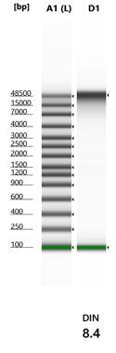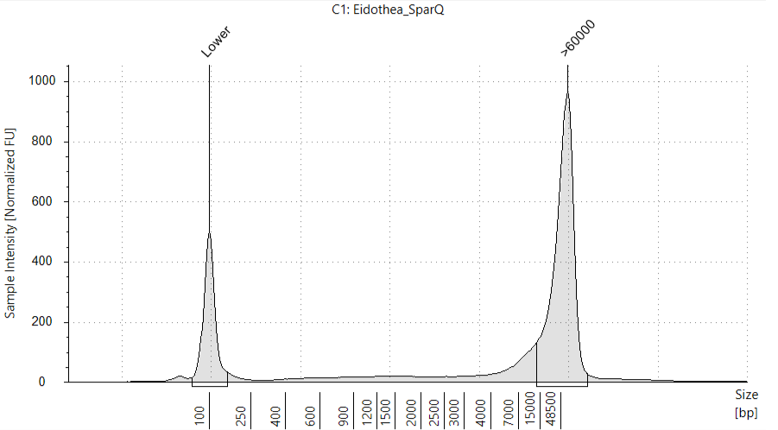

B. Custard apple
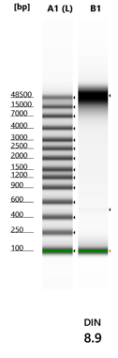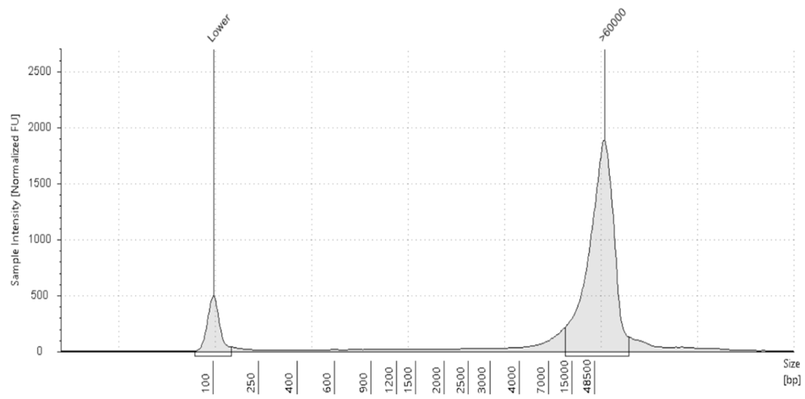
C. Blueberry
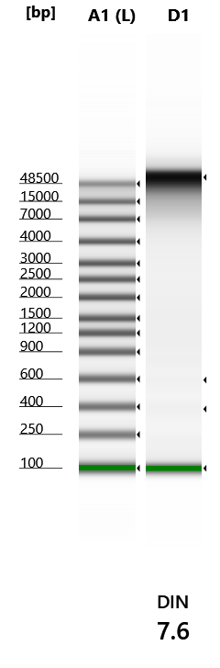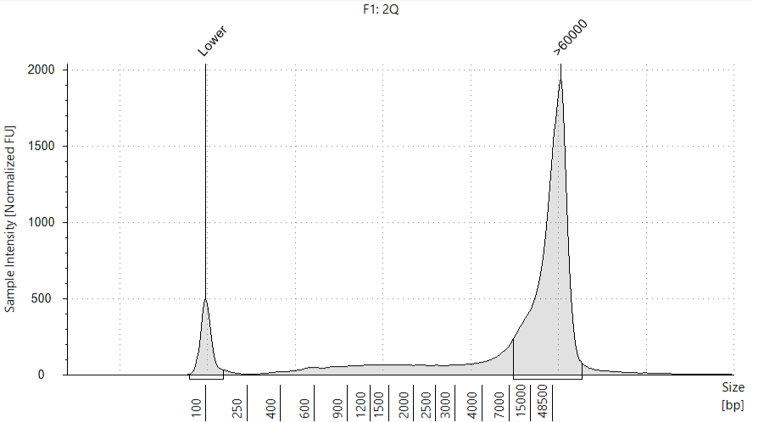
D. Conesnail
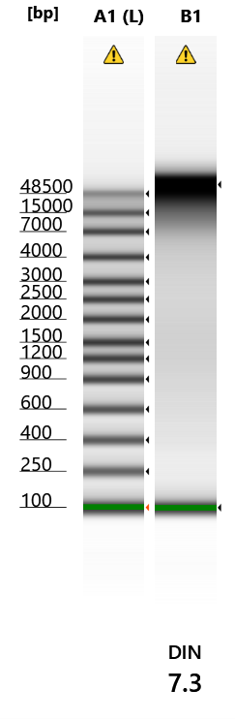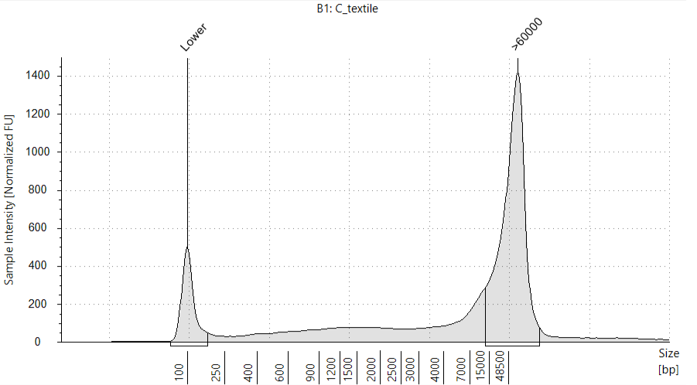

E. sea slug
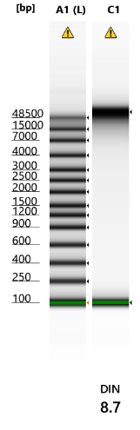
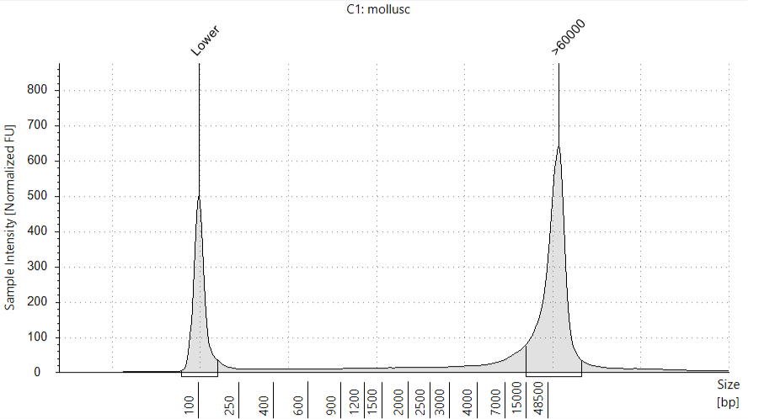
Figure 9. TapeStation gel image and Electropherogram showing HMW total DNA (>50 kb) extracted from a wide variety of samples - A. Eidothea, B. Custard apple, C. Blueberry, D. Conesnail and E. Sea Slug

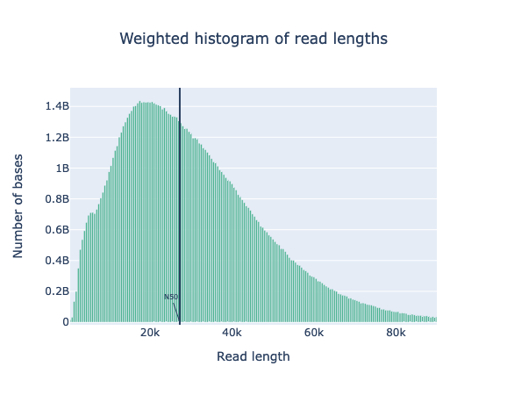

Figure 10. Read length distribution of the Eidothea DNA sequenced with Nanopore PromethION 2 (P2solo) device. Before preparing the library with V14 ligation sequencing kit (SQK-LKS114, ONT), size selection was performed using a short read eliminator kit (Circulomics). The library was run on an R10.4.1 PromethION flow cell until the pores died. The sequencing run yielded 116gb with N50 27.7kb.

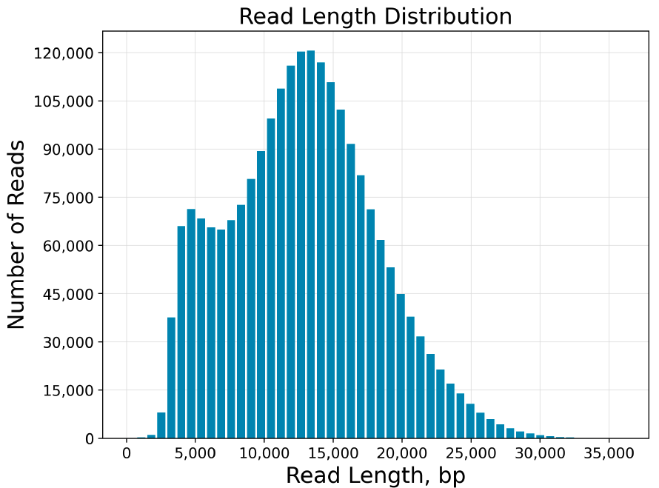

Figure 11. Read length distribution of the Eidothea DNA sequenced on PacBio Sequel-II system. The sequencing yielded HiFi data of 28 gb with a Mean HiFi Read Length of 12.8 kb.

N SOP Validation Details
This SOP is a new version of GIH SOP (GIH_SOP204-01) with slight modifications. The method described in this SOP tested additional non-model species such as custard apple, eidothea, blueberry and conesnails. The quality of extracted DNA was assessed with standard QC – NanoDrop, Qubit, and TapeStation. Eidothea and conesnail DNA was used to verify the DNA length and sequencing performance with Oxford Nanopore Sequencing. The sample compatibility between two long-read sequencing technologies (ONT and PacBio) was also assessed by sequencing the samples with an equivalent standard QC where PacBio performed better in some sample type e.g. conesnails.

O Troubleshooting

Step | Issue | Recommendations
Step 12 | Difficulty with homogenisation of samples | - Reduce the sample amount or increase the lysis buffer volume
Step 23 | Small pellet size, or CTAB-DNA does not form pellet but remains floating in the buffer | - Double the centrifugation time or increase the centrifuge speed to 13000xg  - Add more dilution buffer (half volume), mix and centrifuge.
Step 30 | Large pellet which is hard to dissolve in HSTE buffer | - Use lower amount of tissue materials.  - Avoid pipetting up interface layer by using small volume pipette tips (P100/P20).  - Pipette up-down with a wide-bore pipette tip to dissolve pellet while incubating the solution. Raw DNA pellet does not dissolve completely in all cases.
Analysis | Low DIN Value | - This may be due to –  a) the shearing of DNA during the extraction. To avoid shearing DNA always use wide-bore pipette tips and practice gentle pipetting and washing beads.  b) use of tissue materials which were not processed as described in the SOP. Re-collect and process the tissues as described above. If the extracted DNA is pure and high yield (>6ug and at least 40% of DNA population above 20kb), size selection will help to increase the DIN value.
 | Low NanoDrop A₂₆₀/A₂₈₀ (<1.8) | - Lower the amount of starting tissue and do not skip 5min incubation in washing step
 | Low NanoDrop A₂₆₀/A₂₃₀ (<1.76) | - Lower the amount of starting tissue and do not skip 5min incubation in washing step.  - Perform another round of beads cleaning if A₂₆₀/A₂₈₀ is within standard range

P Waste Management and Disposal
All the chemicals used in this SOP are very low amounts. Experimental work should be done inside a fume hood while working with β-mercaptoethanol and Chloroform:Isoamyl alcohol. Dispose of Chloroform:Isoamyl alcohol in a Chloroform:Isoamyl waste bottle sourced from the UQ Chemical Store, and remaining waste in the clinical waste bin.

Q Data Records Management
Record the amount of tissue/tissue powder before adding lysis buffer. Record NanoDrop (both concentration and absorbance ratio) and Qubit concentration for each DNA extraction. Calculate the ratio of NanoDrop and Qubit concentration. TapeStation DIN value and DNA size should be recorded. Convert the TapeStation report into PDF format.

R Reference Documents
- The previous GIH SOP (GIH_SOP204-01)
- Subash Rai 2022. Total High Molecular Weight DNA Extraction from plant tissues for Long Read Sequencing. protocols.io https://dx.doi.org/10.17504/protocols.io.b5qyq5xw

S Quality Control (QC) & Quality Assurance (QA) Section
Tissue materials should be collected and processed as mentioned in the SOP. The reagents should be prepared as described in the method. This SOP does not necessarily describe the expected yield and quality of DNA if the optimised methods are modified or used in completely different tissues to those described. In general, the HMW DNA extracted using this SOP shows the following characteristics:
- A₂₆₀/A₂₈₀ = 1.8 – 2
- A₂₆₀/A₂₃₀ =1.76 -2.3
- Yield 20-50 ug/1gm
- Ratio of NanoDrop/Qubit concentration =~1-1.5
- DIN value >8
Any extracted sample that deviates from these values should either be reextracted or undergo post-purified with AMPure beads, followed by a re-assessment of the sample. If more starting sample is available, then re-extraction is recommended.

- Contact details
- Stacey Andersen
- Operations Manager, Genome Innovation Hub
T +61 7 334 62077
E s.andersen2@uq.edu.au
W gih.uq.edu.au
-----------------------------------------------------------------------------------------------------------------------------------
- Subash Rai
- Research Specialist, Genome Innovation Hub
T +61 7 334 62607
E subash.rai@uq.edu.au
W gih.uq.edu.au

CRICOS Provider 00025B

