STANDARD OPERATING PROCEDURE (SOP)

STANDARD OPERATING PROCEDURE DETAILS
SOP Title: | High Molecular Weight DNA Extraction from Coral Fragment for Long Read Sequencing
SOP Number: | SOP205-01
Effective Date: | 26 Oct 2021
Current Review Date:
Replaces SOP Number:
Group: | GIH

DECLARATIONS
I have read this document and approve its contents.
 | Name | Team | Signature | Date
Written By: | Subash Kumar Rai | Long Read Sequencing | 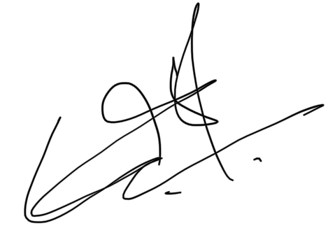 | 26 Oct 2021
Reviewed By:
Reviewed By:
Reviewed By:
Reviewed By:
Authorised By: | Brooke Purdue

DOCUMENT HISTORY
SOP Number | Author | Date Originated or Revised
SOP205-01 | Subash Kumar Rai | 26 Oct 2021

F CONTENTS
STANDARD OPERATING PROCEDURE

A. PURPOSE AND APPLICATION 3
B. BRIEF SUMMARY OF METHOD 3
C. DEFINITIONS AND ABBREVIATIONS 3
D. OCCUPATIONAL HEALTH AND SAFETY 3
E. CAUTIONS 3
F. PERSONNEL QUALIFICATIONS, TRAINING AND RESPONSIBILITIES 3
G. EQUIPMENT AND MATERIALS 4
Equipment 4
Materials and Consumables 4
H. PROCEDURE 4
I. WORKED EXAMPLE 6
J. SOP VALIDATION DETAILS 7
K. WASTE MANAGEMENT AND DISPOSAL 7
L. DATA RECORDS MANAGEMENT 7
M. REFERENCE DOCUMENTS 7
N. QUALITY CONTROL (QC) AND QUALITY ASSURANCE (QA) SECTION 7

E

PURPOSE AND APPLICATION

This SOP covers required equipment, materials, consumables, procedures, and anticipated results along with worked example including the DNA quality tested in NanoDrop, Qubit, and TapeStation. The method described in this SOP suits for the experiment that requires High Molecular Weight DNA from the complex and DNA degradable samples like coral fragment for metagenomic study or similar studies.

BRIEF SUMMARY OF METHOD

Coral fragment is a complex sample for DNA extraction and this protocol avoids DNA degradation during extraction process by modifying the steps susceptible for the DNA degradation. In addition, DNA is first precipitated using Isopropanol and HMW pure DNA is captured using AMPure beads.

DEFINITIONS AND ABBREVIATIONS

EDTA: Ethylenediaminetetraacetic acid
PEG: Polyethylene Glycol
NaCl: Sodium Chloride
HMW DNA: High Molecular Weight DNA
RT: Room Temperature

OCCUPATIONAL HEALTH AND SAFETY

No OH&S risk is identified with this SOP.

CAUTIONS
User should work under the fume hood while working with DNAzol and Chloroform:Isoamyl alcohol (24:1).

PERSONNEL QUALIFICATIONS, TRAINING AND RESPONSIBILITIES

Training Requirements:

X Read and Understand Document X Training Required

EQUIPMENT AND MATERIALS

Equipment
  - Mortar and pestle
  - Mini centrifuge
  - Benchtop centrifuge at 4°C/temperature-controlled benchtop centrifuge
  - HulaMixer or equivalent
  - Magnetic rack
  - Heat block
  - Qubit
  - NanoDrop
  - TapeStation or equivalent
  - Esky/container for ice
  - Flask Dewar or equivalent to transport LN2

Materials and Consumables
  - UltraPure 1M Tris-HCI, pH 8.0 (15568025, Life Technologies Australia)
  - EDTA (0.5 M), pH 8.0, Nuclease-free (AM9260G, Life Technologies Australia)
  - Sodium Chloride (71580-500G, Sigma Aldrich)
  - Chloroform: Isoamyl alcohol (24:1) (ACR327155000, Thermo Fisher Scientific Australia)
  - RNase solution (A7973, Promega)
  - Proteinase K (PK) solution (MC5005, Promega)
  - DNAzol (10503027, Life Technologies)
  - Ammonium Acetate 7.5 M Solution Molecular Biology Grade (A2706-100ML, Sigma)
  - Ethanol (>98%, US015017, Thermo Fisher Scientific)
  - Isopropanol (>98%, W205702-1KG-K, Sigma Aldrich)
  - AMPure beads (A63881, Beckman Coulter Australia)
  - Distilled water Ultra-Pure Dnase/Rnase free Gibco 500ml
  - Qubit 1X dsDNA HS Assay Kit (Q33231, Life Technologies Australia)
  - Wide bore P1000 and P200 tips
  - DNA LoBind tubes 1.5ml (0030108051, Eppendorf)
  - DNA LoBind tubes 2ml (0030108078, Eppendorf)
  - Liquid Nitrogen
  - Dry Ice
  - Spatula (Sterile)
  - Falcon tube 15ml (FAL352096, In Vitro Technologies)

PROCEDURES

A. Homogenisation of Coral Fragments:

Before sample processing:

1. Prepare High-salt TE buffer [2mM EDTA, 10mM Tris-HCl, and 1 M NaCl] by combining 2.907g NaCl, 200µl 0.5M EDTA (pH=8), and 500µl 1M Tris-HCl (pH=8) and adjust the final volume to 50ml with nuclease free water.

2. Take ~500ml Liquid Nitrogen in Flask Dewar/equivalent.

3. Take dry ice in an esky/ a container.

4. Take ice in an esky/ a container

1. Chill the mortar and pestle in Liquid Nitrogen (LN2). Top-up the LN2 2-3 times to chill completely.

2. Grind the coral fragment into a fine powder. Do not let it to dry and top-up the LN2 frequently. Grinding takes time ~5-8min.

3. Place a Falcon tube (15ml) in a dry ice to chill it and swirl ground fine fragment powder with pestle and pour fragment powder-LN2 solution into the falcon tube. Top-up LN2 in the mortar and try to pour all fragment-LN2 solution into the falcon tube. Keep the falcon tube's lid loosely/half opened so that LN2 evaporates out.

B. Sample lysis:

1. Add 1ml DNAzol in 2ml Eppendorf tube.

2. Using spatula take 400-500mg coral fragment powder in DNAzol containing Eppendorf tube and mix gently by inverting the tube (1-2min). A brownish solution appears and put on the ice.

3. Spin the tube at 10,000×g for 5min at 4ºC.

4. Take the supernatant (0.8-0.9ml) in a fresh 2ml tube.

C. DNA Extraction and Capturing:

1. Add an equal volume of Chloroform:Isoamyl alcohol (24:1) and invert the tube ~100 times or until the solution becomes homogenous.

2. Spin the tube at 10,000×g for 10min at 4ºC.

3. Transfer the supernatant in a fresh 2ml tube without disturbing the interface

4. Add equal volume of Isopropanol (>98%) and mix the sample by inverting the tube. Incubate the sample for 5-10min at room temperature (RT).

5. Spin the tube at 3000×g for 5min at RT.

6. Discard the supernatant and a whitish pellet appears at the tube’s bottom which is bigger than usual DNA pellet.

7. Wash the pellet with 1ml 70% ethanol (freshly prepared). To wash the pellet, dislodge the pellet by tapping the tube and incubate are RT for 5min. Spin at 10,000×g for 5min at RT and discard the supernatant without disturbing the pellet.

8. Perform washing step twice. Try to remove washing solution completely by leaving the tube's lid open for 3-4min.

9. Dissolve the pellet in 200μl preheated (60ºC) high-salt TE buffer. Try to dissolve pellet by gentle tapping the tube or pipetting up and down using P200 wide-bore tip. (Pellet may not dissolve completely as this is not pure DNA, other contaminants are still present and if the pellet does not dissolve, proceed the next step).

10. Add 4μl RNaseA, mix well by tapping the tube, and incubate for 15-20min at 37ºC to remove any traces of RNA present in the sample. Take out and leave the AMPure beads at RT for 30min and vortex briefly before using it.

11. Add 100μl ammonium acetate (7.5M) and invert the tube 4-5 times before incubating it for 10min at RT.

12. Spin the tube at 13,000×g for 5min.

13. Transfer the supernatant in a fresh 1.5ml tube.

14. Add 80μl AMPure beads and mix well by tapping the tubes.

15. Incubate in a HulaMixer (9rpm) for 5min. A short spin (2s) the tube in mini centrifuge.

16. Place the tube on a magnetic rack for 2-3min. Remove the supernatant and wash the pellet with 500μl 70% ethanol (freshly prepared) twice without disturbing the beads pellet.

17. Add 52μl preheated (50ºC) 10mM Tris-HCl and incubate for 5min at RT. Place the tube on a magnetic rack and collect the DNA solution using a wide bore tip.

18. Perform QC using NanoDrop, Qubit, and TapeStation.

WORKED EXAMPLE

Table1: Qubit and NanoDrop measurement for DNA extracted from 4 coral samples.

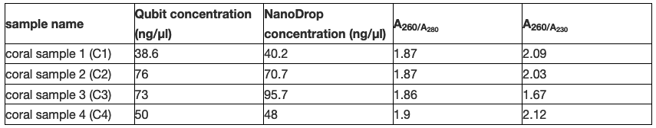

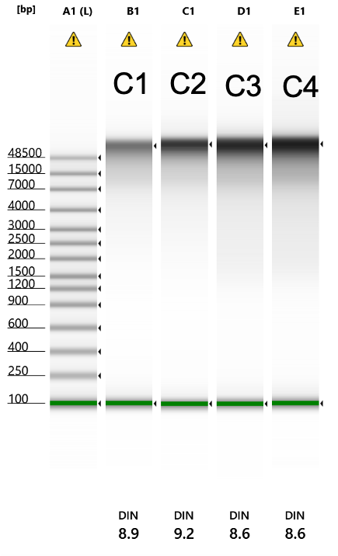
Figure 1. TapeStation gel showing consistent good quality of DNA in four samples (Table 1). Intact (DIN=>8.5) HMW DNA (>60kb) was extracted from coral fragments.

SOP VALIDATION DETAILS

The method described in this SOP has been tested in 4 samples with >5 replicates, and the yielded DNA is consistent in quality and quantity.

WASTE MANAGEMENT AND DISPOSAL

All the chemicals used in this SOP are very low amount. Work under fume hood while working with DNAzol and Chloroform: Isoamyl alcohol. Dispose DNAzol in a DNAzol-specified collection waste bottle, Chloroform: Isoamyl alcohol in the Chloroform:Isoamyl collection waste bottle and remaining waste in the clinical waste bin.

DATA RECORDS MANAGEMENT

All the data generated during QC should be recorded on lab book or digital lab book as soon as the experiment is completed. Saving raw data from TapeStation would recommend customising the sample quality visualisation using TapeStation Analysis Software.

REFERENCE DOCUMENTS

1. User manual (MAN0000847) for DNAzol (10503027, Life Technologies). Rev. 21 Mar 2011.

2. Xin, Z., & Chen, J. (2012). A high throughput DNA extraction method with high yield and quality. Plant Methods, 8(1) 26.

QUALITY CONTROL (QC) AND QUALITY ASSURANCE (QA) SECTION

To get a good performance of this SOP, user should –
a. start with good quality starting materials e. g. snap frozen coral skeleton
b. the better grinding of tissues or cells the better DNA yield
c. must use wide bore pipette tips as mentioned in the procedures

