STANDARD OPERATING PROCEDURE DETAILS

SOP Title: | CRISPR-Cas9/Cas12a expression, purification and validation
SOP Number: | SOP101-01
Effective Date: | 31 Jan 2019
Current Review Date: | 27 May 2020
Replaces SOP Number: | First Issue
Group: | Precise Genome Editing

DECLARATIONS
I have read this document and approve its contents.
 | Name | Team | Signature | Date
Written By: | Max Ma | Gene Editing group | Max Ma | 20-Jan-2019
Reviewed By: | Di Xia | Gene Editing group | Di Xia | 14-May-2020
Reviewed By:
Reviewed By:
Reviewed By:
Authorised By:

DOCUMENT HISTORY
SOP Number | Author | Date Originated or Revised
SOP101-01 | Max Ma | 31 Jan 2019

A. PURPOSE AND APPLICATION 3
B. BRIEF SUMMARY OF METHOD 3
C. DEFINITIONS AND ABBREVIATIONS 3
D. OCCUPATIONAL HEALTH AND SAFETY 3
E. CAUTIONS 3
F. PERSONNEL QUALIFICATIONS, TRAINING AND RESPONSIBILITIES 3
G. EQUIPMENT AND MATERIALS 3
Equipment 3
Materials 3
H. PROCEDURE 4
I. WORKED EXAMPLE 5
J. SOP VALIDATION DETAILS 6
K. WASTE MANAGEMENT AND DISPOSAL 6
L. DATA RECORDS MANAGEMENT 6
M. REFERENCE DOCUMENTS 6
N. QUALITY CONTROL (QC) AND QUALITY ASSURANCE (QA) SECTION 6
O. TOUBLESHOOTING 6

PURPOSE AND APPLICATION
This protocol aims to express and purify soluble protein from E. coli and validate the activity in vitro digestion assay before using for genome editin experiment.

BRIEF SUMMARY OF METHOD
We transform plasmid and express the proteins in E. coli after induction. The proteins are purified by affinity chromatography and size exclusion chromatography from the cell lysate. The in vitro activity test of in-house purified Cas9 and Cas12a shows comparable quality with commercial product.

DEFINITIONS AND ABBREVIATIONS
OD – Optical density
IPTG – β-_{D}-thiogalactopyranoside
SDS-PAGE – Sodium Dodecyl Sulfate-Polyacrylamide Gel Electrophoresis
FPLC – Fast protein liquid chromatography
SpCas9 – Streptococcus pyogenes Cas9
sgRNA – Single guide RNA

OCCUPATIONAL HEALTH AND SAFETY
There is no health and safety issue associated with this SOP, however training of equipment and risk assessment related to protein expression and purification are required before start any experiment listed in this SOP.

CAUTIONS
- Do not scale up the bacterial culture more than 1 L (which may cause spill).
- Staining/destaining solution and sample buffer are prepared in fume hood.

PERSONNEL QUALIFICATIONS, TRAINING AND RESPONSIBILITIES
Training Requirements:
Read and Understand Document Training Required

EQUIPMENT AND MATERIALS

Equipment
- FPLC (AKTA system)
- Size exclusion column (e.g. Superdex 200 Increase 10/300 GL)
- Ion exchange column (e.g. HiTrap column SP HP)
- High-speed centrifuge
- Incubator/shaker with temperature controller
- Spectrophotometer or Nanodrop®
- PowerPacTM power system (Bio-Rad)
- Probe sonicator (or cell disrupter)

Materials
- Plasmid (for Cas9/Cas12a expression or activity test) and target sgRNA (IDT or Synthego)
- Antibiotics (ampicillin, kanamycin, or chloramphenicol etc.)
- Nickel-charged IMAC resin
- SDS-PAGE pre-casting gel
- NEBuffer and Cas9/Cas12a reaction buffer
- Proteinase K
- Tris-Glycine running buffer
- LB broth
- PBS
- Tris, HEPES, NaCl, KCl, imidazole
- Agarose gel
- IPTG
- Coomassie Blue, methanol, acetic acid
- Protein sample buffer (glycerol, SDS, β-mercaptoethanol, 0.5 M Tris pH 6.8 and bromophenol blue)
- PierceTM LAL chromogenic endotoxin quantitation kit

PROCEDURE
  - Protein Expression
    - Inoculate 10 ml of culture medium containing appropriate antibiotics (i.e. 100 ug/ml ampicillin, 50 ug/ml kanamycin, 34 ug/ml chloramphenicol or combinations) and grow overnight culture shaking at 37ºC.
    - Inoculate 800 mL of prewarmed media (with antibiotics) with 10ml of the overnight culture and grow at 37ºC with vigorous shaking until an OD₆₀₀ of 0.6 - 0.8 is reached.
    - Take a 1 ml sample immediately before induction as negative control (-IPTG).
    - Induce expression by adding isopropyl β-_{D}-thiogalactopyranoside (IPTG) to a final concentration of 0.5-1 mM.
    - Incubate the culture for an additional 1-5h at 37ºC or overnight at 22 ºC (depending on the expression level of different proteins, some proteins are not able to reach high expression without long induction times).
Lower temperature is necessary to keep some proteins soluble and prevent formation of inclusion bodies.
    - Harvest the cells by centrifugation at 4000 x g for 30 min at room temperature or 4 ºC.
    - Cell pellet can be stored at -20 ºC or subject to different experiments.

  - Protein Purification
- Thaw the cell pellet on ice and resuspend the cells in lysis buffer (20 mM HEPES, 200 mM KCl, 20mM imidazole, pH 7.5) at 2 - 5 ml per gram wet weight cells. Keep a small sample at each step, to assist with trouble-shooting.
- Sonicate on ice using a probe sonicator or cell disrupter.
- Centrifuge lysate at 20,000 x g for 30 min at 4 ºC to pellet the cellular debris. Save the supernatant.
- Add 1 ml of the 50% w/v Ni²⁺-NTA slurry to 5 ml cleared lysate and mix gently by shaking (200 rpm on a rotary shaker) at 4ºC for 1 hour or overnight.
- Load the lysate and Ni²⁺-NTA mixture into a column with the bottom outlet capped.
- Remove bottom cap and collect the column flow-through.
- Wash column twice with 4 ml wash buffer (20 mM HEPES, 200 mM KCl, 50 mM imidazole, pH7.5); collect wash fractions for SDS-PAGE analysis.
- Add 1.5 ml elution buffer (20 mM HEPES, 200 mM KCl, 400 mM imidazole, pH7.5) to column and collect the eluate in tubes. Collect 10 column volumes of the elution fractions.
- (Optional) Following the Ni²⁺-NTA affinity chromatography, the sample can be also applied to size exclusion chromatography or ion-exchange chromatography connected with a FPLC system (GE Healthcare, AKTA) for further purification.
- Purge/wash (10 mL/min) the system (including all line system and fraction collector dispensor) with 20% ethanol, then water and buffer (0.22-μm protein-compatible filtered and degassed).
- Mount the column vertically on a stable stand, switch the flow speed to column default speed (such as 0.5 mL/min), and connect the column from pump with an extension to the FPLC system (connect top, then bottom). Adjust the pressure alarms (pre-column, ∆column, and system pressure)
- Equilibrate the column with buffer for more than one column volumn (CV)
- Inject the sample (maximum 1 mL sample for Superdex 200 increase 10/300GL column)
- Collect the sample from fraction collector and concentrating.
- Analyse each elution fraction by SDS-PAGE.
- The tank is filled with 1× Tris-Glycine running buffer (25 mM Tris pH8.3, 192mM Glycine, 0.1%SDS,) and the gels are run on the gels bench at 100 V for 1.5 hours.
- Following electrophoresis, separate gel from the glass plates and carefully transfer to a clean container containing the staining solution (0.25g Coomassie Blue R250, 40% methanol, 10% glacial acetic acid in distilled water and filtered through Whatman filter paper).
- Incubate at room temperature for 1 hour with gentle agitation on rocking platform.
- Pour the staining solution into a waste bottle (can be reused) and rinse gel with distilled water.
- Add destaining solution (40% methanol, 10% acetic acid in distilled water) and incubate at room temperature.
- Change the destaining solution three times until background levels are satisfactory.
- Rinse gel well in distilled water to stop further destaining.
- Dry gel onto Whatman filter paper or between cellophane sheets for future reference.

  - Validation of Cas9/Cas12a in vitro activities
- Prepare double stranded substrate DNA by PCR or double digestion from pladmis of your choice
- Assemble the reaction at room temperature in the following order:
20uL Cas9 in-vitro reaction
H₂O | x
10× cas9/cas12a reaction buffer | 2
2uM sgRNA | 0.45
1uM Cas9 (NEB, PCV, MAV) or Cas12a | 1

- Incubate mixture at 25 °C for 10 minutes
- Add substrate DNA (~350 ng) in the mixture and mix thoroughly.
- Incubate at 37°C for 30 minutes (can extend upto 60 minutes).
- Add 1 μl of Proteinase K (20 mg/ml) to each sample, Mix thoroughly and spin in a microfuge.
- Incubate at room temperature for 10 minutes.
- Proceed with gel analysis

- Endotoxin level test (microplate assay procedure)
Since the proteins are required for in-cell assay, an endotoxin assay needs to be done for quality control.
- Equilibrate all reagents to room temperature and pre-equilibrate the microplate in a heating block for 10 minutes at 37 °C before use. Maintainthe the microplate at 37 °C.
- Samples were diluted 1/10 and standards were 1/2 diluted.
- Dispense 50µL of each standard or sample replicate into the microplate well. The blank contains 50µL of endotoxin-free water.
- At time T=0, add 50µL of LAL reagent to each well using a pipettor. Begin timing as the LAL is added. Once the LALhas been added into all plate wells, briefly remove from the heating block and gently tap several times to facilitate mixing. Cover the plate with the lid and return to heating block to incubate at 37°C °C for 10 minutes.
- After 10 minutes (T=10), add 100µL of chromogenic substrate solution (prewarmed to 37 °C) to each well. Once the substrate solution has been added into all plate wells, briefly remove from the heating block and gently tap several times to facilitate mixing. Cover the plate with lid and return to heating block to incubate the plate at 37°C for 6 minutes.
- At T=16 minutes, add 100 µL of stop reagent (i.e. 25% acetic acid). Once the stop reagent was added into all plate wells, remove the plate from heating block and gently tap several times to facilitate mixing.
- Measure the absorbance at 405-410nm on a plate reader.
- Subtract the average absorbance of the blank replicates from the average absorbance of all individual standards and sample replicates to calculate mean ∆ absorbance.
- Prepare a standard curve by plotting the average blank-corrected absorbance for each standard on the y-axis vs. the corresponding endotoxin concentration in EU/mL on the x-axis. The coefficient of determination, r², must be ≥0.98.
- Use the formulated standard curve (linear regression) to determine the endotoxin concentration of each sample

WORKED EXAMPLE
    - Cas9/Cas12a expression and affinity purification
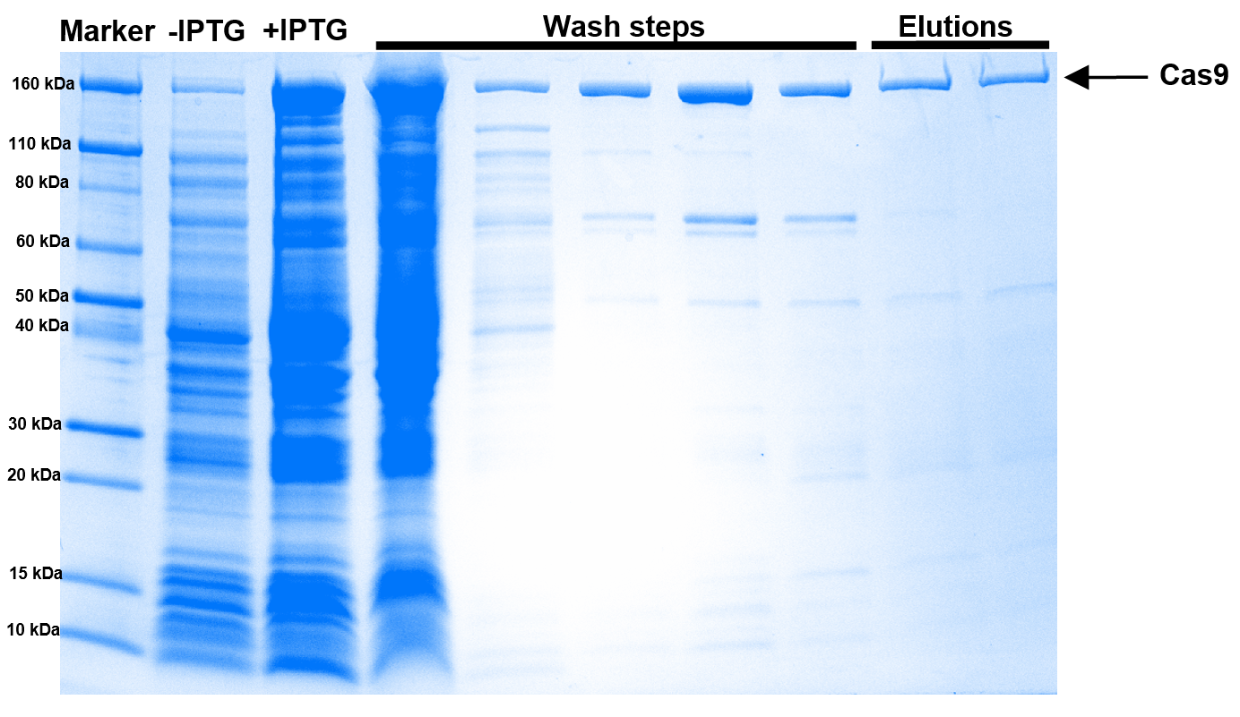
Figure 2: Coomassie blue stained SDS-PAGE showing different fractions (IPTG inductions, wash fractions, elution fractions) during nickel column chromatography of the Cas9/Cas12a extracted from E. coli.

    - Size exclusion purification
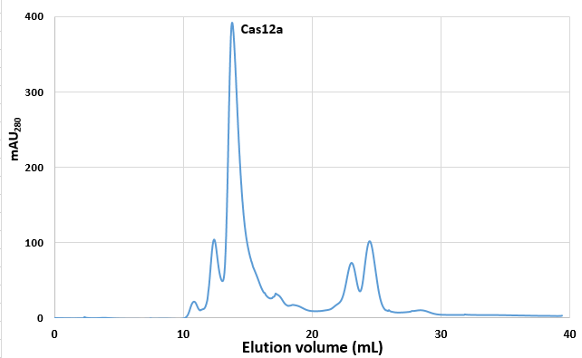
Figure 3: Size-exclusion chromatography elugram obtained for Cas9/Cas12a by ultraviolet detection at 280 nm. Major peaks of monomeric Cas9/Cas12a fractions are pooled and concentrated.

    - GIH in-house Cas9/Cas12a activity test comparing to commercial Cas9/Cas12a activity with two concentrations, i.e. 18 pmol v.s. 1.8 pmol
Figure 4: Activity analysis of GIH in-house Cas9/Cas12a performance compared with commercial Cas endonuclease (COM). (A) Gel electrophoresis of the PCR product to assess the activity of the purified Cas9 in two different concentrations, i.e. 18pmol and 1.8pmol. Negative control (lane 6: CTR) is HPRT fragment amplification template and 18pmol versus 1.8pmol of the in-house purified Cas9 protein. (B) Cas9 activity or editing efficiency is calculated as: intensity of deletion bands divided by intensity of HPRT no deletion bands. (C) Gel electrophoresis of the PCR product to assess the activity of the GIH in-house purified Lbcpf1, Lbcpf1-mScarlet, Cas12a, Cas12a-HF compared with commercial Lbcpf1 (COM). Negative control (lane 11: CTR) is HPRT fragment amplification template. (D) The activity is calculated as intensity of deletion bands divided by intensity of HPRT no deletion bands.

    - Endotoxin level test
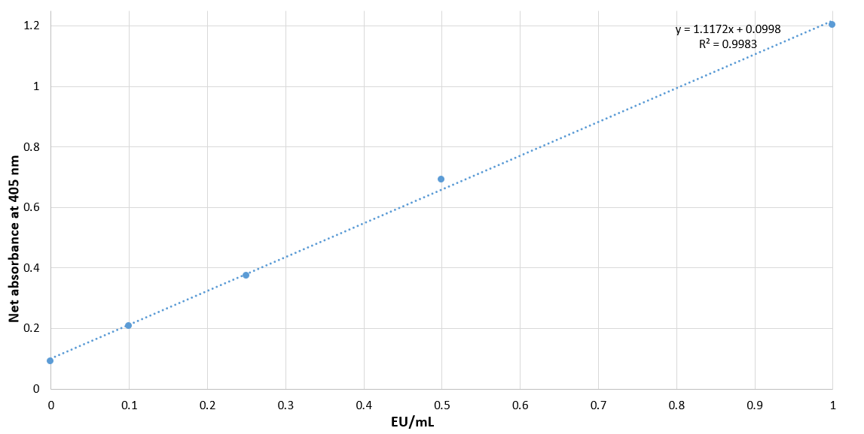
 | Sample Ab₄₀₅ |  | average | EU/mL (1/10 diluted) | EU/mL | EU/ug
PCV | 2.32 | 2.32 | 2.316 | 1.983709273 | 19.83709 | 0.119023
SNAP | 1.96 | 2.21 | 2.088 | 1.779627641 | 17.79628 | 0.106778
Figure 5: The endotoxin LAL assay for GIH in-house purified Cas9. The negligible amounts of endotoxin is less than 0.1 EU/ug.

SOP VALIDATION DETAILS
This protocol has been used to purify and validate spCas9 and different Cas9 viriants successfully.

WASTE MANAGEMENT AND DISPOSAL
Small amount of diluted methanol (flammable) and glacial acetic acid (weak acid) can be disposed to general laboratory sink with excess water

DATA RECORDS MANAGEMENT
- SDS-PAGE gel images are stored at GelDoc folder
- FPLC results are stored at AKTA result folder.

REFERENCE DOCUMENTS
1. Rajagopalan, N., et al. (2018). "A Two-Step Method for Obtaining Highly Pure Cas9 Nuclease for Genome Editing, Biophysical, and Structural Studies." Methods and Protocols 1(2): 17.
2. New England Biolabs. In vitro digestion of DNA with Cas9 Nuclease, S. pyogenes (M0386)
DOI: dx.doi.org/10.17504/protocols.io.idhca36
3. Savic N, Ringnalda FC, Lindsay H, Berk C, Bargsten K, Li Y, Neri D, Robinson MD, Ciaudo C, Hall J, Jinek M, Schwank G. Covalent linkage of the DNA repair template to the CRISPR-Cas9 nuclease enhances homology-directed repair. Elife. 2018 May 29;7:e33761. doi: 10.7554/eLife.33761. PMID: 29809142; PMCID: PMC6023611.

QUALITY CONTROL (QC) AND QUALITY ASSURANCE (QA) SECTION
According to the Qiagen website (https://www.qiagen.com/au/products/top-sellers/endofree-plasmid-kits/#orderinginformation), cell transfection-grade reagent must be less than 0.1 EU/ug.

TOUBLESHOOTING
- Do not add glycerol during elution step, because its viscosity reduces the buffer exchange dramatically
- Work at low temperature environment during the process because the Cas9 is temperature sensitive
- Bacteria is cultured at low temperature (16-18 °C) to help with protein folding and solubility.
- Avoid the pressures over the pressure limit during FPLC
- Clean-in-place can be done after several time use of the columns.
- Final protein product need to sterilize by pass though 0.22 uM PVDF filter before using in genome editing experiment in cell or in vivo to prevent contamination.

