|  |  |
| --- | --- |
| gih.uq.edu.au |  |

|  |
| --- |
| Genome Innovation Hub Standard Operating Procedure (SOP) |

|  |  |
| --- | --- |
| SOP Title: | Precise genome editing using Cas9 fusion protein in mammalian cells |
| SOP Number: | GIH_SOP104-01 |
| Effective Date: |  |
| Replaces SOP Number: | First Issue |
| Group: | Genome Innovation Hub |

Current version:

|  |  |  |
| --- | --- | --- |
|  | Name | Date |
| **First Issue written by:** | Di Xia | dd/mm/yyyy |
| **Latest update by:** |  |  |
| **Authorised by:** |  |  |

#### Document revisions:

*Previous versions:*

|  |  |  |
| --- | --- | --- |
| SOP Number | Authored/Revised by | Date Originated or Revised |
|  |  | dd/mm/yyyy |
|  |  |  |
|  |  |  |
|  |  |  |

Contents

A Purpose and Application 3

B Brief Summary of Method 3

C Definitions and Abbreviations 4

D Occupational Health and Safety 5

E Cautions 6

F Personnel Qualifications, Training and Responsibilities 6

G Equipment and Materials 6

H Procedure 8

I Worked Example 16

J SOP Validation Details 19

K Troubleshooting 19

L Waste Management and Disposal 19

M Data Records Management 19

N Reference Documents 20

O Quality Control (QC) & Quality Assurance (QA) Section 20

# A Purpose and Application

Precise genome editing at single base pair precision is one of the most important applications of CRISPR technology. In the CRISPR-Cas9 system, the Cas9/sgRNA efficiently induces targeted DNA double-strand breaks (DSBs), which are repaired by either non-homologous end-joining (NHEJ) or the homology-directed repair (HDR) pathway. However, due to the low frequency of HDR in comparison to indel (insertion or deletion)-forming NHEJ DNA repair pathway, it is very challenging to perform precise genome editing/HDR without screening a large number of single cell clones. Increasing the efficiency of HDR is critical for expediting the success of precise genome editing projects such as SNP modification in a timely and low labour cost manner. Several strategies have been developed to enhance the efficiency of HDR in the literature. Using small molecule chemical enhancer increased the HDR efficiency by altering the DNA repair pathway. The delivery of DNA repair template in close proximity to the DSB locus by covalent linkage with spCas9/sgRNA complex is another promising strategy to increase the HDR efficiency. This SOP represents an optimized precise genome editing workflow in mammalian cells using a combinational approach of both chemical enhancer treatment and covalent labelling of Cas9 fusion protein with repair template.

# B Brief Summary of Method

This SOP describes an optimized workflow for precise genome editing in mammalian cells using a choice of two different Cas9 fusion proteins, Cas9-SNAP or Cas9-avidin.

* For Cas9-SNAP, single stranded DNA repair templates are linked with O6-benzylguanine (BG), followed by covalent linkage to Cas9-SNAP protein.
* For Cas9-avidin, biotinylated (BT) single stranded DNA repair template are incubated directly with Cas9-avidin to form Cas9-avidin-biotin ssDNA (CAB) complex.

The Cas9-fusion:ssODN are further loaded with sgRNA to form a ribonucleoprotein-DNA (RNPDs) complex and delivered into mammalian cells using electroporation. Transfected cells are subsequently incubated with small molecule chemical enhancer to further boost the HDR efficiency.

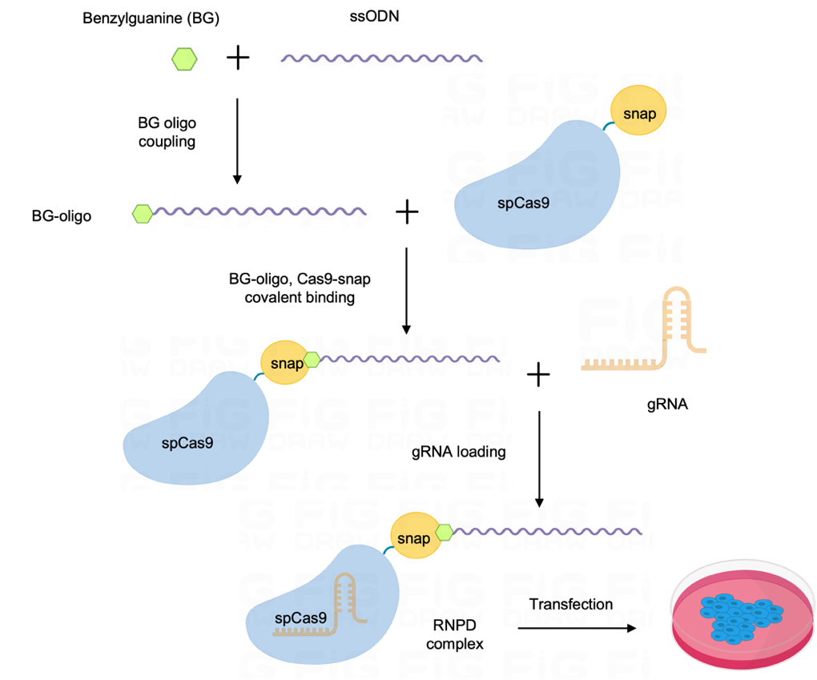

Figure 1, overview of the Cas9-SNAP workflow with key steps

# C Untested Suggested Modifications

This SOP has been validated with short DNA oligo repair template in a traffic light reporter cell line. We expect that it will also work in other endogenous genomic locus in different cell lines and other systems including animal models. Besides, BG or BT tag may also possible to be incorporated into long DNA repair template. By combining the labelled long DNA fragment (double or single strand) with Cas9-SNAP, it may also increase the HDR efficiency for large fragment knock-in project.

# D Experimental Design Considerations

# We recommend to design sgRNA targeting within 15bp of the mutation site, with a repair template size between 60nt to 90nt. The repair template should contain mutations that prevent further cutting by CRISPR after editing, for example a synonymous mutation in the PAM sequence. In our experience the Cas9-SNAP fusion allows highest efficiency for short oligo templates; we hypothesise that Cas9-avidin may be preferable for larger inserts but this is untested.

# E Requisite Prior Knowledge

1. Cell culture information for your cell-line of interest. That includes the cell-line specific culture protocol, number of passages, doubling rate, QC history.
2. Optimized transfection protocol for your cell-line of interest.

We specifically use electroporation-based method (Thermofisher Neon or Lonza nucleofector 4D) for RNP or RNPD transfection as it is more efficient than the lipid based transfection for most cell lines.

For labs with no access to electroporation device, it is also possible to use liposome-based transfection method such as PEI and Lipofectamine (CRISPRmax, Thermofisher). This SOP does not cover lipofection-based methods.

Cell type specific electroporation protocols can be found through literature review or from the following websites:

* Lonza Cell line transfection database [[http://knowledge.lonza.com/search-results?search=*](http://knowledge.lonza.com/search-results?search=*)](http://knowledge.lonza.com/search-results?search=*)
* Thermofisher Cell line transfection database [<https://www.thermofisher.com/au/en/home/life-science/cell-culture/transfection/neon-transfection-system/neon-transfection-system-cell-line-data.html>](https://www.thermofisher.com/au/en/home/life-science/cell-culture/transfection/neon-transfection-system/neon-transfection-system-cell-line-data.html)

For cell lines with unknown transfection protocol, a transfection test and optimization is required.

1. Target gene and editing details.
2. Basic knowledge in cell culture and genetics.

# F Definitions and Abbreviations

HDR homology directed repair

NHEJ non-homologous end joining

DSB double strand break

BG O6-benzylguanine

BT Biotin

CAB Cas9-Avidin-Biotin ssDNA

AM AmMC6 (5’-amino modifier C6 functional group)

PAGE Polyacrylamide Gel Electrophoresis

TE Tris-EDTA

RNP ribonucleoprotein

RNPD ribonucleoprotein-DNA

RT room temperature

IVT in vitro transcription

ssODN single-stranded oligonucleotides

sgRNA single guide RNA

gRNA guide RNA

crRNA CRISPR RNA

tracrRNA trans-activating CRISPR RNA

TLR Traffic-light reporter

# G Occupational Health and Safety

Follow the risk assessment in the reference

IMB Risk assessments #2627: *Using Thermofisher Neon System for Transfection*

IMB Risk assessments #726: *Routine procedures in Tissue Culture room - maintenance of cell lines, Tissue Culture room duties.*

# H Cautions

All reagent and plasticware used for cell culture are sterile by default. Reagents directly used for live cell need to be filter sterilised. All procedures that produce final products directly used for cell culture or genome engineering and involves lid opening steps should be carried out inside a biosafety cabinet to reduce the risk of contamination to the cell.

# I Personnel Qualifications, Training and Responsibilities

The Neon electroporation system is designed to deliver variable high voltage electrical impulses for the purpose of introducing substrates into eukaryotic cells. Improper operation of the device may cause damage to the device. Proper training is required before starting transfection experiments.

Basic training in cell culture, molecular biology and biochemistry is required. OGTR and IBC approval are required for carrying out genome editing project in cell-lines. Human ethics or animal ethics may also need to be obtained before starting experiments in specific cell types.

Training Requirements

X

X

Read and understand documents Training required

# J Equipment and Materials

#### Equipment

1. Biosafety cabinet
2. Benchtop centrifuge for 1.5mL/2mL tubes
3. Mini-PROTEAN Tetra cell vertical electrophoresis system (Bio-Rad Cat.: 1658004)
4. Nanodrop (Thermofisher ND-2000)
5. Countess II automated cell counter (Thermofisher)
6. Neon Transfection System (Thermofisher)
7. Gel Doc XR+ Gel Documentation System (Bio-Rad)
8. Olympus CKX53 microscope with DP74 camera
9. Beckman CytoFLEX Analyzer

#### Software

1. Bio-Rad Image Lab software
2. Olympus cellsens imaging software
3. Snapgene

#### Materials

1. UltraPure DNase/RNase-Free Distilled Water (thermofisher Cat.: 10977015)
2. BG-GLA-NHS (NEB Cat.: S9151S)
3. Dimethyl sulfoxide (DMSO) (Sigma Cat.: D2650)
4. sodium acetate (3 M, pH 5.5) (Thermofisher Cat.: AM9740)
5. ethanol (sigma, Cat.: E7023)
6. Gel-Red Nucleic Acid Gel Stain (Biotium Cat.: 41002)
7. Cell line for editing. eg. (Jurkat, HEK293, iPSC)
8. TLR reporter cell line for assay validation. (Jurkat and HEK293, in-house generated)
9. TBE Buffer (Tris-borate-EDTA) (10X) (thermofisher Cat.: B52)
10. Alt-R Cas9 Electroporation Enhancer (IDT Cat.: 1075915)
11. Alt-R CRISPR-Cas9 crRNA (IDT)
12. Alt-R CRISPR-Cas9 tracrRNA (IDT Cat.: 1072532)
13. Cas9-SNAP (in-house purified using Addgene plasmid #113717)
14. Thermofisher Neon Transfection System 10 µL Kit (MPK1025)
15. Cell Growth medium with supplement (cell type specific)
16. NU7441 (Selleckchem Cat.: S2638)
17. TBE-Urea Sample Buffer (2X) (Thermofisher Cat.: LC6876)
18. TE buffer (pH 7.5, 10 mM Tris, 0.1 mM EDTA, IDT Cat.: 11-05-01-15)
19. 10x TBE (Tris/Boric Acid/EDTA) Buffer, (Biorad 1610770).
20. 15% Mini-PROTEAN precast TBE-Urea Gel, 15 well, 15 µl (Biorad 4566056)
21. Nuclease Free Duplex Buffer (IDT 11-01-03-01)
22. 50bp dsDNA ladder (NEB N3236S)

#### Oligos

|  |  |  |  |  |
| --- | --- | --- | --- | --- |
| Oligo Name | Sequence | Type | Source | Grade |
| AM-mutRFP-68-NT | /5AmMC6/CCTTCGCCTTCGACATCCTGGCTACCAGCTTCATGtaCGGCAGCAAAGCCTTCATCAACCACACCCAG | Single strand **DNA** | IDT | Desalted |
| AM-mutRFP-68-T | /5AmMC6/CTGGGTGTGGTTGATGAAGGCTTTGCTGCCGtaCATGAAGCTGGTAGCCAGGATGTCGAAGGCGAAGG | Single strand **DNA** | IDT | Desalted |
| BT-mutRFP-68-NT | /5Biosg/CCTTCGCCTTCGACATCCTGGCTACCAGCTTCATGtaCGGCAGCAAAGCCTTCATCAACCACACCCAG | Single strand **DNA** | IDT | Desalted |
| BT-mutRFP-68-T | /5Biosg/CTGGGTGTGGTTGATGAAGGCTTTGCTGCCGtaCATGAAGCTGGTAGCCAGGATGTCGAAGGCGAAGG | Single strand **DNA** | IDT | Desalted |
| mutRFP crRNA | UGGCUACCAGCUUCAUGCU | Single strand **RNA** | IDT | Desalted |

**Reagent setup**

1. HEPES pH 8.5 200mM

Dissolve 4.77 g of HEPES in 80 ml of ddH2O,

Adjust pH to 8.5 using 10 M NaOH

Adjust final volume to 100 ml with ddH2O

Filter sterilize with 0.22um filter

Store at 4ºC

1. BG-GLA-NHS 20 mM stock solution

Dissolve 2 mg BG-GLA-NHS in 207μl DMSO

Aliquot 25ul each and store at -80ºC.

CRITICAL POINT: BG-GLA-NHS is unstable and readily hydrolyses in moisture. Therefore, it should be stored bellow 20ºC before dissolving and shall be aliquoted and freeze immediately after resuspension. No filter sterilization step is required.

1. Oligos (DNA or RNA)

All oligos are prepared in TE buffer at a stock concentration of 100 uM. ssODN should be stored at -20ºC after resuspension. crRNA and tracrRNA should be stored at -80ºC after resuspension.

1. NU7441

Dissolve 5mg of NU7441 in 604ul DMSO to make stock concentration of 20mM

Filter sterilize with 0.22um filter

Aliquot 10ul each and store at -20ºC.

1. 1X TBE Running Buffer

Add 200 mL 5X TBE Running Buffer to 800 mL deionized water to make 1L of 1X TBE Running Buffer

# K Procedure

# Workflow outline:

**Day 1**

#### Step 1 BG oligo coupling reactions.

#### Step 2 Ethanol precipitation and QC

**Day 2**

#### Step 3 Validation of coupling efficiency with PAGE

Step 4 Quantification of coupling efficiency

**Day 3**

#### Step 5 Covalent labelling of Cas9-SNAP protein and BG oligos

Step 6 Non-Covalent labelling of Cas9-Avidin protein and BT oligo

#### Step 7 Guide RNA annealing

#### Step 8 Prepare RNPD complex for transfection

**Day 4**

#### Step 9 Cell culture and transfection

**Day 7+**

Step 10 Post transfection analysis

**Note: For Cas9-Avidin method, skip step 1~ 5 and start from Step 6**

# Day 1

#### Step 1 BG oligo coupling reaction

1. Prepare AM oligo (Oligo with 5’-amino modifier C6 functional group) stock solution in 100uM using Ultrapure water.
2. Prepare the reaction by adding the components sequentially to a Lo-Bind 1.5mL tube in the order listed in Table 1.

**Table 1** : BG oligo coupling reaction setup

|  |  |  |  |
| --- | --- | --- | --- |
| Component | Stock Concentration | Volume [μl] | Total amount |
| BG-GLA-NHS | 20 mM | 25 | 500 nmol |
| DMSO |  | 125 |  |
| AM Oligo | 100 μM | 50 | 5 nmol |
| HEPES pH 8.5 | 200 mM | 100 |  |
| *Total* |  | 300 |  |

1. Mix the components by pipetting >5 times.
2. Incubate the reaction at 30 °C for 60 min.

**Note:**

1. Coupling reactions were performed in 100:1 BG-GLA-NHS: AM-oligo ratio to maximize the coupling efficiency.
2. Reaction above produces 5 nmols of BG oligo. In our protocol, each transfection requires 40 pmol of BG-oligo using the thermofisher 10ul neon electroporation tips. For a total of 5 nmol of BG oligo, one coupling reaction is enough for 125 transfections.

#### Step 2 Ethanol precipitation and QC

1. Add 30ul (1/10) volume of sodium acetate (3M, pH5.2) and mix well
2. Add 660ul (2 volumes) of ice-cold 100% ethanol and mix by flipping the tubes twice.
3. Store ethanolic mixture solution at 4ºC for 1hr for DNA precipitation.
4. Centrifuge at 14000g/4ºC for 30mins.
5. Carefully remove supernatant with 1ml pipet without touching the pellet
6. Add 800µL cold 70% ethanol (freshly prepared) and wash the DNA pellet flipping the tubes twice. The pellet may appear floating as small sheets of precipitate.
7. Centrifuge at 14000g/4ºC for 30mins, carefully remove supernatant.
8. Repeat the wash step as in step 2.6
9. Centrifuge at 14000g/4ºC for 30mins, carefully remove supernatant
10. Air dry in biosafety cabinet with open lid for about 10~15min until all ethanol evaporate. Expect to see a translucent pellet.
11. Dissolve the pellet using 20ul 1XTE buffer.
12. Use 1ul and dilute 10 times in TE buffer for nanodrop QC and quantification. Sample could be compared directly with ethanol precipitated AM-oligo (1:10 dilution in TE). Please see the comment in note.
13. use 1XTE to adjust to final concentration to 100uM.
14. aliquot 2ul each and keep at -80ºC before use.

**Note**:

1. step 2.3 can also be done at -20ºC overnight according to other nucleic acid precipitation protocols.
2. The pellet may appear to be white if over-dry in step 2.11. DNA may take longer to dissolve in this case. Use 50ºC 1XTE buffer or keep the sample at 4ºC fridge over-night may help to dissolve the DNA.
3. The publication on which this protocol is based used HPLC and size exclusion chromatography for further purification of the oligo after ethanol precipitation. This will remove uncoupled oligos and further increase the product purity. Since our coupling efficiency is high (>80%), we have skipped this step and found no problem in transfection and genome editing.
4. The ratio of A260:A230 and A260:A280 may appear to be off (± 0.6) in comparison to the common ratio of pure DNA sample (A260:A280 = 1.8, A260:A230 2.0-2.2). This is largely due to the variation in the nucleic acid composition in oligos. We also noticed that the commercial desalted oligo has very low A260:A230 ratio (1 ~ 1.2), indicating impurity in desalting procedure in oligo production, which could be improved by ethanol precipitation (A260:A230 ratio doubles after purification). The pure BG-oligos have shown similar A260:A280 and A260:A230 ratio in comparison to ethanol precipitated AM-oligo counterpart. Therefore, ethanol precipitated AM-oligo was used as a reference for the BG-oligo in nanodrop QC.

# Day 2

#### Step 3 Validation of coupling efficiency with PAGE

1. Prepare 20ng each of BG oligo and AM oligo (uncoupled control) in separate tubes. Depends on the stock concentration of the oligo, a dilution of 1:100 or 1:200 is expected in order to pipette correct amount of oligos for PAGE analysis.
2. Prepare PAGE sample as following table, mix diluted oligo with water and 2XTBE-urea buffer.

**Table 2**: PAGE sample mix

|  |  |  |
| --- | --- | --- |
| Component | Volume [ul] | Note |
| oligo | X | 20ng |
| deionized Water | 5-X |  |
| 2XTBE-urea buffer | 5 |  |
| *Total* | 10 |  |

1. Heat samples at 70°C for 3 minutes for denaturing and keep on ice before loading to PAGE gel.
2. Assemble 15% precast TBE-urea gel according to product manual.
3. Fill the tank with 1XTBE buffer in both up chamber (200ml) and bottom chamber (600ml)
4. Remove the comb and flush the well by pipetting with 1XTBE buffer to remove excessive urea.
5. Load sample to the well.
6. Run the gel at constant 150V for about 5h (or 200V for 2h) until the Bromophenol Blue dye indicator (10bp) reaches to the bottom of the gel.
7. Stain gel with Gel-Red in 1:10000 dilution in 1XTBE buffer for 30 minutes at room temperature with gentle agitation on an orbital shaker.
8. Discard the staining buffer and wash the gel in deionized water for three times with 5min each
9. Image gel using a UV transilluminator (eg. Bio-Rad Gel Doc XR+).

**Note:**

1. Gel-Red is very sensitive. Do not overload the oligo sample in PAGE as the band signal may become oversaturated and difficult to be distinguished between coupled and uncoupled fragments. We tested with 10ng and 20ng oligo in PAGE gel and found 20ng is a suitable amount with good resolution.
2. Gel-Red is classified as non-hazardous for drain disposal.
3. Gel-Red could be also replaced by SYBR gold (Thermofisher) with similar sensitivity.

#### Step 4 Quantification of coupling efficiency

The aim for this step is to estimate the labelling efficiency using image lab (Bio-rad) or image J software. Both are free software could be obtained from Bio-Rad and NCBI website. The following steps is based on the image lab.

1. Open the gel image and click the volume tool at the bottom of the Analysis tool box (fig. 2).

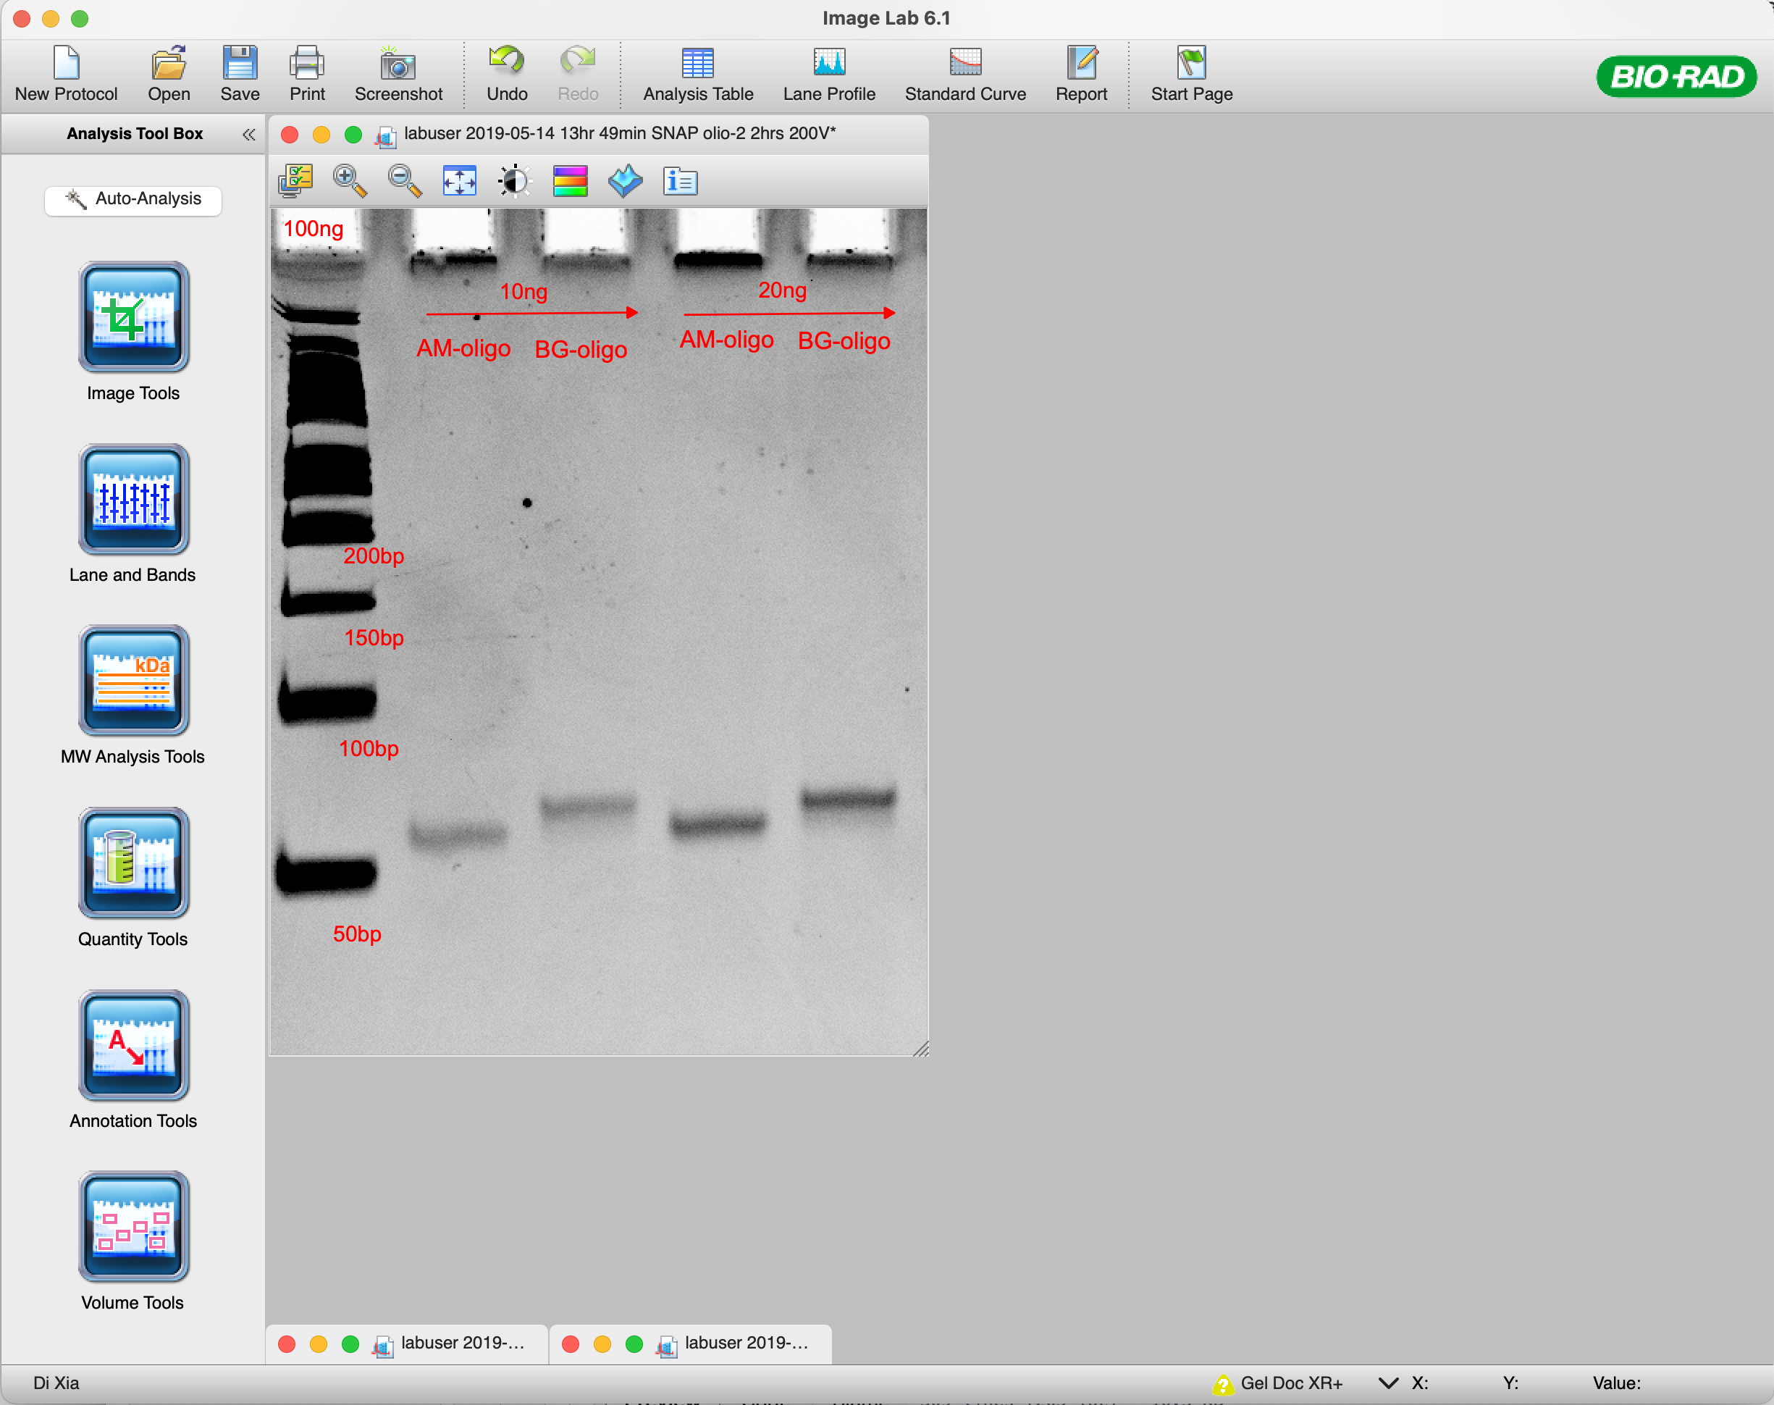

Figure 2 image lab

1. In the volume tools, select “Rectangle tool” and draw around the band at the AM-oligo (U3) and BG-oligo (U1) sample lane, a region for uncoupled oligo (U2) in the BG-oligo lane was draw according to reference location of AM-oligo (fig, 3 left panel).
2. Draw a background region next to the band of interest (B1) and double click the rectangle and change the volume type to “Background” (fig 3, right panel).
3. Choose “subtraction method as Global” in the volume tools and Click “Analysis table” from the menu bar of the software.
4. Choose the second “Volume table” tab in the analysis table at the bottom screen.
5. In the Volume table, the “Adj. Vol. (int)” shows the list of the adjusted volume of a band after background subtraction, which is a relative quantification of the band signal.
6. The coupling efficiency is calculated as follows:

U1/ (U1+U2), where U1 and U2 are adjusted volume of coupled oligo and uncoupled oligos.

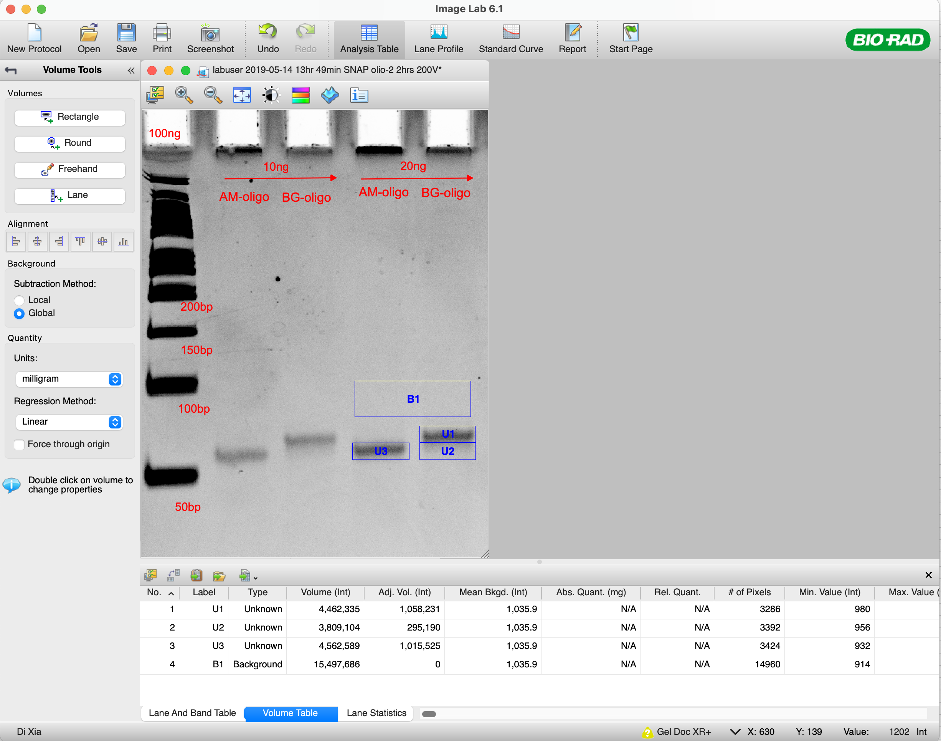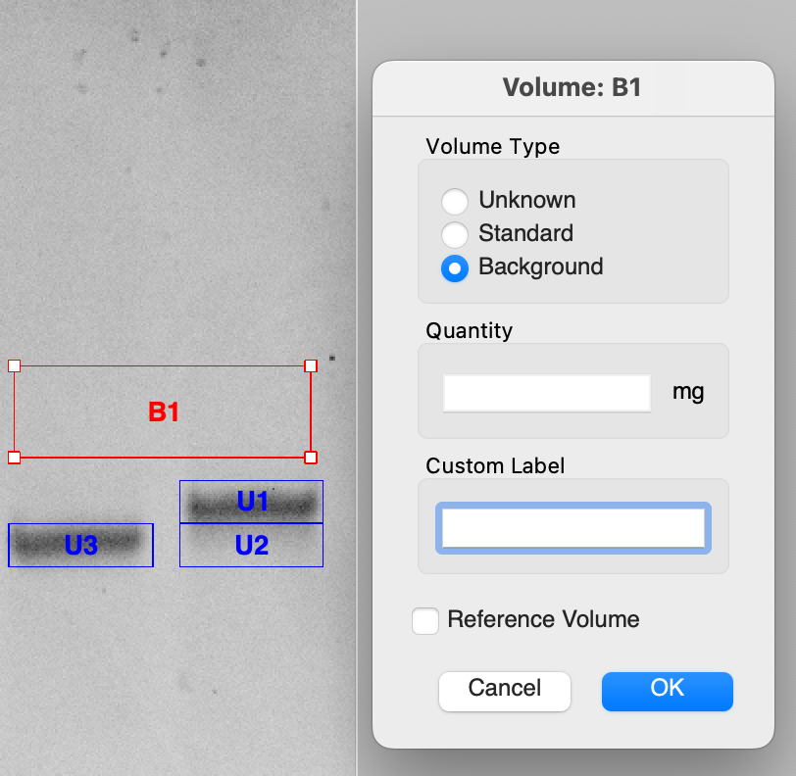

Figure 3 PAGE gel analysis in image lab

**Note:** the uncoupled oligo may appear to be smear in PAGE. Therefore, our method could only give a rough estimation for the coupling efficiency which is sufficient as an indication of successful coupling of BG-oligos. With >80% high coupling efficiency and clear shift of band, further analysis and purification by HPLC may not be necessary.

# Day 3

#### Step 5. Covalent labelling of Cas9-SNAP protein and BG oligos

Use the following table as guideline for preparing Cas9-SNAP: BG-oligo covalent reaction.

**Table 3**: gRNA annealing

|  |  |  |  |
| --- | --- | --- | --- |
| Component | Stock [uM] | Volume [ul] | Total amount [pmol] |
| **BG-oligo** | 100 | 1.6 | 160.0 |
| **Cas9-snap** | 30 | 2.7 | 80.0 |
| ***Total*** |  | 4.3 |  |

1. Mix BG-oligo:Cas9-SNAP at 2:1 ratio in a 0.2ml PCR tube.
2. Incubate for 60 min at 30°C using Thermocycler.
3. The end product will be 80pmol of Cas9-SNAP:BG-oligo complex.

**Note**:

1. Use BG-oligo:Cas9-SNAP in 2:1 ratio to maximize the covalent labeling efficiency.
2. The current setup is for 4 standard transfections using neon 10ul tips, with 20pmol of Cas9-SNAP per transfection. Upscale or downscale accordingly.

#### Step 6. Non-Covalent labelling of Cas9-Avidin protein and BT oligo

|  |  |  |  |
| --- | --- | --- | --- |
| Component | Stock [uM] | Volume [ul] | Total amount [pmol] |
| **BT-oligo** | 100 | 1.6 | 160 |
| **Cas9-Avdin** | 30 | 2.7 | 80 |
| ***Total (RNPD)*** |  | 4.3 |  |

1. Mix BT-oligo and Cas9-SNAP at 2:1 ratio in a 0.2ml PCR tube.
2. Incubate at RT for 10 min.
3. The end product will be 80pmol of Cas9-Avidin:BT-oligo complex.

**Note**:

1. Use BT-oligo and Cas9-Avidin at 2:1 ratio to maximize the labeling efficiency.
2. The current setup is for 4 standard transfections using neon 10ul tips, with 20pmol of Cas9-Avidin per transfection. Upscale or downscale accordingly.

#### Step 7. Guide RNA annealing.

1. In a PCR tube, mix crRNA, tracrRNA and duplex buffer according to the table below.

**Table 4** : gRNA annealing

|  |  |  |
| --- | --- | --- |
|  | Stock [uM] | Volume [ul] |
| crRNA | 100 | 2 |
| tracrRNA | 100 | 2 |
| duplex buffer |  | 1 |
| *Total* |  | 5 |

1. Sample were heated at 95ºC for a 1min on a thermocycler.
2. Bring the sample to a rack and let it cool to RT in 10 ~ 15min
3. The final concentration of gRNA after annealing is 40uM. Annealed gRNA to be used immediately for transfection or store at -80ºC for long term.

**Note**:

skip this step if using sgRNA (100 ~ 120nt single guide RNA, in-house IVT or purchase from vendors)

#### Step 8. Prepare RNPD complex for transfection

Use the following table as a general guideline for preparation of RNPD for transfection.

**Table 5 :** RNPD setup

|  |  |  |  |
| --- | --- | --- | --- |
| Component | Stock [uM] | Volume [ul] | Total amount [pmol] |
| **Cas9-fusion:ssODN mix** | as in step 4 | 4.3 | 80.0 |
| **gRNA** | 40 | 2.4 | 96.0 |
| ***Total (RNPD)*** |  | 6.7 | 80.0 |

1. gRNA was loaded to the Cas9-fusion: ssODN mix as 1.2:1 ratio from step 4
2. incubate at room temperature for 10min
3. Store RNPD at 4ºC before transfection on the same day, or store at -80ºC for long term.

**Note:**

1. The current setup is for 4 transfections with the same gRNA and 20pmol of RNPD per transfection. Upscale or downscale accordingly.

# Day 4

#### Step 9. Cell culture and transfection

We recommend using early passage stock of cells in the lab for genome editing project. Cell culture may start after successful validation of BG-oligo coupling. Additional one week is expected when bringing a new cell-line from frozen stocks. Routing cell cultures could also be used for validation purpose.

The following steps are standard cell culture and electroporation protocol for adherent cells growing in T75 flask. For cells grow in suspension, skip steps 8.3 to 8.5.

1. Seeded cells in flask should be in optimal confluency between 70 ~90 %.
2. Warm growth medium in water bath.
3. Aspirate cell culture media from the flask and wash cells once with 5ml PBS.
4. Add 1ml of 0.05 ~ 0.25% Trypsin-EDTA (Cell-dependent) and incubate the cells for 3~5 minutes until the cells fully detach from the plate.
5. Neutralize the dissociation reaction with 4ml of prewarmed growth medium in flask.
6. Transfer cell suspension from flask to 15ml falcon tube. Pipette up and down for 5~10 time to break cell aggerates into a single cell suspension.
7. Centrifuge cells at 150 x g for 5 minutes at room temperature, remove supernatant and resuspend the cell in 1ml of prewarmed growth medium
8. Count the cells to determine cell density (number of cells per ml) using manual or automatic cell counter (eg. countess II).
9. Calculation

*The total number of cells per experiment = number of cells per transfection X (number of transfections + number of controls).*

*The total volume of cells per experiment = The total number of cells per experiment / cell density*

1. Transfer calculated volume of cells into a 2ml microcentrifuge tube.
2. Centrifuge cells at 150 x g for 5 minutes at room temperature. Remove the supernatant and resuspend the cell in 1ml PBS as a washing step to remove any component in media that may inhibit the electroporation.
3. Centrifuge cells at 150 x g for 5 minutes at room temperature.
4. Carefully remove all supernatant and resuspend the cells in buffer R (10ul per each reaction).
5. For each transfection, mix cell with RNPD as follows.

**Table 6 :** RNPD-cell mix for transfection

|  |  |  |  |
| --- | --- | --- | --- |
| Component | Volume [ul] | Amount [pmol] | Note |
| **RNPD complex** | 1.67 | 20 | from step 7 |
| **IDT Electroporation Enhancer** | 0.5 | 50 | 100uM stock |
| **Cell mixture in buffer R** | 10 |  | 100K |
| **Buffer R** | X |  |  |
| ***Total*** | 12 ~ 13 |  |  |

1. Aspirate 10 μl of cell-RNPD solution using 10 μl Neon tip.
2. Electroporate using cell type specific protocol.
3. Transfer each transfected cells to single well of 12 well tissue culture plate and return cells to 37ºC incubator.
4. In order to further increase the HDR efficiency, transfected cells was treated with 2uM of NU7441 (DNA-PK inhibitor) for 48 hours post transfection.
5. Monitoring the growth and recover of cells post transfection the next three days. Change media if there is excessive cell death.

**Note:**

1. When using 10ul neon tips, it is important to prepare the total volume of the reaction at 12 ~ 13 ul which reduce the risk of the bulb formation during step 8.9.
2. Always add a non-transfected negative control to monitor the cell death by transfection. A positive control using GFP plasmid is recommended to monitor the performance of the transfection.
3. The amount of RNPD and number of cells used per each transfection may vary in different cell lines or different transfection methods, which could be optimized and determined empirically.

For electroporation using 10ul Neon tips, we suggest using 20pmol RNPD and 100K cells as a starting point. When doing transfection optimization, RNPD could be test in the range between 10pmol to 60pmol and number of cells between 50K to 500K cells per each neon transfection.

# L Next Steps

#### Step 10 Validation of CRISPR editing

CRISPR editing outcome including precise editing through HDR DNA repair pathway and random indels through NHEJ DNA repair pathway. Efficiency could be validated by imaging / flow cytometry (for targeting fluorescent reporter genes), or Sanger / amplicon sequencing. The RNPD will degrade in the cell in 48 hours for the editing to complete. It may take longer for the cell to fully recover from electroporation. Minimal three days is recommended for CRISPR validation post transfection. We suggest using amplicon sequencing for analysing the efficiency of small modification bellow 100bp. The efficiency analysis in bulk population can be used to predict the number of single cell clones for screening.

#### Step 11 Single cell cloning and genotyping

The HDR based precise editing method may generate many incorrect edited cells as by-products due to indel formation at the locus where double strand break by spCas9/sgRNA and DNA repair happens. Those indels may have unpredictable outcome for the target gene including reading-frame shift mutations and in-frame mutations. This is especially important for cells with multiple copies of chromosomes and genes where a heterogenous modification could happen at different locus. Therefore, single cell cloning is still required even the editing efficiency is high in bulk population.

# M Worked Example

#### Experiment design

To validate the SOP, ﻿a Jurkat TLR (traffic-light reporter) cell line expressing non-fluorescence mutant RFP (turboRFP, Y63L) and fluorescence GFP was generated by CRISPR knock-in at AAVS1 locus of the genome (AAVS1-CAG-mutRFP-2A-GFP). The TLR reporter will switch from GFP into RFP/GFP double positive fluorescent after correction of Y63L mutation in RFP gene by HDR DNA repair pathway, and it will also lost GFP signal under the NHEJ pathway (figure 4). This creates an easy and high throughput read out for precise editing (HDR) and NHEJ efficiency.

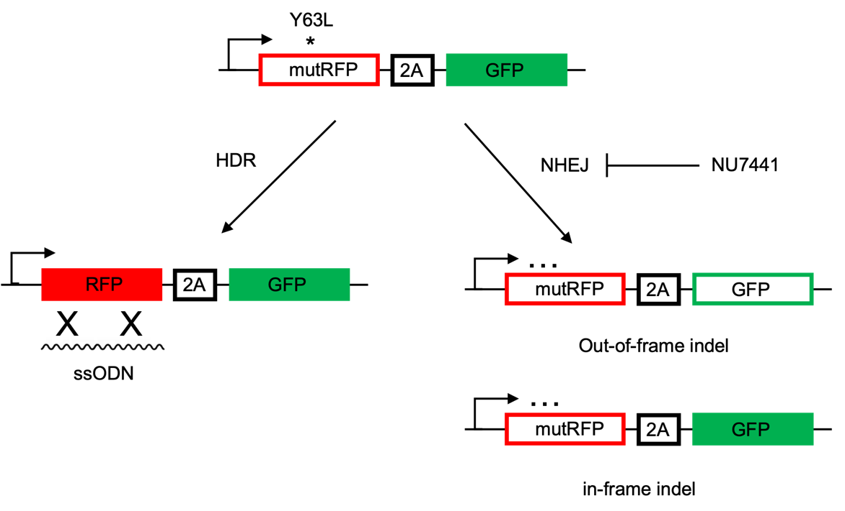

Figure 4. Schematic overview of the Jurkat TLR system.

#### Coupling reaction and QC by nanodrop

**Table 7 :** nanodrop QC of oligos

|  |  |  |  |  |  |  |  |
| --- | --- | --- | --- | --- | --- | --- | --- |
| Sample | Nucleic Acid | Unit | A260 (Abs) | A280 (Abs) | 260/280 | 260/230 | Sample Type |
| AM-oligo 1 | 391.2 | ng/µl | 11.855 | 7.461 | 1.59 | 1.02 | ssDNA |
| AM-oligo 1 purified | 437.6 | ng/µl | 13.262 | 8.073 | 1.64 | 2.03 | ssDNA |
| BG-oligo 1 purified | 407.3 | ng/µl | 12.343 | 7.364 | 1.68 | 2.03 | ssDNA |
| AM-oligo 2 | 489.1 | ng/µl | 14.822 | 7.22 | 2.05 | 1.19 | ssDNA |
| AM-oligo 2 purified | 484 | ng/µl | 14.667 | 7.052 | 2.08 | 2.55 | ssDNA |
| BG-oligo 2 purified | 498.8 | ng/µl | 15.115 | 7.326 | 2.06 | 2.49 | ssDNA |

#### QC by PAGE analysis

10ng or 20ng of BG-oligo and AM-oligo were loaded in a 15% TBE-urea PAGE gel and run at 200 V for 2h. The gel was stained for 30 min in 1x TBE containing Gel-Red (1:10, 000) and imaged with a UV transilluminator (Bio-rad). Successful BG-oligo coupling reactions shown a clear shift of band due to increase of molecular weight (Figure 4). The coupling efficiency was estimated as 83%, as calculated by Image lab app.

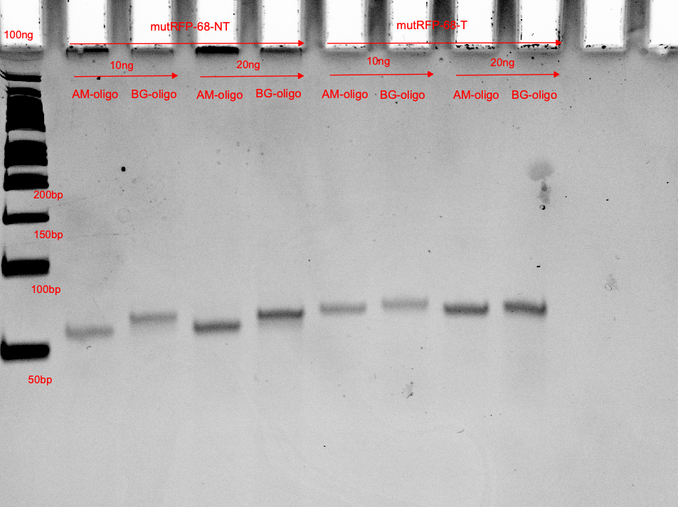

Figure 4 PAGE analysis of BG oligo coupling reaction.

Lane 1, NEB 50bp dsDNA ladder, Lane 2~5 (AM-oligo 1 and BG-oligo 1, mutRFP-68-NT, 10ng or 20ng), lane 6~9 ( AM-oligo 2 and BG-oligo 2, mutRFP-68-T, 10ng or 20ng)

#### Transfection and validation of CRISPR editing

200K of Jurkat TLR cells were transfected with 10 pmol of RNPD using Neon electroporation system (protocol 1500V*10ms*3pulse). Cells were maintained in RPMI+10% FBS media and split every 4 day. Cells were treated with 2uM NU7441 for 48 hours post transfection and images were taken 5 days post transfection. Up to 46% precise editing efficiency (based on flow cytometry) has been achieved using a combination of covalent labelling (Cas9-Snap-tag fusion protein and O6-benzylguanine (BG)-linked DNA repair templates) and small molecule enhancer.



Figure 5 representative image of the Jurkat TLR reporter cells after precise editing

# N SOP Validation Details

This SOP is validated using gRNA and repair template targeting to RFP gene in a traffic light reporter cell line, which will switch from GFP to GFP/RFP double positive as indication of successful precise editing experiment. Validated details as described in session M of the Worked Example.

# O Troubleshooting

|  |  |  |
| --- | --- | --- |
| Step | Issue | Recommendations |
| Step 3 | BG oligo coupling unsuccessful or  low coupling efficiency | * BG may already expire or stored improperly. Prepare fresh BG, make small aliquots, store at -80C, and avoid freeze and thaw cycle. * Incorrect oligo design. Oligo may not contain the NH2 function group for coupling. Check Oligo design and re-order. * Inactive Cas9-fusion protein. The fusion fragment may be non-functional or could not bind of BG oligo. Check storage condition and repeat the protein purification. |
| Step 10 | HDR efficiency low | * Low Transfection efficiency, optimize the transfection protocol for the cell of interest and use a positive control for each experiment. * Cas9-fusion protein inactive. Validate Cas9-fusion activity by in vitro digestion assay using a known working sgRNA and use a working spCas9 as a positive control. * sgRNA inactive. Validate sgRNA activity using in vitro digestion assay using a standard spCas9 and Cas9-fusion. * If the sgRNA is inactive, redesign the sgRNA. We recommend designing a few different sgRNAs per each target, which increases the likelihood of finding a working one. However, some target locus may have less sgRNA options. * Incorrect repair template design. HDR repair template shall be designed close to the spCas9/sgRNA DSB locus with minimal of 30bp of homologous arms at each end. * It is possible that some locus in genome is harder to be target in comparison to others. Therefore, more single cell clones may need to be screened after the optimization attempts. |

# P Waste Management and Disposal

Cell culture ware with media and cells shall be treated with 8% bleach for at least half hour before drain the media waste and dispose empty Cell culture ware to the clinical waste bins. Other solid and low-volume liquid waste generated through performing this SOP are to be disposed into clinical waste bins according to IMB waste management protocol. Sharps are to be disposed of into puncture-resistant clinical sharps bins. There are no special waste disposal requirements associated with this SOP.

# Q Data Records Management

The SOP will generate the following raw data. Raw data shall be stored at RDM. Experiment record shall be recorded at labarchieves.

|  |  |
| --- | --- |
| RAW data | File formats |
| Sanger sequencing | .abl file |
| Amplicon-seq | .FASTQ |
| Plasmid/genomic sequence and map | .dna or .gb |
| Gel images | .scn |
| Primer, sgRNA and oligo sequence | Excel/word |
| Cell-line record | Excel/word |
| Flow cytometry | .fcs |
| Microscope images | .tiff |

# R Reference Documents

1. IMB Risk assessments #2627: *Using Thermofisher Neon System for Transfection*
2. IMB Risk assessments #726: *Routine procedures in Tissue Culture room - maintenance of cell lines, Tissue Culture room duties.*
3. GIH_SOP103 spCas9-SNAP expression, purification, and validation
4. GIH_SOP105 CRISPR knockout in mammalian cells using RNP approach.
5. Savic, N. *et al.* Covalent linkage of the DNA repair template to the CRISPR-Cas9 nuclease enhances homology-directed repair. *eLife* **7**, 163 (2018).
6. Savić, N. *et al.* In vitro Generation of CRISPR-Cas9 Complexes with Covalently Bound Repair Templates for Genome Editing in Mammalian Cells. *Bio-protocol* **9**, (2019).
7. Ma, M. et al. Efficient generation of mice carrying homozygous double-floxp alleles using the Cas9-Avidin/Biotin-donor DNA system. Cell Research 27, 578–581 (2017)

# S Quality Control (QC) & Quality Assurance (QA) Section

This SOP is validated using gRNA and repair template targeting to RFP gene in a traffic light reporter cell line, which will switch from GFP to GFP/RFP double positive as indication of successful precise editing experiment. The reporter cell line, sgRNA and repair template could be used as positive control for the method. An alternative method for validation would be testing the protocol using a published control sgRNA and repair template targeting at an endogenous genomic locus and use amplicon sequencing to validate the precise editing efficiency. Information of the control sgRNA and repair template could be found in the Reference 5

1. **Contact details**
2. **Stacey Andersen**
3. **Operations Manager, Genome Innovation Hub**

T +61 7 334 62607  
E [s.andersen2@uq.edu.au](mailto:john@uq.edu.au)  
W gih.[uq.edu.au](http://www.uq.edu.au/)

-----------------------------------------------------------------------------------------------------------------------------------

1. **Collaborator name (optional)**
2. **Collaborator title (optional)**

T   
E   
W

CRICOS Provider 00025B

