  - gih.uq.edu.au

QFAGE/Genome Innovation Hub Standard Operating Procedure (SOP)

SOP Title: | CRISPR knockout in mammalian cells using RNP approach
SOP Number: | GIH_SOP105
Effective Date:
Current Review Date:
Replaces SOP Number:
Group: | QFAGE/Genome Innovation Hub
I have read this document and approve its contents.
 | Name | Signature | Date
Written by: | Di Xia
Reviewed by:

Authorised by:

SOP Number | Author | Date Originated or Revised
 |  | dd MMM yyyy

Contents
[PLEASE DELETE BEFORE SUBMISSION
This table will autopopulate – after completing the SOP, right-click, select ‘Update Field’, and choose ‘Update page numbers only’.]

A Purpose and Application 3
B Brief Summary of Method 3
C Definitions and Abbreviations 3
D Occupational Health and Safety 3
E Cautions 3
F Personnel Qualifications, Training and Responsibilities 3
G Equipment and Materials 4
H Procedure 4
I Worked Example 5
J SOP Validation Details 5
K Troubleshooting 5
L Waste Management and Disposal 5
M Data Records Management 5
N Reference Documents 5
O Quality Control (QC) & Quality Assurance (QA) Section 6

A Purpose and Application
Using CRISPR/Cas9 method for making gene knockout is one of the most common applications for gene editing and has been wildly used for loss of function study in many different species. Ribonucleoprotein (RNP) is the most convenient way of making CRISPR knockout in mailman cells, which saves the efforts in plasmid cloning or lentivirus packaging and also have the benefit of both high efficiency and low off-targeting in comparison to DNA based method. This SOP aim to provide a general guideline for CRISPR knockout in mammalian cells using RNP approach.

B Brief Summary of Method
This SOP describe a basic workflow of CRISPR knockout in mammalian cells including guide RNA design, transfection using electroporation method to deliver ribonucleoprotein (RNP) to the cell, editing analysis using T7E1, ICE or amplicon sequencing methods, as well as single cell cloning and genotyping to isolate correct cell clones.

C Definitions and Abbreviations
RNP: ribonucleoprotein
sgRNA: single guide RNA
gDNA: genomic DNA
gPCR: genomic PCR
crRNA: CRISPR RNA
tracrRNA: Trans-activating CRISPR RNA
INDEL: insertion and deletion
ICE: Inference of CRISPR Edits
TIDE: Tracking of indels by decomposition
T7E1: T7 Endonuclease I
CDS: coding sequence
IVT: in vitro transcription

D Occupational Health and Safety
The Neon electroporation and lonza 4D nucleofector system is designed to deliver variable high voltage electrical impulses for the purpose of introducing substrates into eukaryotic cells. Improper operate the device may cause damage to the device. Proper training is required before start transfection experiment. For QBP user, please check the following risk assessment before start of the experiment. For non-QBP users, new risk assessments may need to be established at UQ safe.
1. Risk assessments #2609: Using Lonza 4D-Nucleofector System for Transfection
2. Risk assessments #2627: Using Thermofisher Neon System for Transfection
3. Risk assessments #726: Routine procedures in Tissue Culture room - maintenance of cell lines, Tissue Culture room duties.

E Cautions
All reagent and plasticware used for cell culture must be sterile. Steps for preparing reagent for live cell should be filter sterile or carried out inside a biosafety cabinet to reduce the risk of contamination.

F Personnel Qualifications, Training and Responsibilities
Basic training in cell culture, molecular biology is required. OGTR, IBC approval are required for carrying out genome editing project in cell-lines. Human ethics or animal ethics may also need to be obtained before starting experiment in specific cell types. eg. Primary cells obtained from human patient or primary cells isolate directly from animal tissues. Training for equipment used in this SOP is needed.
Training Requirements
X
X

Read and understand documents Training required

G Equipment and Materials

Equipment
- Lonza 4D-Nucleofector System with X Unit
- Thermofisher Neon Transfection System
- Bio-Rad Mini-Sub Horizontal Electrophoresis Systems
- Bio-Rad T100 Thermal Cycler
- Nanodrop (ThermoFisher ND-2000)
- Countess II automated cell counter
- Biosafety Cabinet
- Benchtop Centrifuge
- Gel doc imager (Bio-Rad)

Materials
- Synthetic guide RNA (sgRNA or crRNA, tracrRNA) from in vitro transcription or commercial source (eg. IDT, Synthego, Sigma).
- Purified spCas9 nuclease protein (In house purified spCas9 protein or commercial spCas9 eg. NEB#M0646T, Sigma#PECAS9, Thermofisher#A36499, IDT#1081059).
- Lonza 4D-Nucleofector X Kit S (cell type specific)
- Thermofisher Neon Transfection System 10 µL Kit (MPK1025)
- Cell Growth medium with supplement (cell type specific)
- Cell dissociation reagent (cell type specific)
- Tissue culture plates ( 96well, 12well, 6well)
- Microcentrifuge tubes (Eppendorf 1.5ml and 2ml)
- T7 Endonuclease I (NEB #0302S)
- Cryostorage media
- 0.2ml PCR tubes or PCR strips
- IDTE buffer
- IDT electroporation enhancer

Oligos
Oligo Name | Sequence | Type | Resource | Purification
Human HPRT F1 | AAAGAATGTTGTGATAAAAGGTGATG | Single strand DNA | IDT | Desalted
Human HPRT R1 | ACACATCCATGGGACTTCTGCCTC | Single strand DNA | IDT | Desalted
HPRT gRNA1 | AATTATGGGGATTACTAGGA | Single guide RNA | IDT | Desalted
HPRT gRNA2 | CAAAACACGCATAAAAATTT | Single guide RNA | IDT | Desalted

Reagent setup
Oligos (DNA oligo or crRNA, sgRNA oligo)
All oligos are prepared in TE buffer for a stock concentration of 100 uM. DNA oligo should be stored at -20C after resuspension. RNA oligo should be stored at -80C after resuspension.

H Procedure

Workflow outline:
Caution: All reagent and plasticware used for cell culture must be sterile. Steps with live cell or preparation of reagent for live cell usage should be carried out inside a biosafety cabinet to reduce the risk of contamination.

Week1

Step 1 Experiment design
Purpose:
- Search for protocols for transfection for cell line of interest.
- Choose the right target and sgRNA for targeting.
- Choose the right primer for analysing the CRISPR editing.
CRITICAL POINT: Proper project design is critical for the success of the CRISPR editing.
- Check the literature, cell line transfection protocol from Lonza and neon cell line database (Ref 5 and 6). If no validated protocol available, a transfection optimization is needed for new cell line. Please check the SOP for transfection optimization in Lonza 4D and thermofisher Neon product manual.
- Design guide RNA. sgRNA can be designed using free online tools eg: CHOPCHOP, CRISPOR, CRISPR RGEN etc. Commercial vendors eg. IDT and synthego also provide predesign sgRNA in common species and own online tools for CRISPR design. The following steps are using CRISPOR as example.
    - Download your gene sequence as genebank file from NCBI gene website. https://www.ncbi.nlm.nih.gov/gene/
    - Open sequence file using Snapgene software. Identity target exons contain CDS. We usually pickup early exons close to ATG start codon. However not all early exons contain locus with good sgRNA score. Choose a few exons and screen for the best one.
    - Go to the CRISPOR website http://crispor.tefor.net
    - Input your target exon sequence and choose the right genome and PAM sequence according to different CRISPR system and click submit.

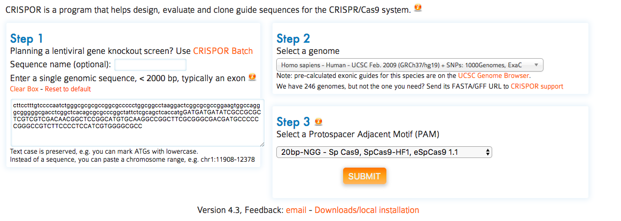

    - In the results window, select the guide sequence that shows both high specificity (specify score >50, higher the better) and high efficiency (Doench 16 score > 30, higher the better). For CRISPR knockout, we usually pickup 2~4 different sgRNA per each target gene.

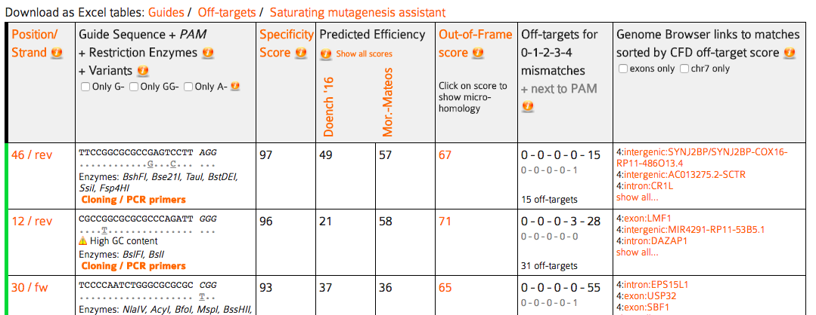

- Design primers for CRISPR analysis
- Primers for PCR amplifying the sgRNA targeting region and sanger sequencing (TIDE or ICE analysis) are designed using either Primers3 or Benchling. We recommend Benchling as it has better user interface.

- For genomic PCR, primers shall be at least 150bp away from the nearest sgRNA targeting locus, with amplicon size between 400 ~ 1000 bp in T7E1 assay or TIDE/ICE analysis. For NGS, amplicon size is limited to 550bp. We suggest to design a few pairs of primers (2~3) for each target region which will increase the likelihood of finding good primer pairs for genomic PCR and reduce the efforts in PCR condition optimization.

- For sequencing primers used in TIDE/ICE analysis, it needs to be at least 150 bp (optimal range 200-300 bp ) from the closest sgRNA cut-site, resulting in high quality sequencing for the first hundred base pairs before the mixed heterogenous peaks emerges.

- Use sequencing primers that are 18–22 bp in length, with Tm between 55°C - 60C and GC content between 45–60%.

Week2

Step 2 Ordering reagent
- Depends on equipment availability in the lab. Order cell line specific electroporation kit from Lonza or Thermofisher. Alternatively, RNP could also be transfected using lipid based reagent (eg. Thermofisher CRISPRMAX). In general, electroporation works more efficient lipofection in most cell-lines. However electroporation requires specific equipment and the reagent cost is also much higer than lipofection.
- Once the desired guide has been chosen, order synthesized sgRNA from commercial vendors including Synthego, Sigma, Genescript or IDT etc. We normally order crRNA, tracrRNA, together with primers from IDT as it is cheaper and more connivence than other options, with no sacrifice in quality and editing efficiency in most cell types. The delivery time is around one week to UQ. sgRNA could also be generated in-house by in vitro transcription (IVT). More efforts and additional QC steps are required for IVT. We normally do not recommend using IVT sgRNA for CRISPR knockout unless a large library of sgRNA needs to be generated for cost saving.

Week3

Step 3 Transfection

Option 1 Transfection using Thermofisher Neon electroporation System
- Seeded cells in plates should be in optimal confluency between 70 ~90 %.
- Pre-warm normal growth medium.
- Assemble RNPs. For each transfection, mix Cas9 and gRNA in 1:1 ratio as follows and incubate at room temperature for 10min to allow RNP to form.

Component | Concentration | Volume [ul] *
spCas9 | 20 ~ 60 [uM] | 10 ~ 30 pmol
sgRNA | 20 ~ 100 [uM] | 10 ~ 30 pmol
IDT electroporation enhancer | 100 uM | 0.5 ul
Cells in resuspension Buffer R | 50K~200K | X
Total |  | 12ul
Note:
- The amount of RNP and number of cells used per each reaction may vary in different cell lines and need to be optimized for each cell line.
- Prepared RNP is stable at RT for a few hours or can be stored at 4C overnight. RNP can be stored at -20C for few weeks or stored at -80C for long term before used for transfection. Avoid freeze-thaw cycle.
- The total amount non-buffer R solution in final reaction shall be within 20% as higher than that it may reduce the transfection efficiency.
- IDT electroporation enhancer is optional. It reduce the amount of RNP required for transfection.
- Aspirate cell culture media from the plate and wash cells once with PBS.
- Add appropriate amount of 0.25% Trypsin-EDTA and incubate the cells for 3~5 minutes (Cell-dependent) until they detach from the plate completely.
- Neutralize the dissociation reaction with prewarmed growth medium.
- Count the cells to determine cell density.
- For each reaction, aliquot 100K cells into a microcentrifuge tube. Centrifuge cells at 200 x g for 5 minutes at room temperature.
- Carefully Remove the supernatant and resuspend the cell in buffer R per each reaction.
- Mix cell with RNP.
- Aspirate 10 μl of cell-RNP solution to a 10 μl Neon tip.
- Electroporate using cell type optimized conditions.
- Transfer all transfected cells to 12 well tissue culture plate and return cells to 37 C incubator.

Option 2 Transfection using Lonza 4D-Nucleofector System
- Seeded cells in plates should be at optimal confluency between 70 ~90 %.
- Pre-warm normal growth medium.
- Assemble RNPs. For each transfection, mix Cas9 and gRNA in 1:1 ratio as follows (without cells) and incubate at room temperature for 10min to allow RNP to form.

Component | Concentration | Amount*
spCas9 | 20 ~ 60 uM | 20 ~ 60 pmol
sgRNA | 20 ~ 100 uM | 20 ~ 60 pmol
IDT electroporation enhancer | 100 uM | 1 ul
Cells in transfection Buffer | 100K~400K | 20 ul
Total |  | 20 ~ 30 ul

- Aspirate cell culture media from the plate and wash cells once with PBS.
- Add appropriate amount of 0.25% Trypsin-EDTA and incubate the cells for 3~5 minutes (Cell-dependent) until they detach from the plate completely.
- Neutralize the dissociation reaction with prewarmed growth medium.
- Count the cells to determine cell density.
- For each reaction, aliquot 200K cells into a microcentrifuge tube. Centrifuge cells at 100 x g for 8 minutes at room temperature.
- Carefully Remove the supernatant and resuspend the cell in 20ul nucleofection solution
- Mix cell with RNP.
- Transfer all cell with transfection mix to Nucleocuvette strips and click the lid into place.
Place the Nucleocuvette strip in the right orientation into the retainer of the 4D-X Core unit.
- Choose the protocol and press “Start” on the display of the 4D-X Core unit core unit.
After run completion, the screen should display a green “+” over the wells indicate that cells were successfully transfected.
- Resuspend the cells in each well with pre-warmed growth media
- Transfer all transfected cells to 12 well tissue culture plate and return cells to 37 C incubator.

Week4

Editing Validation
After RNP delivery by electroporation, the editing will start immediately until all RNP degraded. The cell will reach the maximal efficiency between 48 to 72 hour, when the genomic DNA is extracted. Cells can continue to expand with no loss of editing efficiency unless the CRISPR target gene affect the cell growth etc.

Step 4 Genomic DNA extraction
- Wash cells once with PBS
- Add adequate Quickextract buffer into each well of transfected cell. We normally use ~25ul per well of 96 well plate, ~50 ul per well of 24 well plate, or ~100 ul per well of 12 well plate.
- Transfer cell lysis into PCR tube and run the PCR machine using the following setting.
65C 15min
68C 15min
98C 10min
Cool to RT
- Read on the Nanodrop and dilute the DNA to a concentration of 100 ng/μl with TE buffer and store at -20ºC before use.

Step 5 Genomic PCR
Use high fidelity DNA polymerase (eg. NEB Q5, Thermofisher Phusion etc) to amplify the target region. Please refer to the product manual to the polymerase of choice. Primer pare may needs to be screened and PCR condition (melting temperature, PCR additives etc.) optimized using genomic DNA from unedited cells. The following are the standard PCR protocol used in the lab.
5XQ5 buffer | 5 | ul
10mM dNTP | 0.5 | ul
5uM Primer mix | 2.5 | ul
Template | 1.25 | ul
Q5 DNA polymerase | 0.30 | ul
H2O | 15.45 | ul
Total | 25 | ul

Initial denature | 98C | 1min
Denature | 98C | 5s~10s
Annealing | 60C | 5s
Extension | 72C | 30s
 | X30 cycle
Final extension | 72C | 5min
Hold | 4C

Step 6 T7E1 assay
- Analyse a small amount of the of the PCR product to verify size and appropriate amplification.
- Calculate the DNA concentration of PCR product based on the intensity of gel and DNA ladder as reference or column purify and quantify the
- Assemble reactions as follows:

Component | 19 µl annealing reaction
DNA | 200 ng
10X NEBuffer 2 | 2 µl
Nuclease-free Water | To 19 µl

- Anneal the PCR products in a thermocycler using the following conditions:

Step | Temperature | Ramp Rate | Time
Initial Denaturation | 95°C |  | 5 minutes
Annealing | 95-85°C | -2°C/second
 | 85-25°C | -0.1°C/second
Hold | 4°C |  | Hold

- Add T7EI to the annealed PCR products and incubation.

Component | 20 µl reaction
Annealed PCR product | 19 µl
T7 Endonuclease I (NEB M0302) | 1 µl
Incubation Time | 15 minutes
Incubation Temperature | 37°C

- Run on 2% TBE agarose gel and image by gel doc.
- Calculate the estimated gene modification using the following formula:
% gene modification = 100 x (1 – (1- fraction cleaved)^{1/2})

Step 7 ICE analysis

Step 8 Single cell cloning
In order to obtain knockout cell line clones with defined genotype, single cell cloning is reqired. We normally use FACS to seed single cell into 96 well plate. Depends on the cell type, it will take 3~4 weeks for the single cell clones to expand and replate into 12 well plate for further expand for stocking and genotyping.

I Worked Example
We use the following sgRNA as Positive control:

Human HEK293 was transfected with control sgRNA (Protospacer sequence: AATTATGGGGATTACTAGGA, PAM: AGG) targeting to human HPRT site (ChrX: -134498211) using and the following RNP setup and thermofisher Neon electroporation system (protocol: 1,150V, 20ms, 2 Pulse)

Component | Concentration/uM | Volume/ul
spCas9-NLS (IDT) | 20 | 1
gRNA (IDT crRNA+tracrRNA or synthego sgRNA) | 20 | 1
IDT electroporation enhancer (optional) | 40 | 0.5
Cells in resuspension Buffer R | 100K | 10
Total |  | 12

The result of T7E1 has been shown as follows. Both sgRNA from Synthego and IDT was used as comparison. Control was un-transfected cell.

The primer used for genomic PCR and fragment expected after T7E1 treatment are as follows.
Forward primer AAGAATGTTGTGATAAAAGGTGATGCT
Reverse primer ACACATCCATGGGACTTCTGCCTC
Amplicon Size; 1083 bp
Predicted Cut Products: 256/827 bp

J SOP Validation Details
This SOP has been developed in the dual sgRNA screening project (Project code: GIHIN19GRN) at GIH and routinely used by QFAGE CRISPR cell-line knockout service. Details of validation could be found in the description of the worked example.

K Troubleshooting

Step | Issue | Recommendations
Step 7 | Editing efficiency low | - Low Transfection efficiency, optimize the transfection protocol for the cell of interest and use a positive control for each experiment.  - Cas9/sgRNA inactive. Validate Cas9/sgRNA activity by in vitro digestion assay using a known working sgRNA and spCas9 as a positive control.  - If the sgRNA is inactive, redesign the sgRNA. We recommend to design 2~4 sgRNAs per gene, which increases the chance of finding a working one. However, some target locus may have less sgRNA options.  - It is possible that some locus in genome is harder to be target in comparison to others. Therefore, more single cell clones may need to be screened after the optimization attempts with a working positive control sgRNA.
Step 8 | Fail to obtain knockout clones | - The knockout gene may be essential for cell growth.  - The editing efficiency may be very low. Always analyse the editing efficiency at bulk population before start single cell cloning. Screen more clones or repeat the editing with new sgRNA design

L Waste Management and Disposal
Please check the reference in the section N of SOP.

M Data Records Management
Date type: Gel image, PCR conditions, oligo sequences, and analysis calculation results to be recorded at labachieves.

N Reference Documents
- Risk assessments #2609: Using Lonza 4D-Nucleofector System for Transfection
- Risk assessments #2627: Using Thermofisher Neon System for Transfection
- Risk assessments #726: Routine procedures in Tissue Culture room - maintenance of cell lines, Tissue Culture room duties.
- Product manual: Lonza 4D-nucleofector
- Product manual: Thermofisher Neon electroporation system
- Lonza Cell line transfection database http://knowledge.lonza.com/search-results?search=*
- Thermofisher Cell line transfection database https://www.thermofisher.com/au/en/home/life-science/cell-culture/transfection/neon-transfection-system/neon-transfection-system-cell-line-data.html

O Quality Control (QC) & Quality Assurance (QA) Section
- QC of sgRNA and DNA oligo provided by manufacture.
- QC of Cas9-Snap provided by protein purification service provider. For in-house purified Cas9, follow the QC protocol from SOP103 spCas9-SNAP expression, purification, and validation.

- Contact details
- Stacey Andersen
- Operations Manager, Genome Innovation Hub
T +61 7 334 62607
E s.andersen2@uq.edu.au
W gih.uq.edu.au
-----------------------------------------------------------------------------------------------------------------------------------
- Collaborator name (optional)
- Collaborator title (optional)
T
E
W

CRICOS Provider 00025B

