Lentiviral sgRNA construct design and cloning for single cell perturb-seq

Di Xia / Genome Innovation Hub / Version 1; 7/8/2023

Overview
This protocol describes designing and cloning of individual sgRNA lentiviral vectors for CRISPR inhibition and activation in single cell perturb-seq project. The sgRNA sequence was ordered as pair of oligos, annealed and ligated into BstXI-BlpI digested backbone.
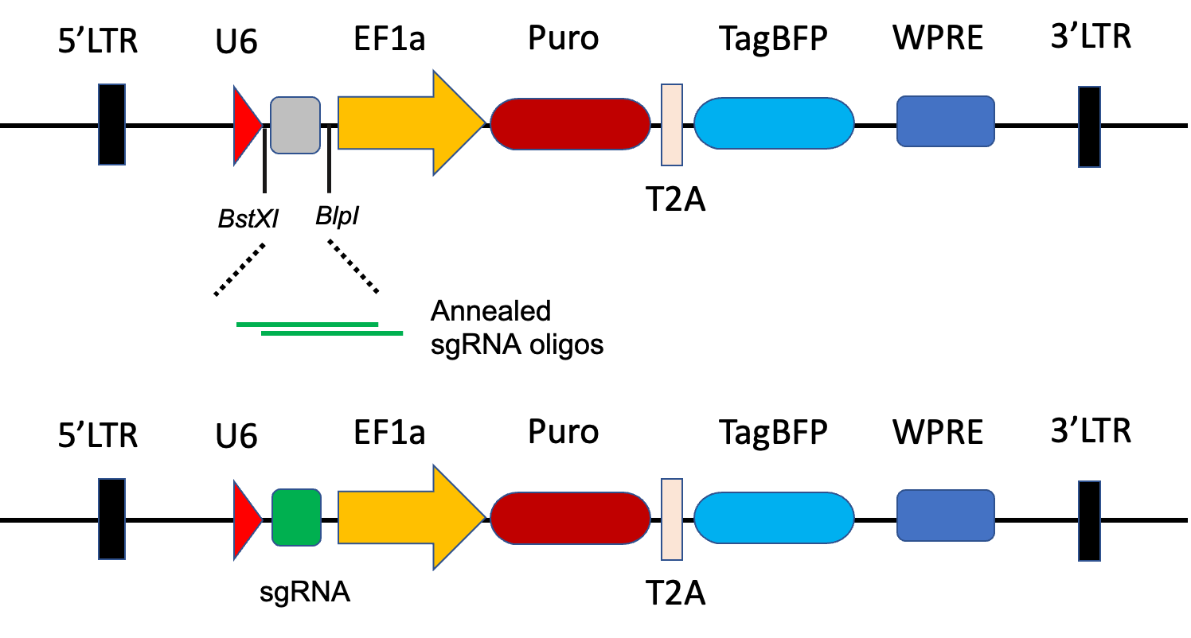

Schematic of sgRNA cloning strategy

Design notes
sgRNAs were selected from published human whole genome CRISPRi/a library (M. A. Horlbeck et al., eLife. 5 (2016), doi:10.7554/elife.19760). Three sgRNA per gene from the top of the list were chosen for either CRISPR inhibition or activation experiment.
For each sgRNA, synthesize two oligos in the following format.
Oligo 1 -> 5’-TTGGNNNNNNNNNNNNNNNNNNNNGTTTAAGAGC - 3’
3’- GAACAACCNNNNNNNNNNNNNNNNNNNNCAAATTCTCGATT - 5’<-Oligo 2
“N” in oligo 1 is the protospacers sequence of the sgRNA, “N” in Oligo2 is the reverser complementary of protospacers sequence. The NGG PAM shall not be included in the designed oligo.
For transcription initiation of sgRNA, an additional G nucleotide shall be added if the protospacers does not start with G.

Material
- pCRISPRia-v2 (Addgene plasmid #84832)
- Standard de-salted oligos resuspended in 100 uM TE buffer
- BstXI (NEB R0113S)
- BlpI (NEB R0585S)
- AleI (NEB R0685S)
- AflII (NEB R0520S)
- Quick CIP (NEB M0525S)
- T4 PNK (NEB M0201S)
- T4 DNA Ligase Reaction Buffer (NEB B0202S)
- Quick ligation kit (NEB M2200S)
- NEB stable cell (NEB C3040H)
- Gel purification kit
- Plasmid Miniprep Kit
Protocol

Backbone digestion and dephosphorylation

Backbone vector | 3 | ug
BstXI | 2 | ul
BlpI | 1 | ul
10Xbuffer 2 | 5 | ul
ddH2O | x | ul
Total | 50 | ul

- Setup the digestion reaction in PCR tube
- Digest at 37ºC for 5h ~ overnight in a thermocycler.
- Add 2ul Quick CIP into reaction and incubate at 37ºC for another 1h in the thermocycler.
- Run on a 1% agarose gel with undigested plasmid as control
- Gel purification for linearized band at size of 8.9 kb
- Quantification of purified DNA with nanodrop
- Dilute the backbone DNA into 25ng/ul in ddH2O

Oligo phosphorylation and annealing

Oligo Forward (100 μM) | 1 | ul
Oligo Reverse (100 μM) | 1 | ul
10X T4 Ligation Buffer | 1 | ul
ddH2O | 6.5 | ul
T4 PNK (NEB M0201S) | 0.5 | ul
Total | 10 | ul

- Setup the reaction as above in PCR tube per each sgRNA
- Incubate at 37ºC for 30 min in thermocycler
- 95ºC 5 min and then ramp down to 25C at 1ºC/min
- Add 50 ul of TE buffer into 10ul annealed oligos for 6X dilution
- Transfer 1ul of 6X oligo into 100ul of ddH2O for 600X final dilution

Ligation reaction

 | Reaction |  |  | Neg control (No oligo)
Digested backbone | 1 | ul |  | 1 | ul
Diluted oligo mix | 1.5 | ul
ddH2O |  |  |  | 1.5 | ul
2X Quick Ligase buffer | 2.5 | ul |  | 2.5 | ul
Quick ligase | 0.3 | ul |  | 0.3 | ul
Total | 5.3 | ul |  | 5.3 | ul

- Prepare ligation reaction according to the table above. mix digested backbone, diluted oligo and 2X Quick ligase buffer in PCR tube. For negative control, replace oligo with same amount of water.
- add Quick ligase into mixture.
- Incubate at RT for 15min.
- The ligation product could be used for transformation or freeze at -20 ºC for storage

Transformation
- Defrost 10ul of NEB stable cell per each ligation reaction on ice.
- Add 1ul of ligation product into each tube of competent cells.
- Mix by tapping and brief centrifuge
- Incubate on ice for 30min
- 42ºC water bath heat shock for 30s
- Incubate on ice for 3 min
- Add 150ul of NEB stable outgrowth medium
- 37C incubator, 300rpm, 1hour
- Spread 50ul of bacteria solution into each agarose plate (ampicillin)
- Incubate at 30ºC incubator overnight (20 ~ 24 hour)

Pickup clones and DNA preparation
- Pickup 1~2 clones per each sgRNA plate and transfer into 10ml LB broth in 50ml Falcon tube
- Grow overnight at 37 ºC overnight on a 300rpm shaker (16 ~ 18h)
- Keep 0.5ml bacteria for glycerol stock.
- Miniprep using the Plasmid Miniprep Kit
- Nanodrop quantification (for sequencing and digestion verification purpose)
- Qubit quantification (for lentivirus packaging that requires more accurate quantification)

Digestion Verification

sgRNA construct | 200~500 | ng
AleI | 0.5 | ul
AflII | 0.5 | ul
10X CutSmart buffer | 2 | ul
ddH2O | x | ul
Total | 20 | ul

- Setup the double digestion reaction in PCR tube, Use the backbone plasmid as control
- Digest at 37ºC 1 ~ 3h in a thermocycler.
- Run on a 1% agarose gel with undigested plasmid as control
- Expected band size: 3470 bp, 1933 bp, 1534 bp, 1062 bp, 905 bp
Note: A correct clone shall show same digestion pattern as the backbone plasmid. Incorrect digestion pattern indicates recombination of the construct and shall be excluded for experiment. Only send the clone with correct digestion pattern for sanger sequencing.

Sanger sequencing

Plasmid | 600 - 1500 | ng
Sequencing Primer | 10 | pmol = 1ul of 10uM stock
ddH2O | X | ul
Total | 12 | ul

Sequencing primer: pQM_F CTTGTGGGAGAAGCTCGGCT

For sanger sequencing at AGRF, mix the plasmid with sequencing primer according to the table above.

