  - gih.uq.edu.au

Genome Innovation Hub Standard Operating Procedure (SOP)

SOP Title: | TimeLapse-seq
SOP Number: | GIH_SOP011-01
Effective Date:
Current Review Date:
Replaces SOP Number: | First Issue
Group: | Genome Innovation Hub
I have read this document and approve its contents.
 | Name | Signature | Date
Written by: | Sohye Yoon
Reviewed by:

Authorised by:

SOP Number | Author | Date Originated or Revised

Contents

A Purpose and Application 3
B Brief Summary of Method 3
C Definitions and Abbreviations 3
D Occupational Health and Safety 3
E Cautions 3
F Personnel Qualifications, Training and Responsibilities 3
G Equipment and Materials 4
H Procedure 4
I Worked Example 5
J SOP Validation Details 5
K Troubleshooting 5
L Waste Management and Disposal 5
M Data Records Management 5
N Reference Documents 5
O Quality Control (QC) & Quality Assurance (QA) Section 6

A Purpose and Application
This SOP is developed to provide a workflow for TimeLapse-sequencing, which use oxidative nucleophilic aromatic substitution to convert 4-thirouridine (4sU) into cytidine analogs, yielding apparent U to C mutations that mark new transcripts upon sequencing. 4sU treatment condition to cells will vary based on cell type and desired application and this SOP described the workflow that can be applied to any standard 4SU metabolic labelling. This SOP does not cover the treatment to cells prior to 4sU labelling.

B Brief Summary of Method
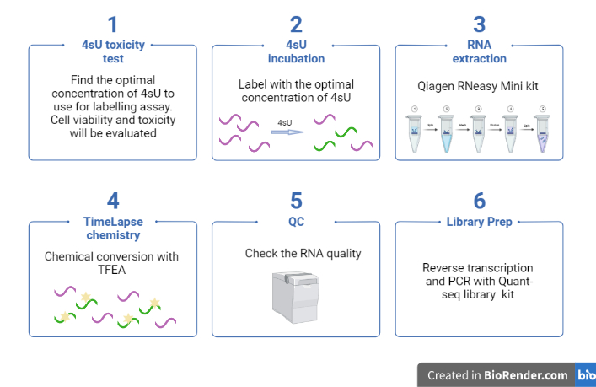

C Definitions and Abbreviations
4sU: 4-thirouridine
TFEA: 2,2,2-trifluoroethylamine
DTT: dithiothreitol

D Occupational Health and Safety
Most of chemicals that are used in the assay may cause skin acute toxicity, skin irritation/corrosion when exposed. User must read, understand, and sign on Risk assessment #2848 in the IMB Risk Assessment database.
If cells are associated with high-risk biological materials, you must be vaccinated for hepatitis B and show 10IU minimum titre before beginning work.

E Cautions
4sU is light sensitive and can crosslink. Keep all the 4sU containing samples in the dark whenever possible.
For best results, make up 4sU fresh before each use. If the solution must be stored, store at -20C and avoid freeze-thaw cycles.

F Personnel Qualifications, Training and Responsibilities
Training Requirements

X

Read and understand documents Training required [Author to delete X in relevant box]

G Equipment and Materials

Equipment
- 96 well tissue culture plates (white)
- 96 well tissue culture plates (standard)
- 6 well tissue culture plates
- 12 well tissue culture plates (standard)
- Tissue culture dish, Round and square Sterile
- P1000, P200, P20, P10 Pipette/tips
- Stripettes, 10ml, 25ml
- Centrifuge
- 1. 5 ml Eppendorf tubes
- Tubes, 15ml, 50 ml
- UVC machine
- Cell countess and slides
- Aluminium foil, for protection of reagents from light
- Plate reader with fluorescence and luminescence capabilities
- Thermocycler
      - Magnetic isolation rack
      - 96 well lobind plate

Materials
- Cell media appropriate to cell type used
- 70% of Ethanol spray
- 1x PBS
- Trypan blue
- 4sU (powder)
- UltraPure water
- CellTox Green Viability Assay (Promega)
- Cell-Titer Glo Cytotoxicity Assay (Promega)
- Qiagen RNeasy mini kit
- DL-dithiotheritol (Sigma-Aldrich, cat. no. D9799-1G)
- Gylcogen, RNA grade (Thermo Fisher, R0551)
- NaOAc (3M, pH 5.2)
- Ethanol 100%
- 2,2,2,-trifluoroethylamine (TFEA) (Sigma-Aldrich, cat. No. 269042-1)
- EDTA (0.5M)
- NaIO₄
- RNAclean beads
- Tris-HCl (1M, pH 7.4)
- NaCl (5M)
- QuantSeq-Flex Targeted RNA-Seq Library Prep Kit V2 : catalogue number 026 and 015

Reagent setup
1 M DTT
Prepare 1 M stocks solution by dissolving 154.2 mg of DTT in 1ml of H2O. Make 100 ul of aliquot and store at -20C.
Sodium phosphate buffer (NaPO4, pH 8)
Prepare 1 M stocks solutions of NaH2PO4 (monobasic) and Na2HPO4 (dibasic): Dissolve 138 g of NaH2PO4•H2O (monobasic) in H2O to make a final volume of 1 L and dissolve 142 g of Na2HPO4 (dibasic) in H2O to make a final volume of 1 L.
To prepare 200 ml of 0.5 M sodium phosphate buffer (pH 8), mix 93.2 mL of 1 M Na2HPO4 and 6.8 ml of 1 M NaH2PO4 and add 100 ml of H2O. Control pH after buffer preparation using a pH meter.

H Procedure

Workflow outline:
Day 1
4sU toxicity test
Day 2
labelling with the optimal concentration of 4sU
Day 3
RNA extraction and chemical conversion (Time Lapse Chemistry)
Day 4
Library preparation and QC

Day 1

4sU toxicity test (time: )
Purpose: to test the 4sU toxicity in our experimental system and find the optimal concentration to use for the labelling assay.
CRITICAL POINT: S4U is light sensitive and can crosslink. Keep the cells and all the 4sU-containing samples in the dark whenever possible. For best results, make up 4sU fresh before each use.
- Preparation of 4sU-containing media
  - Prepare 1300 uL of 32mM 4sU by weighing out 10.8 mg 4sU (molecular weight 260.27) and dissolving in 1300 uL nuclease-free water
  - Prepare serial dilutions of 4sU in complete media in 1.5mL tubes covered with aluminum foil by following the table below. We will need a total of ~325 uL of each concentration for 3 conditions x 2 biological replicates.
Tube | Volume complete media (uL) | Volume 4sU (uL) | Concentration in tube | Final concentration in plate | Final volume in tube (uL)
1 |  | 650 of 32mM | 32mM | 16mM | 325
2 | 325 | 325 of 16mM | 16mM | 8mM | 325
3 | 325 | 325 of 8mM | 8mM | 4mM | 325
4 | 325 | 325 of 4mM | 4mM | 2mM | 325
5 | 325 | 325 of 2mM | 2mM | 1mM | 325
6 | 325 | 325 of 1mM | 1mM | 0.5mM | 325
7 | 325 | 325 of 0.5mM | 0.5mM | 0.25mM | 325
8 | 325 | 325 of 0.25mM | 0.25mM | 0.125mM | 325
9 | 325 | 650 of 32mM | 32mM | 16mM | 325
10 | 325 | 325 of 16mM | 16mM | 8mM | 325
11 | 325 | 325 of 8mM | 8mM | 4mM | 325
12 | 325 | - | - | - | 325

- Cover the tubes with a new aluminium foil and warm to 37C.
- Make extra tubes by following the table below and store the tubes at 4C (in dark). (for replacement after 3 hour)

Tube | Volume complete media (uL) | Volume 4sU (uL) | Concentration in tube | Final concentration in plate | Final volume in tube (uL)
1 | 650 | 650 of 32mM (from step 1.a) | 32mM | 16mM | 650
2 | 650 | 650 of 16mM | 16mM | 8mM | 650
3 | 650 | 650 of 8mM | 8mM | 4mM | 650
4 | 650 | 650 of 4mM | 4mM | 2mM | 650
5 | 650 | 650 of 2mM | 2mM | 1mM | 650
6 | 650 | 650 of 1mM | 1mM | 0.5mM | 650
7 | 650 | 650 of 0.5mM | 0.5mM | 0.25mM | 650
8 | 650 | 650 of 0.25mM | 0.25mM | 0.125mM | 650
9 | 650 |  |  |  | 650
- Cover with a new aluminium foil and store at 4C for mid-test media change.

- Set-up of experimental assay with 4sU labelling
Note: The target cells were plated into 96 well plate prior to the treatment.
- Collect cells with treatment ‘A’ into a new 1.5 ml tube (1 well of 6 well plate is transferred into a 1.5 ml tube).
- Collect cells with treatment ‘B’ into a new 1.5 ml tube (1 well of 6 well plate is transferred into a 1.5 ml tube).
- Centrifuge the 1.5 ml tubes at maximum speed (15,000g) for 20 min.
- Remove the media and re-suspend the pellet with 200 ul of complete media.
- Pool 6 of tubes into one tube. The volume will be 1200ul (conc. 4x10^6cells/50ul)
- Prepare treatment media according to the table below using a clear 96 well plate, by combining 105uL “treatment A” and 105uL 4sU-containing media (that are stored at 37C) for the wells A1-9. Spare whatever left in the tube, add an equal volume of complete media and label as “A” and put aside (This will be used for treatment A control wells, G4-6).
- Prepare treatment media according to the table below using a clear 96 well plate, by combining 105uL “treatment B” and 105uL 4sU-containing media (that are stored at 37C) for the wells C1-9. Spare whatever left in the tube, add an equal volume of complete media and label as “B” and put aside (This will be used for treatment A control wells, G7-9).
- Add 210 ul of 4sU-containing media (that are stored at 37C) for the wells E1-9.

 |  |  |  | Media tube
 |  |  |  | 1 | 2 | 3 | 4 | 5 | 6 | 7 | 8 | 9
 |  |  |  | -> | -> | -> | -> | -> | -> | -> | -> | ->
 |  |  |  | 1 | 2 | 3 | 4 | 5 | 6 | 7 | 8 | 9
Treatment A |  | -> | A
 |  |  | B
Treatment B |  | -> | C
 |  |  | D
media only (control) |  | -> | E
 |  |  | F
 |  |  | G
 |  |  | H

- Remove all the media from the ‘cells’ plate and wash gently with PBS.
- Remove PBS and gently add 100uL of ‘treatment A or B’ + 4sU media per well that is prepared from Step 2. f - g to the designated wells A1-9, B1-9, C1-9, D 1-9 according to the table below.
- Remove PBS and gently add 100ul of 4sU media per well that is prepared from step 2. h to the designated wells E1-9, F1-9 according to the table below.
 |  |  |  | Media tube
 |  |  |  | 1 | 2 | 3 | 4 | 5 | 6 | 7 | 8 | 9
 |  |  |  | -> | -> | -> | -> | -> | -> | -> | -> | ->
 |  |  |  | 1 | 2 | 3 | 4 | 5 | 6 | 7 | 8 | 9
Treatment A |  | Rep1 | A
 |  | Rep 2 | B
Treatment B |  | Rep1 | C
 |  | Rep 2 | D
No treatment -BMMs only (control) |  | Rep1 | E
 |  | Rep 2 | F
Viability assay controls |  |  | G
 |  |  | H
 |  |  |  | cytotoxicity control |  |  | Treatment A control |  |  | Treatment B  control |  |  | assay background control
G1-3 = Cell only + Lysis Solution -> positive control for cytotoxicity
G4-6 = ‘A’ only, no cells –> measure of background for viability assay
G7-9 = ‘B’ only, no cells –> measure of background for viability assay
G10-12 = no cells, assay reagents only -> measure of assay baseline

- Add 100uL of complete media to cytotoxicity control wells containing cells (G1-G3).
- Add 100uL of treatment A control condition (‘A’) to treatment A control wells (G4-G6).
- Add 100 ul of treatment B control condition (‘B’) to treatment B control wells (G7-G9).
- Add 100uL of complete media to background control wells without cells (G10-G12).
- Gently agitate the plate and incubate at 37°C for 3 hours.
--------------------------------------------------------------------------------------------------------------------------
- With ~20 minutes of incubation remaining, collect the supernatant from well A1-9, B1-9, C1-9, D1-9 and transfer it into a new 1.5ml tube. Centrifuge at 15,000g for 10 min. Discard media from E1-9, F1-9.
- Meanwhile, add 100uL of appropriate fresh 4sU media that are stored in 4C to appropriate wells (A – F 1-9).
- When spin has finished, remove supernatant from wells, resuspend pellet in fresh media from A-D 1-9, and return to appropriate well of the cell plate.
- Incubate another 3hours at 37C.
--------------------------------------------------------------------------------------------------------------------------
- Make up fresh 4sU media for the next 6hr incubation following Step 1.
- Prepare 1300 uL of 32mM 4sU by weighing out 10.8 mg 4sU (molecular weight 260.27) and dissolving in 1300 uL nuclease-free water.
- Prepare serial dilutions of 4sU in complete media in 1.5mL tubes covered with aluminium foil by following the table below. We will need a total of ~325 uL of each concentration for 3 conditions x 2 biological replicates.
Tube | Volume complete media (uL) | Volume 4sU (uL) | Concentration in tube | Final concentration in plate | Final volume in tube (uL)
1 |  | 650 of 32mM | 32mM | 16mM | 325
2 | 325 | 325 of 16mM | 16mM | 8mM | 325
3 | 325 | 325 of 8mM | 8mM | 4mM | 325
4 | 325 | 325 of 4mM | 4mM | 2mM | 325
5 | 325 | 325 of 2mM | 2mM | 1mM | 325
6 | 325 | 325 of 1mM | 1mM | 0.5mM | 325
7 | 325 | 325 of 0.5mM | 0.5mM | 0.25mM | 325
8 | 325 | 325 of 0.25mM | 0.25mM | 0.125mM | 325
9 | 325 | 650 of 32mM | 32mM | 16mM | 325
10 | 325 | 325 of 16mM | 16mM | 8mM | 325
11 | 325 | 325 of 8mM | 8mM | 4mM | 325
12 | 325 | - | - | - | 325

- Cover the tubes with a new aluminium foil and warm to 37C.
- Make extra tubes by following the table below and store the tubes at 4C (in dark).
Tube | Volume complete media (uL) | Volume 4sU (uL) | Concentration in tube | Final concentration in plate | Final volume in tube (uL)
1 | 650 | 650 of 32mM (from step 1.a) | 32mM | 16mM | 650
2 | 650 | 650 of 16mM | 16mM | 8mM | 650
3 | 650 | 650 of 8mM | 8mM | 4mM | 650
4 | 650 | 650 of 4mM | 4mM | 2mM | 650
5 | 650 | 650 of 2mM | 2mM | 1mM | 650
6 | 650 | 650 of 1mM | 1mM | 0.5mM | 650
7 | 650 | 650 of 0.5mM | 0.5mM | 0.25mM | 650
8 | 650 | 650 of 0.25mM | 0.25mM | 0.125mM | 650
9 | 650 |  |  |  | 650
- Cover with a new aluminium foil and store at 4C for mid-test media change.
- With ~20 minutes of 3h incubation remaining, thaw CellTox Green Dye Concentrate and Lysis Solution. Remove stored media (1st set) from fridge and add 0.65 ul of CellTox Green Dye Concentrate to each tube.
- Aliquot 750 uL fresh media to separate tube, add 0.75 uL CellTox Green Dye Concentrate. Transfer 320 uL to an additional tube for cytotoxicity control samples (G1-3), and add 12.8 uL Lysis Solution (1:25 ratio).
- Incubate all tubes, protected from light, at 37C to equilibrate to temperature.

- Toxicity test media change
- After 6hour of incubation, discard dead cells from wells and wash with cold PBS six times.
- Replace with the fresh 4sU media that were prepared from step 2. v~w.
- For G1 -3, discard media and add 100ul of the new media that were prepared from step 2.x.
- For G10 – 12, discard media and add 100ul of the media that are left from step 2.x.
- For G4 – 6, pool the media into a new 1.5ml tube and add 0.3ul of CellTox Green Dye Concentrate. Dispense 100ul each to G4 – 6.
- For G7 – 9, pool the media into a new 1.5ml tube and add 0.3ul of CellTox Green Dye Concentrate. Dispense 100ul each to G7 – 9.
- Incubate 3 hours at 37C.
- With ~20 minutes of incubation remaining, take out the second set of the 4sU media tubes from fridge. Add 0.65 ul of CellTox Green Dye Concentrate to each tube.
- Discard the media from A1 – F9 and add 100ul of 4sU media + CellTox Green Dye concentration to the designated wells.
- Towards the end of incubation, equilibrate Cell-Titer Glo reagent to room temperature.

- Viability/toxicity assays
- After incubating plate for a total of 12hrs, place into Tecan plate reader and measure fluorescence intensity.
- Log in and click "i control 2.0 Microplate Reader software" on desktop.
- Choose "[GRE96fw_chimmey] - Greiner 96 Flat White" from 'Plate definition'.
- Go to 'Action - Shaking' if the plate is to be shaken before the measurement (Duration 2 min, Mode: orbital).
- In " Part of Plate" section, to measure individual wells, click the desired well or to measure a range of wells drag a frame around the desired range.
- Double click "Fluorescence Intensity" from "Measurements" and modify the setting as below.
- Wavelength - Excitation: 485 - 500 nm, Emission: 520 - 530 nm
- Mode - Top
- Z-position - Manual (default value: 20000 um)
- Read - Number of flashes: 25
- Gain - Optimal
- Integration - Integration time - 20 µs
- Place the plate in and press the green start button to read the plate.
Note: i-control presents the raw data for further use in Excel.
- After the final fluorescence measurement, mix Cell-Titer Glo 2.0 reagent thoroughly by inverting and add 100uL to each well A1-G12.
- Shake for 2 min, and incubate at room temperature for 10min, protected from light.
- Measure luminescence (use an integration time of 0.25-1 second/well as a guideline).
- For luminescence measure, double click "luminescence" from Control bar on the software.
- Modify the setting as below:
- Attenuation - NONE
- Integration time - 500 ms (0.25 - 1 sec/well as a guideline).
- Settle time - 0 ms
- Place the plate in and press the green start button to read the plate.
Note: i-control presents the raw data for further use in Excel.
- Take out the plate and close the software.
- Save the excel files.
- Analysis
- Plot the cell viability measures vs concentration to obtain an inhibition vs 4sU concentration curve. If there are many dead cells in the wells, we will need to adjust the baseline of the assay using control wells as background.

Day 2

labelling with the optimal concentration of 4sU (time: )
Purpose:
- Prepare ~9 ml of complete media containing 1 mM of 4sU – 2.3 mg in 9 ml of ultrapure water (molecular weight 260.27) and cover the tube with foil. Store 4.5 ml at 37C. Keep the rest 4.5 ml at 4C and transfer to 37C at 30 min before the 3hr media change.
- Transfer “A”/”B” treated cells into a new 1.5ml tube and centrifuge at 10,000g for 10 min.
- Resuspend the pellet in the media that is prepared in Step a – Two of 1.5ml tubes will go into a well of 12 well plate. Therefore add 370 ul to the first tube, resuspend and transfer to the second tube. For the no 4sU labelling plate, resuspend the pellet in 370 ul of fresh complete media.
- Remove the media from the cell plates and add 370 ul of the media from Step c.
- Incubate total of 6 hours at 37C.
- Replace the media with fresh complete media containing 4sU every 3 hour; 1) Make 100mM concentration of 4sU : 2.6mg dissolves in 100ul of H2O. Spike in 3.7ul of 100mM 4sU per well..
- After another 3 hour, remove the media and wash carefully with cold PBS x 6 times. Check under the microscope to see whether the cells are still adherent.
- Lyse the cells directly in 350 ul RLT buffer (Qiagen RNeasy mini kit) supplemented with DTT (22 samples x 350 = 7700 -> make up 7.625 ml of RLT buffer + 320 ul of 1 M DTT). Pass cell suspension through a 22-gauge needle 5 times to lyse the cells and transfer the mix to a 1.5 mL Eppendorf tube.
- Store samples at -80C or directly proceed with RNA isolation.

Day 3

RNA extraction (time: )
Purpose:
- Add 350 µl freshly prepared 70% ethanol to the lysis mixture and mix well by inversion. Transfer 700 µl of mixture to a RNeasy spin column, and centrifuge >10,000 RPM for 15 sec. Discard flow through.
- Add 700 µl buffer RW1 to column and centrifuge >10,000 RPM for 15 sec. Discard flow through.
- Add 500 µl buffer RPE supplemented with 5 ul of 10mM DTT (0.1mM final concentration) to column and centrifuge >10,000 rpm for 15 sec. Discard flow through.
- Add 700 µl freshly prepared 80% ethanol with 7 ul of 10mM DTT to column and centrifuge at maximum speed for 2 min. Transfer column to fresh collection tube and centrifuge at maximum speed for an additional 5 min.
- Transfer column to 1.5 ml Eppendorf tube and add 30 µl UltraPure water supplemented with 3 ul of 10 mM DTT (1mM final concentration) directly to column membrane. Let column stand 1 min, then centrifuge >10,000 RPM for 1 min. Assess RNA concentration by nanodrop and Qubit. Note: Incubating spin column at 65°C for 5 min prior to centrifugation increases total RNA yield.
- 30 ul of RNA were DNase treated (Turbo DNase kit) and final volume is ~20ul.

<QC1> BioAnalyser : Eukaryote Total RNA 6000 nano
OPTIONAL STOPPING POINT: store RNA samples in -80C.

Time Lapse Chemistry (time: )
Purpose:
- Dilute RNA to 400 ng in 10 µl UltraPure water.
- Create a master mix by combining the following reagents (15 µl total per sample, multiplied by number of samples, +10% to account for pipetting errors) on ice.
Reagent | Volume (ul)
3M NaOAc pH 5.2 | 0.84
0.5M EDTA, pH 8 | 0.2
TFFA | 1.5
UltraPure | 11.2
Final Volume | 13.7
- Combine well by vortexing.
Note: TFEA is volatile. Pipette up and down several times prior to dispensing the reagent to ensure vapor pressure equilibration and accurate volumes.
- Add 15 µl master mix from step 4.2 to RNA sample from step 4.1 in a 0.2 ml PCR 8 strip tube. Combine well by flicking PCR tubes, and briefly spin to collect sample at bottom of tube.
- Add 1.3 µl of 192 mM solution of NaIO4 in UltraPure water (freshly prepared, 10 mM final concentration). Combine well by flicking PCR tubes several times, and briefly spin to collect sample at bottom of tube.
- Incubate samples at 45°C for 1 h in a pre-heated PCR thermocycler with a heated lid. Cool sample to 4°C after incubation.
- Add an equal volume (e.g. 25 µl) of RNAClean beads to each sample and gently vortex to combine. Incubate at room temperature 10 min.
Note: An aliquot of RNAClean beads should be brought to room temperature for 30 min prior to use.
- Briefly spin to collect sample at bottom of tube, and place on a magnetic isolation rack until solution is clear (~5 min).
- Carefully remove supernatant without disturbing bead pellet, and wash beads twice with 200 µl of freshly prepared 80% ethanol.
- After removing second ethanol wash, briefly spin tubes, and recapture beads on magnetic isolation rack for 1 min. Remove residual ethanol with a pipette and allow bead pellet to dry (2-4 min).
Notes: A small crack will appear when beads are dried. Do not over-dry beads.
- Add 18 µl of UltraPure water to dried beads. Flick tubes until beads are completely resuspended, and allow to rehydrate for 2 min.
- Briefly spin tubes, and place on magnetic isolation rack until solution is clear (~2 min).
- Carefully collect the supernatant and transfer to a fresh PCR tube strip (18 ul).
- Prepare a 10X reducing master mix (100 µl recipe):
Reagent | Volume (ul)
1 M Tris-HCl, pH 7.4 | 10
1 M DTT | 10
5 M NaCl | 20
0.5 M EDTA, pH 8 | 2
UltraPure water | 58
- Add 2 µl master mix from step 5.14 to 18 µl of supernatant from step 5.13 and mix well to combine. Spin tubes briefly, and incubate samples at 37°C for 30 min.
- Add an equal volume (e.g. 20 µl) of RNAClean beads to each sample and gently vortex to combine. Incubate at room temperature 10 min.
- Repeat steps h-j.
- Add 12 µl of UltraPure water to dried beads. Flick tubes until beads are completely resuspended, and allow to rehydrate for 2 min.
- Repeat steps l-m.
- Assess concentration and quality of RNA by bioanalyzer.

<QC2> BioAnalyser: Agilent RNA 6000 Pico
OPTIONAL STOPPING POINT: store RNA samples in -80C.

Day 4

Library preparation with QuantSeq-Flex Targeted RNA-Seq Library Prep Kit V2 and QC (time: )
Purpose: To generate library for Illumina compatible library from total RNA. The QuantSeq-Flex protocol generates only one fragment per transcript, resulting in extremely accurate gene expression values, regardless if oligodT priming or target-specific priming is used during first strand synthesis.
NOTE: The library preparation procedure follows the modified protocol for low input RNA, FFPE, or degraded RNA.
- OligodT Primed Reverse Transcription (QuantSeq-Flex First Strand Synthesis Module Cat. No. 026)
- Prepare a mastermix containing 5 μl First Strand cDNA Synthesis Mix 1 (FS1), 5 μl OligodT Primer (dT), 4.5 μl FS2 , and 0.5 μl E1 per sample. Mix well, spin down, and prewarm for 2 - 3 minutes at 42 °C.
NOTE: Do not cool mastermixes on ice!
- add 15 μl of the pre-warmed FS1 / dT / FS2 / E1 mastermix to each 5 μl RNA (150ng) sample. Seal the plate / tubes and mix with gentle vortexing. Quickly spin down at room temperature and incubate the reactions for 1 hr at 42 °C.
NOTE: Proceed immediately to the RNA removal step! Do not cool the samples below room temperature after reverse transcription.
- Random Primed Second Strand Synthesis
- Add 5 μl RNA Removal Solution 1 (RS) directly to the first strand cDNA synthesis reaction. Mix well and reseal the plate using a fresh foil.
- Incubate 10 minutes at 95 °C, then cool down to 25 °C. Spin down the plate at room temperature and carefully remove the sealing foil.
NOTE: Second Strand Synthesis Mix 1 (SS1) is a viscous solution and needs to be mixed thoroughly before use. Thaw at 37 °C. If a precipitate is visible, incubate at 37 °C and mix until buffer components dissolve completely.
NOTE: At this point we recommend placing the Purification Module (PB, PS, EB) for step Purification at room temperature to give it enough time to equilibrate.
- Add 10 μl Second Strand Synthesis Mix 1 (SS1). Mix well by pipetting and seal the plate.
- Incubate the plate for 1 minute at 98 °C in a thermocycler, and slowly cool down to 25 °C by setting the ramp speed to 10 % (0.5 °C/second). Incubate the reaction for 30 minutes at 25 °C. Quickly spin down the plate at room temperature before removing the sealing foil.
- Prepare a mastermix containing 4 μl Second Strand Synthesis Mix 2 (SS2) and 1 μl Enzyme Mix 2 (E2). Mix well.
- Add 5 μl of the SS2 / E2 mastermix per reaction. Mix well.
- Incubate the reaction at 25 °C for 15 minutes. Safe stopping point. Libraries can be stored at -20 °C at this point.
- Purification
NOTE: If the libraries were stored at -20 °C, ensure that they are thawed and equilibrated to room temperature before restarting the protocol.
- Add 16 μl of properly resuspended Purification Beads (PB) to each reaction, mix well, and incubate for 5 minutes at room temperature.
- Place the plate onto a magnetic plate, and let the beads collect for 2 - 5 minutes or until the supernatant is completely clear (depends on the strength of your magnet).
- Remove and discard the clear supernatant without removing the PCR plate from the magnetic plate. Make sure that accumulated beads are not disturbed.
- Add 40 μl of Elution Buffer (EB). Remove the plate from the magnet and resuspend the beads properly in EB. Incubate for 2 minutes at room temperature.
- Add 48 μl of Purification Solution (PS) to the beads / EB mix to reprecipitate the library.Mix thoroughly and incubate for 5 minutes at room temperature.
- Place the plate onto a magnetic plate and let the beads collect for 2 - 5 minutes or until the supernatant is completely clear.
- Remove and discard the clear supernatant without removing the PCR plate from the magnetic plate. Make sure that accumulated beads are not disturbed.
- Add 120 μl of 80 % EtOH and incubate the beads for 30 seconds. Leave the plate in contact with the magnet as beads should not be resuspended during this washing step. Remove and discard the supernatant.
- Repeat this washing step once for a total of two washes. Make sure to remove the supernatant completely as traces of ethanol can inhibit subsequent PCR reactions.
- Leave the plate in contact with the magnet, and let the beads dry for 5 - 10 minutes or until all ethanol has evaporated.
CRITICAL POINT: Dry the beads at room temperature only and do not let the beads dry too long (visible cracks appear), this will negatively influence the elution and the resulting library yield.
- Add 20 μl of Elution Buffer (EB) per well, remove the plate from the magnet, and resuspend the beads properly in EB. Incubate for 2 minutes at room temperature.
- Place the plate onto a magnetic plate and let the beads collect for 2 - 5 minutes or until the supernatant is completely clear.
- Transfer 17 μl of the clear supernatant into a fresh PCR plate. Make sure not to transfer any beads. Safe stopping point. Libraries can be stored at -20 °C at this point.
- PCR
- Prepare a mastermix containing 7 μl of PCR Mix (PCR) and 1 μl Enzyme Mix 3 (E3) per reaction.
- Add 8 μl of this PCR / E3 mastermix to 17 μl of the eluted library.
- Add 5 μl of the respective i7 index (7001-7096, in 96-well plate). Mix well by pipetting. Seal the PCR plate and quickly spin down to make sure all liquid is collected at the bottom of the well.
CRITICAL POINT: Spin down the i7 Index Plate before opening! Visually check fill levels. Pierce or cut open the sealing foil of the wells containing the desired indices. Avoid cross contamination! Reseal opened wells of the i7 Index Plate after usage to prevent cross contamination!
NOTE: Each well of the i7 Index Plate is intended for single use only!
- Conduct 20 cycles of PCR with the following program as Table #. Safe stopping point. Libraries can be stored at -20 °C at this point.
Temperature | Time | Cycles
98 °C | 30 sec | 1
98 °C | 10 sec | 20
65 °C | 20 sec
72 °C | 30 sec
72 °C | 1 min | 1
10 °C | hold | 1
- Purification
NOTE: If the libraries were stored at -20 °C, ensure that they are thawed and equilibrated to room temperature before restarting the protocol.
- For low input, degraded, and FFPE RNA add 27 μl of properly resuspended Purification Beads (PB) to each reaction, mix well, and incubate for 5 minutes at room temperature.
- Place the plate onto a magnetic plate, and let the beads collect for 2 - 5 minutes or until the supernatant is completely clear.
- Remove and discard the clear supernatant without removing the PCR plate from the magnetic plate. Make sure that accumulated beads are not disturbed.
- Add 30 μl of Elution Buffer (EB), remove the plate from the magnet and resuspend the beads properly in EB. Incubate for 2 minutes at room temperature.
- Add 30 μl of Purification Solution (PS) to the beads / EB mix to reprecipitate the library. Mix thoroughly and incubate for 5 minutes at room temperature.
- Place the plate onto a magnetic plate and let the beads collect for 2 - 5 minutes or until the supernatant is completely clear.
- Remove and discard the clear supernatant without removing the PCR plate from the magnetic plate. Make sure that accumulated beads are not disturbed.
- Add 120 μl of 80 % EtOH and incubate the beads for 30 seconds. Leave the plate in contact with the magnet as beads should not be resuspended during this washing step. Remove and discard the supernatant.
- Repeat this washing step once for a total of two washes. Make sure to remove the supernatant completely.
- Leave the plate in contact with the magnet, and let the beads dry for 5 - 10 minutes or until all ethanol has evaporated. ATTENTION: Dry the beads at room temperature only and do not let the beads dry too long (visible cracks appear), this will negatively influence the elution and the resulting library yield.
- Add 20 μl of Elution Buffer (EB) per well, remove the plate from the magnet, and resuspend the beads properly in EB. Incubate for 2 minutes at room temperature.
- Place the plate onto a magnetic plate and let the beads collect for 2 - 5 minutes or until the supernatant is completely clear.
- Transfer 17 μl of the supernatant into a fresh PCR plate. Make sure not to transfer any beads.
- At this point, the libraries are finished and ready for quality control, pooling, and cluster generation.
- Safe stopping point. Libraries can be stored at -20 °C at this point.

<QC3> Bioanalyzer or LabChip High Sensitivity DNA assay
- Pool library using equimolar amounts and proceed to sequencing on NovaSeq.

I Worked Example
- 4sU toxicity test
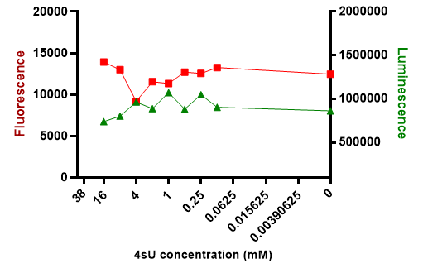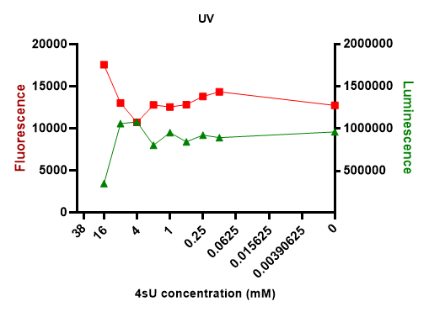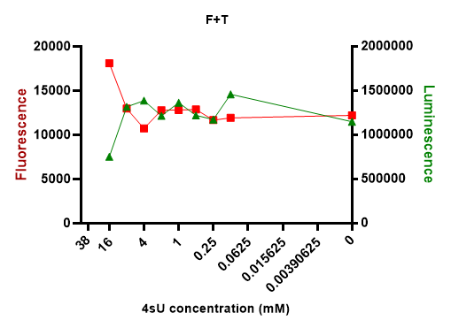
Figure 1 control Figure 2 treatment A Figure 3 treatment B

1mM of 4sU was selected as an optimal concentration based on the toxicity and viability test.

- QC1 : RNA quality check

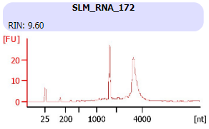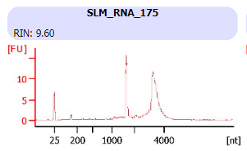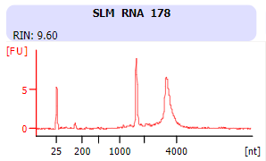
RNA quality after extraction was determined using BioAnalyser Eukaryote Total RNA 6000 nano assay.
SLM_RNA_172 : no 4sU, cells only (control)
SLM_RNA_175 : treatment ‘A’, 4sU labelled cells
SLM_RNA_177 : treatment ‘B’, 4sU labelled cells

3. QC2 : chemially converted RNA quality check
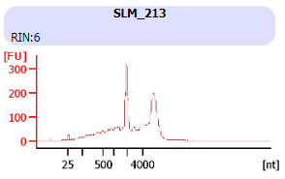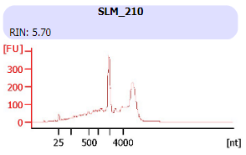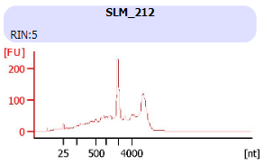
TFEA treated RNA quality was determined using BioAnalyser: Agilent RNA 6000 Pico assay. RNA before and after chemical treatment should not lead to RNA degradation and appear similar in size distribution.
SLM_RNA_213: ‘SLM_RNA_172’ treated with TFEA
SLM_RNA_210: ‘SLM_RNA_175’ treated with TFEA
SLM_RNA_212: ‘SLM_RNA_177’ treated with TFEA

4. QC3: Library quality check
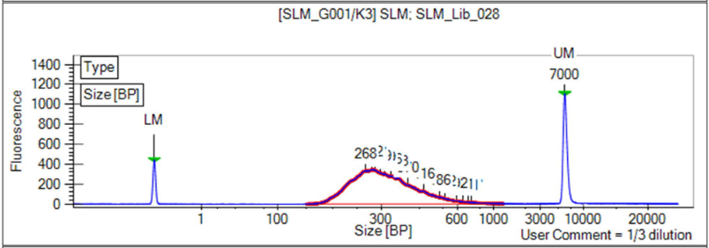
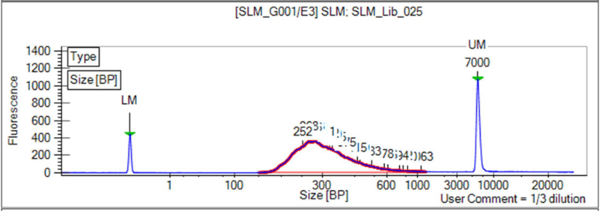
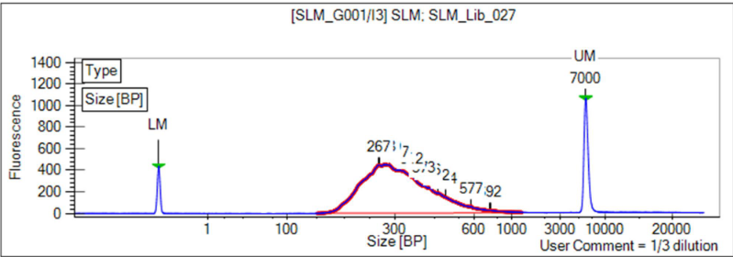
SLM_Lib_028: Library generated from SLM_RNA_213
SLM_Lib_025: Library generated from SLM_RNA_210
SLM_Lib_027: Library generated from SLM_RNA_212
Anticipated results: A successful TimeLapse-seq library results in a curve with a peak size of ~400bp.
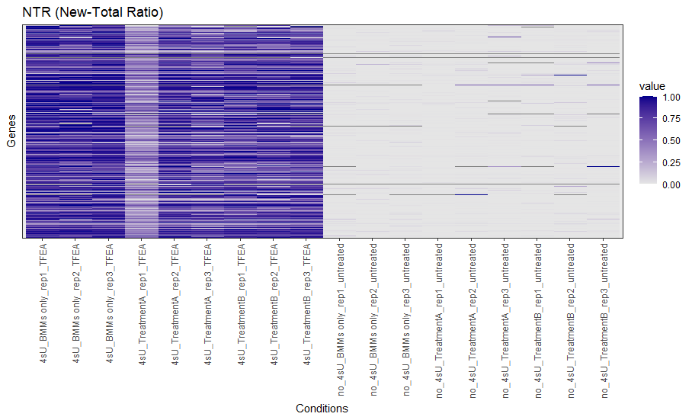
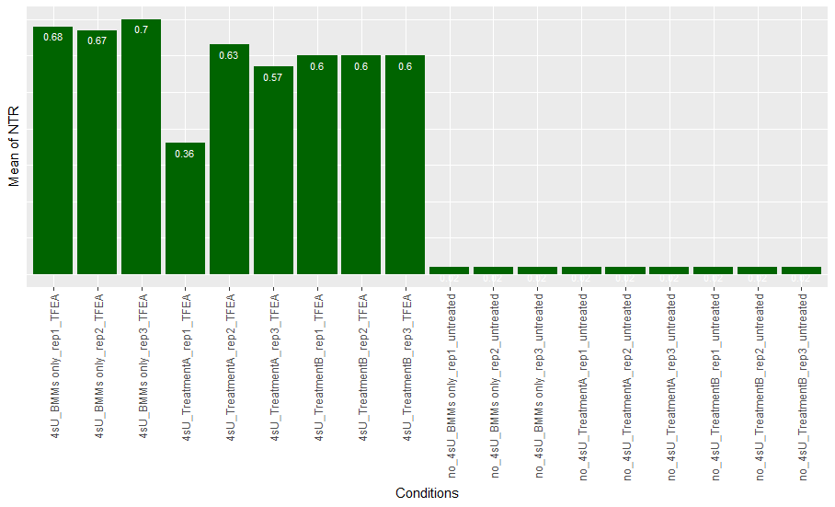

J SOP Validation Details
1.RIN value comparison
3. GRAND-SLAM set analysis pipeline -> Obtain the total number of T to C conversions in total. Obtain the total number of U(T) covered by any reads (total U in reads mapped to genome)
T->C conversion rate (the number of T->C conversion-containing reads)

 | Sequencing depth (millions) | Total transcripts* | Conversion** | Coverage*** | Conversion Ratio
4sU_TFEA_BMMs_only_rep1 | 40.8 | 26275117 | 49566391 | 924739204 | 5.4
4sU_TFEA_BMMs_only_rep2 | 47.6 | 32030955 | 60807287 | 1173250322 | 5.2
4sU_TFEA_BMMs_only_rep3 | 86 | 52061593 | 95638268 | 1665683999 | 5.7
4sU_TFEA_treatA_rep1 | 66.2 | 43284107 | 76631533 | 1725497894 | 4.4
4sU_TFEA_treatA_rep2 | 46.8 | 31773618 | 55496738 | 1177688507 | 4.7
4sU_TFEA_treatA_rep3 | 45.1 | 31001041 | 56635178 | 1235360347 | 4.6
4sU_TFEA_treatB_rep1 | 50.6 | 35211079 | 45629905 | 1361273845 | 3.4
4sU_TFEA_treatB_rep2 | 31.3 | 21287149 | 38055128 | 736130836 | 5.2
4sU_TFEA_treatB_rep3 | 24.6 | 16656500 | 29426445 | 651217850 | 4.5
no4sU_noTFEA_BMMs_only_rep1 | 30.6 | 21461540 | 3414930 | 815851142 | 0.4
no4sU_noTFEA_BMMs_only_rep2 | 98.2 | 68270731 | 10507185 | 2785102433 | 0.4
no4sU_noTFEA_BMMs_only_rep3 | 41.9 | 28812265 | 4454312 | 1233961761 | 0.4
no4sU_noFT_treatA_rep1 | 52.3 | 35979984 | 5466281 | 1631987794 | 0.3
no4sU_noFT_treatA_rep2 | 68.7 | 46748923 | 7133102 | 1899857325 | 0.4
no4sU_noFT_treatA_rep3 | 79.1 | 54722499 | 8098744 | 2459677253 | 0.3
no4sU_noFT_treatB_rep1 | 55.6 | 37993604 | 5787529 | 1655594863 | 0.3
no4sU_noFT_treatB_rep2 | 49.9 | 32376999 | 4951681 | 1295123576 | 0.4
no4sU_noFT_treatB_rep3 | 33.6 | 21097090 | 3263887 | 884210262 | 0.4
*, The total reads mapped onto genes
**, The total number of conversions
***, The total number of U covered by any reads (if all U were converted, the conversions=coverage)

Please refer DAP (Data Analysis Pipeline) ‘GIH_DAP001_01, SLAM-seq Data Processing’ for validation details.

K Troubleshooting

Step | Issue | Recommendations
Day 4 – Library preparation | Over amplified library | - Determine the optimal cycling number by qPCR

L Waste Management and Disposal
- Cell culture waste liquid can be decontaminated with a final concentration of 1% bleach for 20 min and subsequently eliminate a waste down the sink.
- All the consumables can be disposed into clinical waste bins according to IMB waste management protocol. Sharps are to be disposed of into puncture-resistant clinical sharps bins.
- Use a labelled chemical waste container from UQ Chemical Waste for all "flow-through" waste containing those chemicals.
- Other solid and low-volume liquid waste generated through this protocol can be diluted and be flushed down the sink.

M Data Records Management
All the QC results are saved in GIHEX20SLM project LabArchive.

N Reference Documents
- Thiol-linked alkylation for the metabolic sequencing of RNA (SLAMseq) (https://doi.org/10.1038/protex.2017.105)
- QuantSeq-Flex Targeted RNA-Seq Library Prep Kit V2 User Guide (015UG058V0230)
- CellTiter-Glo® 2.0 Assay technical manual (TM403)
- GIH_DAP001_01, SLAM-seq Data Processing

O Quality Control (QC) & Quality Assurance (QA) Section

- Contact details
- Stacey Andersen
- Operations Manager, Genome Innovation Hub
T +61 7 334 62607
E s.andersen2@uq.edu.au
W gih.uq.edu.au
-----------------------------------------------------------------------------------------------------------------------------------
- Collaborator name (optional)
- Collaborator title (optional)
T
E
W

CRICOS Provider 00025B

