  - gih.uq.edu.au

Genome Innovation Hub Standard Operating Procedure (SOP)

SOP Title: | Optimization of ddPCR Evagreen assay
SOP Number: | GIH_SOP00XX-01
Effective Date: | 11 Nov 2022
Current Review Date:
Replaces SOP Number: | First Issue
Group: | Collaborating group/Genome Innovation Hub
I have read this document and approve its contents.
 | Name | Signature | Date
Written by: | Sohye Yoon
Reviewed by:

Authorised by:

SOP Number | Author | Date Originated or Revised
 |  | dd MMM yyyy

Contents

A Purpose and Application 3
B Brief Summary of Method 3
C Definitions and Abbreviations 3
D Occupational Health and Safety 3
E Cautions 4
F Personnel Qualifications, Training and Responsibilities 4
G Equipment and Materials 4
H Procedure 5
I Worked Example 10
J SOP Validation Details 12
K Troubleshooting 12
L Waste Management and Disposal 12
M Data Records Management 12
N Reference Documents 12
O Quality Control (QC) & Quality Assurance (QA) Section 12

A Purpose and Application

Digital droplet PCR (ddPCR) is a technique used to quantify nucleic acid targets in a sample. The ddPCR EvaGreen assay is a specific type of ddPCR that uses a fluorescent DNA binding dye called EvaGreen to detect and quantify the amount of target DNA in a sample. The assay involves partitioning the sample into thousands of droplets, each of which undergoes PCR amplification, and the resulting fluorescence is measured to determine the amount of target DNA present. The ddPCR EvaGreen assay is a highly sensitive and accurate method for quantifying nucleic acid targets, making it useful in a variety of research and diagnostic applications.

The SOP described here outlines the process for determining the optimal conditions for running a ddPCR EvaGreen assay. The purpose of this procedure is to ensure that the assay is set up correctly before the actual run, which involves testing different annealing temperatures and concentrations of input DNA, as well as conducting basic analysis of the run.

B Brief Summary of Method
The brief protocol for ddPCR with EvaGreen involves the following steps:
1. Sample preparation: The nucleic acid target is extracted and purified from the sample using appropriate method (This step is not included in this SOP).
2. Droplet generation: The sample is mixed with a PCR master mix and a droplet generator is used to partition the mixture into thousands of droplets, each containing a single copy of the target nucleic acid.
3. PCR amplification: The droplets are transferred to a PCR machine and undergo thermal cycling to amplify the target sequence. The PCR conditions are optimized for the specific assay being performed.
4. Droplet reading: The droplets are analyzed using a droplet reader, which measures the fluorescence intensity of each droplet to determine whether it contains the target sequence.
5. Data analysis: The data from the droplet reader is analyzed using software to quantify the amount of target nucleic acid present in the sample.

C Definitions and Abbreviations
ddPCR – Digital droplet PCR
Auto DG – Automated Droplet Generator

D Occupational Health and Safety
Biohazardous samples: Some samples used in ddPCR, such as those containing infectious agents or human blood or tissues, may be biohazardous. Proper handling and disposal procedures should be followed to minimize the risk of infection or exposure to these samples.
Extreme Temperature/Light: Potential burn from hot surface of PCR plates sealed with the PX100 PCR plate sealer or by touching the metal block of the C100 Touch Thermal cycler.
Please read UQ Risk Assessment- Ref No: 9023 or IMB Risk Assessment No 2741 for detail.

E Cautions
When performing ddPCR using an automated droplet generator, there are several critical steps in the procedure that must be followed to avoid equipment damage, sample degradation, or invalidation of results. Some cautions to consider include:
1. Sample preparation and handling: Care should be taken to properly prepare and handle the sample, including ensuring that it is properly mixed with the PCR master mix and avoiding bubbles or particulates that can interfere with droplet formation.
2. Monitoring the quality of droplets: It is important to monitor the quality of droplets generated by the instrument, including ensuring that the droplet size is consistent and that there is minimal variation in droplet fluorescence. Any issues with droplet quality should be addressed immediately to avoid compromising the results.
3. Proper maintenance and cleaning of the instrument: The automated droplet generator requires regular maintenance and cleaning to ensure optimal performance. It is important to follow the manufacturer's instructions for maintenance and cleaning to avoid equipment damage and ensure accurate results.

F Personnel Qualifications, Training and Responsibilities
Training Requirements
X
X

Read and understand documents Training required [Author to delete X in relevant box]

G Equipment and Materials

Equipment
- Automated Droplet Generator (Auto DG)
- QX200 Droplet Reader
- PX1 PCR plate sealer
- C1000 Touch Thermal Cycler with 96 deep well reaction module
- Pipette - P10, P20, P200, P1000. For many samples, multichannels may be useful.
- Benchtop centrifuges for 1.5ml tubes and 96 well plates

Materials
- Pierceable foil heat seal
- DG32 AutoDG Cartridges
- Droplet generation oil for Evagreen
- QX200™ ddPCR™ EvaGreen® Supermix (cat no. 1864034)
- Pipet Tip waste for AutoDG system
- Bio-rad 96 well plate for ddPCR (cat no. 12001925) : Bio-rad Tech support recommendation!
- Cooling block
- Pierceable foil heat seal
- Microseal ‘B’ Adhesive seal
- ddPCR Droplet Reader Oil
- Ranin pipette tips : Bio-rad Tech support recommendation!
- 1.5ml LoBind tubes
- UltraPure water

Oligos
Oligo Name | Sequence | Purification | Scale
GIH_0162_DIN_probeF1 | TGACTGGAGTTCAGACGTG | Salt
GIH_0163_DIN_probeR1 | GGACCGGCCTTAAAGCTAA | Salt

H Procedure

Step 1 Preparation of the reaction mix using ddPCR EvaGreen supermix (time: 30 min)
Purpose: Make a serial dilution of sample to determine the optimal concentration for ddPCR input.
- Prepare the serial dilution from the stock (8 ng/ul) as shown in Table 1.
Table. Serial dilution of oligo.
Component (template) | Concentration | Input amount (µL)
Target DNA/RNA* | 8 ng/µL | 1
 | 800 pg/µL | 1
 | 80 pg/µL | 1
 | 8 pg/µL | 1
 | 800 fg/µL | 1
 | 80 fg/µL | 1
 | 8 fg/µL | 1
dH2O |  | 1

*, The range of sample dilution depends on expression level of target gene in the sample. Sample concentrations >66ng per reaction may require restriction digestion for optimal target detection.
- Thaw all components to room temperature. Mix thoroughly by vortexing each tube to ensure homogeneity because a concentration gradient may form during -20°C storage. Centrifuge briefly to collect contents at the bottom of the tubes.
- Prepare the reaction mix for the number of reactions needed according to the guidelines in Table 2. Assemble all required components except the sample, vortex and spin down. Dispense equal aliquots into a lobind 96 well plate.
Note: As normally we do not run a full 96 plate, the sample set up plate can be store and re-used after marking the used column.
Table 2. Preparation of the reaction mix.
Reagent | Volume (1 sample) | Volume (8 samples + 10%)
2X QX200 ddPCR EvaGreen Supermix | 10 µL | 88 µL
GIH_0162_DIN_probeF1 (10uM) | 1 µL | 8.8 µL
GIH_0163_DIN_probeR1 (10uM)
DNA template | 1 µL
RNase/DNase free water | 18 µL | 70.4 µL
Total volume | 20 µL | 167.2 µL
- Add 1 µL of each template that were prepared above, into the plate. Seal the plate with microseal 'B' adhesive seal and mix thoroughly by vortexing the plates. Centrifuge briefly to ensure that all components are at the bottom of the reaction wells. Allow reaction tubes to equilibrate at room temperature for about 3 min.

Step 2 Generation droplet using automated DG (time: 20 min)
Note: The cooling block should be placed in a -20°C freezer for a least 2 hours before configuring a run on the AutoDG instrument and inserting the Droplet Plate assembly into the instrument (store the cooling block at -20°C freezer all the times).
- Bring the AutoDG out of idle mode by touching the screen. Please wait while the instrument performs a self-check.
- Ensure EvaGreen AutoDG generation oil is loaded. Leave the cap next to the bottle.
- Check the indicator lights on the deck of the AutoDG instrument and the consumable icons on the touch screen and make that the indicator lights on the deck of the instrument should be off, indicating that no consumables are present. The corresponding areas of the touch screen will be grey.
- Touch the Configure Sample Plate button at the bottom centre of the screen and touch or swipe across to select the columns in which your samples are located on the sample plate (the plate name and plate notes are optional). Click OK when done.
- Based on the number of columns selected in the previous step, the consumable icons on the screen will begin to blink yellow to indicate where new consumable need to be loaded into the instrument (if the blinking yellow icon displays Used on the screen, remove the used consumable from that location in the instrument and load a new consumable).
- Open the door on the AutoDG by lifting up on the handle at the front of the instrument. To avoid contamination, load the consumables from the backs to the front of the instrument.
- Place the DG32 AutoDG Cartridges along the back row of the instrument, with the green gaskets to the right, into the plate holders. The holders are keyed for proper orientation of each DG32 Cartridge to prevent incorrect loading. Check the Cartridge is sat stable if it is too wobble, change it to a new one.
- The lights on the DG32 plate holders will change from yellow to green when the DG32 cartridges are inserted correctly. Also the corresponding icons on the touch screen will go from blinking yellow to solid green, and Ready will be displayed.
- To load the AutoDG Pipet Tips along the centre row of the instrument, remove box lids form the tip boxes and place into the plate holders in the middle of the deck.
Note: 2 rows of tips are needed for every one row of samples. Please note that only AutoDG pipet tips should be used. The tips should be full from the left side.
- Remove the tip waste bin containing any tips from a previous run and replace with a clean waste bin.
- The lights on the tip box holders will change from yellow to green when the tip boxes are inserted correctly. Also, the corresponding icons on the touch screen will go from blinking yellow to solid green, and Ready will be displayed.
- Place the plate containing your prepared ddPCR reactions into the front left plate holder, labelled on the screen as Sample Plate. The holder is keyed for proper orientation and contain plate clips to support plates.
- Take off the adhesive seal.
- The light on the Sample Plate holder will change from yellow to green when the plate is inserted correctly. Also the corresponding icon on the touch screen will go from blinking yellow to solid green, and Ready will be displayed.
- Place the cooling block, that was placed in a freezer for at least 2 hours, into the front right plate holder, labelled on the screen as Droplet Plate. The holder is keyed for proper orientation of the cooling block.
- The block should be a dark purple colour, indicating it is at the proper temperature.
- The light on the instrument will change from yellow to green when the block is inserted correctly. Also the corresponding icon on the touch screen will go from blinking yellow to solid green, and Ready will be displayed.
- Place a clean 96 well semi skirted PCR plate for droplet collection into the cooling block accessory. The cooling block is also keyed for proper orientation of the plate.
- Once all of the consumables are loaded and the corresponding lights are green on the deck and touch screen, a blue start button will appear at the bottom right of the screen. Touching Start will bring up a confirmation window.
- Once you have confirmed the pate setup, touch the Start Run button to begin droplet generation. The door will automatically close at the beginning of the run and must remain closed during the run.
- Once the plate of droplets is ready, the screen will display a finalizing window followed by a blue Droplets ready message with a timer showing time elapsed since complete.
- Remove the droplet plate containing ddPCR droplets and seal within 30 min of droplet generation completing. Check the cartridge one at a time to see whether any droplets are left in the columns with green gasket. If there the droplets left, transfer into a corresponding well in the droplet plate and take out equal volume of oil from the bottom of the well.
Note : Carefully transfer droplets from the cartridge into the droplet plate without disturbing droplet:oil layer.
- Use the PX1 PCR plate Sealer and foil seals to seal the plate at 180°C for 5 sec. Begin thermal cycling within 30 min of sealing the plate, or store the plate at 4°C for up to 4 hr prior to thermal cycling.

Step 3 Perform PCR using C1000 Touch Thermal Cycler (time: 2 hr )
- Proceed to thermal cycling according to the Table 3.
Table 3. Cycling condition for Bio-Rad’s C1000 Touch Thermal Cycler*
Cycling Step | Temperature (°C)** | Time | Cycles
Enzyme activation | 95 | 5 min | 1
Denaturation | 95 | 30 sec | 40
Annealing/extension*** | 60 | 1 min | 40
Signal stabilization | 4 | 5 min | 1
 | 90 | 5 min | 1
Hold | 4 | Infinite | 1
*, Use a heated lid set to 105°C and set the sample volume to 40 ul.
**, Check/adjust ramp rate setting to ~2°C/sec.
***, Combine annealing and extension for a short target size amplicon (<100bp).
- Take out the plate from the thermal cycler and transfer it to the QX200 droplet reader.

Step 4 Read droplets with QX200 droplet reader (time:30 min)
- After thermal cycling, place the sealed 96-well plate in the QX200 Droplet Reader.
- Open QuantaSoft™ Software to set up a new plate layout according to the experimental design. Refer to the QX200 Droplet Reader and QuantaSoft Software Instruction Manual (#10031906).
- Under Setup, double click on a well in the plate layout to open the Well Editor dialog box.
- Designate the sample name, experiment type, QX200 ddPCR EvaGreen Supermix as the supermix type, target name, and target type: Ch1 for FAM.
- Select Apply to load the wells and when finished, select OK.
- Once the plate layout is complete, select Run to begin the droplet reading process. Select EvaGreen as the dye set used and run options when prompted.
- After data acquisition, select samples in the well selector under Analyze. Examine the automatic thresholding applied to the 1-D amplitude data and, if necessary, set thresholds or clusters manually.
- The concentration reported is copies/µl of the final 1x ddPCR reaction.
Note: Alternatively, download QuantaSoft Pro Analysis (free) for analysis.

Step 5 Determination of optimal annealing temperature and primer concentration
Purpose; To determine the optimal annealing temperature and primer concentration, thermal gradient for annealing temperature and different concentration of primer will be tested using the optimal concentration of sample determined previously.
1. Prepare PCR reaction for each concentration of primers as listed in Table 4.
Reagent | Volume (1 sample) | Volume (8 samples + 10%)
2X QX200 ddPCR EvaGreen Supermix | 10 µL | 88 µL
GIH_0162_DIN_probeF1 (10uM) | 1 µL (500nM final concentration) | 8.8 µL
GIH_0163_DIN_probeR1 (10uM) | 1 µL (500nM final concentration) | 8.8 µL
DNA template (determined above step) | 1 µL
RNase/DNase free water | 7 µL | 61.6 µL
Total volume | 20 µL | 167.2 µL

Reagent | Volume (1 sample) | Volume (8 samples + 10%)
2X QX200 ddPCR EvaGreen Supermix | 10 µL | 88 µL
GIH_0162_DIN_probeF1 (10uM) | 0.5 µL (250nM final concentration) | 4.4 µL
GIH_0163_DIN_probeR1 (10uM) | 0.5 µL (250nM final concentration) | 4.4 µL
DNA template (determined above step) | 1 µL
RNase/DNase free water | 8 µL | 70.4 µL
Total volume | 20 µL | 167.2 µL

Reagent | Volume (1 sample) | Volume (8 samples + 10%)
2X QX200 ddPCR EvaGreen Supermix | 10 µL | 88 µL
GIH_0162_DIN_probeF1 (10uM) | 0.3 µL (150nM final concentration) | 2.64 µL
GIH_0163_DIN_probeR1 (10uM) | 0.3 µL (150nM final concentration) | 2.64 µL
DNA template (determined above step) | 1 µL
RNase/DNase free water | 8.4 µL | 73.92 µL
Total volume | 20 µL | 167.2 µL
3. Dispense the each mastermix and the template as the outline below. Seal the plate with microseal 'B' adhesive seal and mix thoroughly by vortexing the plates. Centrifuge briefly to ensure that all components are at the bottom of the reaction wells. Allow reaction tubes to equilibrate at room temperature for about 3 min.
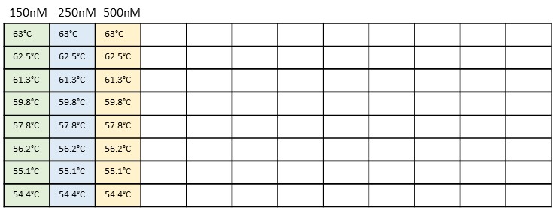

Step 6 Generation droplet using automated DG (time: 20 min)
Repeat step 2 above.

Step 7 Perform PCR using C1000 Touch Thermal Cycler (time: 2 hr )
1. Proceed to thermal cycling following the PCR condition as below Table 5.
Cycling Step | Temperature (°C) | Time | Cycles
Enzyme activation | 95 | 5 min | 1
Denaturation | 95 | 30 sec | 35
Annealing/extension | 54.4 to 63 (gradient) | 1 min
Signal stabilization | 4 | 5 min | 1
 | 90 | 5
Hold | 4 | Infinite | 1
2. Take out the plate from the thermal cycler and transfer it to the QX200 droplet reader.

Step 8 Read droplets with QX200 droplet reader (time:30 min)
Repeat step 4 above.

I Worked Example
[PLEASE DELETE BEFORE SUBMISSION
Describe an example experiment performed using the SOP. Ideally this will be an experiment that can be performed by new users to test the SOP and act as a positive control for the procedure. Where possible describe expected results at each QC step and provide evidence (e.g., gel pictures or other data).]
The statue of the droplets has been inspected after droplet generation, sealing, PCR cycling and reading steps. The oil and droplets were clearly separated in the bottom and upper halves, respectively, until the cycling step. Following droplet reading, a drop reader was used to measure fluorescence intensity and the droplets in each well were found to be depleted.

1. After droplet generation
2. After sealing
3. After cycling
4. After reading
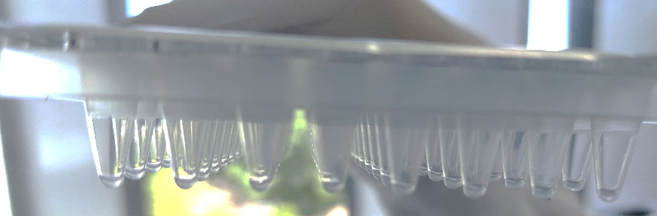

Amplitude figure

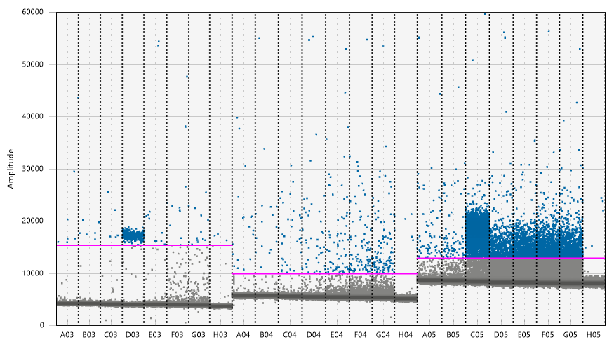
Although the rain effects are seen in the group with the higher concentration of primer, this experimental condition resulted more positive droplets.
The optimal annealing/elongation temperature is between 60C to 61C.

J SOP Validation Details

K Troubleshooting

L Waste Management and Disposal

M Data Records Management

N Reference Documents

O Quality Control (QC) & Quality Assurance (QA) Section

- Contact details
- Stacey Andersen
- Operations Manager, Genome Innovation Hub
T +61 7 334 62607
E s.andersen2@uq.edu.au
W gih.uq.edu.au
-----------------------------------------------------------------------------------------------------------------------------------
- Collaborator name (optional)
- Collaborator title (optional)
T
E
W

CRICOS Provider 00025B

