  - gih.uq.edu.au

Genome Innovation Hub Standard Operating Procedure (SOP)

SOP Title: | Automated droplet digital PCR analysis with probe
SOP Number: | GIH_SOP0008-01
Effective Date: | 01/06/2023
Replaces SOP Number: | First issue
Group: | Genome Innovation Hub
Current version:
 | Name | Date
First Issue written by: | Sohye Yoon | 01/06/2023
Latest update by:
Authorised by:

Document revisions:
n/a

Previous versions:
SOP Number | Authored/Revised by | Date Originated or Revised
 |  | dd/mm/yyyy

Contents

A Purpose and Application 3
B Brief Summary of Method 3
C Untested Suggested Modifications 3
D Experimental Design Considerations 4
E Requisite Prior Knowledge 4
F Definitions and Abbreviations 4
G Occupational Health and Safety 4
H Cautions 4
I Personnel Qualifications, Training and Responsibilities 4
J Equipment and Materials 5
K Procedure 6
L Next Steps 10
M Worked Example 10
N SOP Validation Details 12
O Troubleshooting 12
P Waste Management and Disposal 13
Q Data Records Management 14
R Reference Documents 14
S Quality Control (QC) & Quality Assurance (QA) Section 14

A Purpose and Application

The purpose of this SOP is to accurately quantify target sequences in DNA or RNA samples using pre-determined PCR condition. This procedure allows for the absolute quantification of nucleic acids, enabling a wide range of applications in various fields of research and diagnostics.

The scope of this procedure covers the analysis of DNA or RNA samples using the automated droplet digital PCR (ddPCR) platform with probe-based detection. It is run based on the optimization of PCR conditions determined by optimization test, such as annealing temperature and probe concentration, to achieve optimal assay performance. The procedure follows the manufacturer's instructions and has been validated through experimental projects, ensuring its reliability and reproducibility.

B Brief Summary of Method

Droplet Digital PCR involves the following steps (4.5 – 5.5 hour for the complete workflow)

Prepare PCR-ready samples – combine nucleic acid sample (DNA or RNA), primers, and probes (FAM of HEX) with Bio-rad ddPCR supermix for Probes (no dUTP).

Generate droplet – load 22 ul of the ddPCR reaction into 96 well plate and load the plate and required consumables into the Automated Droplet Generator to partition the sample into droplets. The Automated DG uses microfluids to combine oil and aqueous sample to generate the nanolitre-sized droplets require for ddPCR analysis. It processes up to 96 samples at a time in less than 45 min.

Perform PCR – remove the 96 well plate containing droplets from the Automated DG, seal the plate with foil, and perform PCR to end point (~40 cyclyes) using aa PX1 Plate Sealer and C1000 Touch Thermal Cycler.

Read droplets – load the plate into the QX200 Droplet Reader and start your run. The droplet reader sips each sample, singulates the droplets, and streams them in single file past a two-color detector. The detector reads the droplets to determine which contain a target (+) and which do not (-).

Analyse results – the droplet reader connects to a laptop computer running QuantaSoft Software. The software provides a complete set of tools for setting up and naming samples, running and controlling the instrument, and analysing results. It also reads the positive and negative droplets in each sample and plots the fluorescence, droplet by droplet. The fraction of positive droplets in a sample determines the concentration of target in copies/ul.

C Untested Suggested Modifications
n/a

D Experimental Design Considerations

The Minimum experimental design considerations for ddPCR using probes typically include incorporating negative controls and performing triplicate reactions. Negative controls are important to assess background signal and identify any potential contamination, while triplicate reactions help to ensure the reproducibility and reliability of the results by assessing variability and obtaining statistically significant data.

E Requisite Prior Knowledge
Basic knowledge for qPCR and fluorescence detection.

Please refer to GIH SOP007-01 "Optimization of automated droplet digital PCR using probe" for determining the optimal conditions prior to performing this assay. The optimization process outlined in that SOP ensures reliable and accurate results in this assay.

F Definitions and Abbreviations
ddPCR : Droplet Digital PCR
AutoDG : Automated Droplet Generator

G Occupational Health and Safety
Standard PC2 laboratory guidelines and procedures are to be adhered to while performing this protocol.
If you ae a student/staff in Institute of Molecular Biosciences, please refer to IMB risk assessment #2741 Bio-Rad's Automated Droplet Digital PCR system.

H Cautions
- Please ensure that you use Bio-Rad manufactured 96-well plates and Ranin tips for the entire procedure. The use of other plasticware may result in droplet shearing and a decrease in droplet count.
- A cooling block is needed during droplet generation to prevent droplet evaporation, much like the DG requires you to cover the wells once droplets are transferred. The cooling block should be stored in a freezer for at least 2 hours before configuring a run. The block should be a dark purple colour, indicating it is at the proper temperature. If the block is pink, it has warmed up and should not be used.
- Be gentle with droplets not to break the droplets during handling the plate containing ddPCR droplets.

I Personnel Qualifications, Training and Responsibilities
Training Requirements:
X Read and Understand Document X Training Required [Author to delete X in relevant box]

J Equipment and Materials

Equipment
- Automated Droplet Generator (Auto DG)
- QX200 Droplet Reader
- PX1 PCR plate sealer
- C1000 Touch Thermal Cycler with 96 deep well reaction module
- Pipette - P10, P20, P200, P1000. For many samples, multichannels may be useful.
- Benchtop centrifuges for 1.5ml tubes and 96 well plates

Materials
- Pierceable foil heat seal (Bio-Rad, cat no. 1814040)
- DG32 AutoDG Cartridges (Bio-Rad, cat no. 1864108)
- Droplet generation oil for Probe (Bio-Rad, cat no. 1864110)
- QX200™ ddPCR™ Supermix for probe (no dUTP) (Bio-Rad, cat no. 1863024)
- Pipet Tip waste for AutoDG system (Bio-Rad, cat no. 1864124)
- Pipet tips for AutoDG (Bio-Rad, cat no. 1864120)
- Bio-rad 96 well plate for ddPCR (Bio-Rad cat no. 12001925)
- Cooling block
- Microseal 'B' Adhesive seal
- ddPCR Droplet Reader Oil (Bio-Rad cat no.1863004)
- Ranin pipette tips P10, P20, P200, P1000 uL
- 1.5ml LoBind tubes
- UltraPure water
- Custom probes for ddPCR

Oligos
Oligo Name | Unique Assay ID | Fluorophore | Probe Purification | Primer Purification
ACTB, Human | dHsaCPE5190199 | HEX | HPLC | Desalted
CD207, Human | dHsaCPE5035151 | HEX | HPLC | Desalted
ITGAM, Human | dHsaCPE5192726 | HEX | HPLC | Desalted
CSF1R, Human | dHsaCPE5042034 | FAM | HPLC | Desalted
IL-34, Human | dHsaCPE5038840 | FAM | HPLC | Desalted
THY1, Human | dHsaCPE5029974 | FAM | HPLC | Desalted
Note: Amplicon Context Sequence is not provided here.

K Procedure

Workflow outline:

Step 1 Preparation of the reaction mix for ddPCR (No dUTP) Description (time: ~ 40 min)
Purpose: Prepare reaction mix for ddPCR using ddPCR supermix for Probes to ensure proper preparation of the mix, which is critical for obtaining accurate and reliable results in ddPCR experiments.
- Thaw all components to room temperature. Mix thoroughly by vortexing each tube to ensure homogeneity and centrifuge briefly to collect contents at the bottom of the tubes.
- Prepare samples at the desired concentration before setting up the reaction mix.
- Prepare the reaction mix for the number of reactions needed according to the guidelines in Table 1.
Note: If there are a number of probes to test, group one FAM probe and one HEX probe as a pair. It is recommended to pair the probes that show similar gene expression level if known.
Table 1. Preparation of the reaction mix.
Reagent | Volume per Reaction (uL)
2x ddPCR supermix for Probes (No dUTP) | 11
20x target primers/probe (FAM) | 1.1
20x target primers/probe (HEX) | 1.1
cDNA* | 1
dH2O | 7.8
Total volume | 22
Note; For each sample, 3 technical replicates are recommended.
*, up to 6 ul cDNA (not exceeding the equivalent of 50 ng initial RNA) can be used per ddPCR reaction. Generally, the cDNA resulting from 1 ng RNA is sufficient for detection of most transcripts. However, dilutions may be required for abundant transcripts.
- Dispense the master mix and cDNA according to the plate layout illustrated below (Figure 1).
Figure 1. Plate layout for ddPCR assay. the No RT Control and ddPCR Supermix Control are optional components that can be included based on experimental requirements.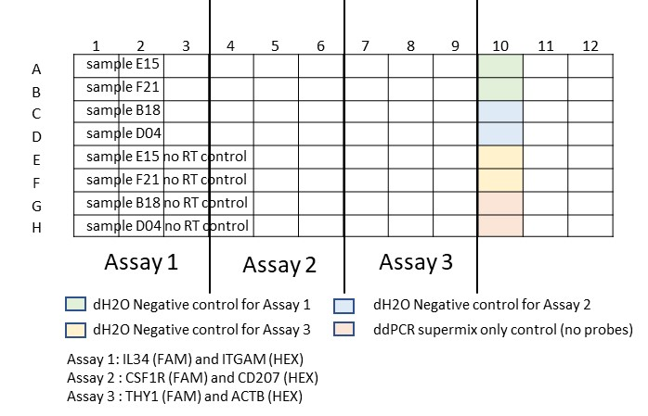
- Seal the plate with microseal 'B' adhesive seal and mix thoroughly by vortexing the plates. Centrifuge briefly to ensure that all components are at the bottom of the reaction wells. Allow reaction tubes to equilibrate at room temperature for about 3 min.

Step 2 . Generation droplet using AutoDG (time; 20 min)
Purpose: The purpose of these steps is to prepare and set up the AutoDG instrument for the efficient and accurate processing of samples, including configuring the instrument, loading consumables, sample plates, and cooling blocks, and verifying proper setup before starting the run.
Note: The Automated DG is designed to remain powered on in order to preserve positive airflow inside of the instrument and track consumable use. The instrument stays in an idle state when not being used.
Confirm that AutoDG Oil is loaded. You may be prompted to confirm the type of oil currently loaded into the instrument (Probes or Evagreen).
CRITICAL POINT: The cooling block should be placed in a -20°C freezer for a least 2 hours before configuring a run on the AutoDG instrument and inserting the Droplet Plate assembly into the instrument (store the cooling block at -20°C freezer all the times if possible).
- Bring the AutoDG out of idle mode by touching the screen. Please wait while the instrument performs a self-check.
- Ensure no consumables are present and confirm on the touch screen. The corresponding areas of the touch screen will be grey.
- Touch the Configure Sample Plate button at the bottom centre of the screen and touch or swipe across to select the columns in which your samples are located on the sample plate (the plate name and plate notes are optional). Click OK when done.
- Based on the number of columns selected in the previous step, the consumable icons on the screen will begin to blink yellow to indicate where new consumable need to be loaded into the instrument (if the blinking yellow icon displays Used on the screen, remove the used consumable from that location in the instrument and load a new consumable).
- Open the door on the AutoDG by lifting up on the handle at the front of the instrument. To avoid contamination, load the consumables from the backs to the front of the instrument.
- Place the DG32 AutoDG Cartridges along the back row of the instrument, with the green gaskets to the right, into the plate holders.
- To load the AutoDG Pipet Tips along the centre row of the instrument, remove box lids form the tip boxes and place into the plate holders in the middle of the deck. Only full tip boxes should be loaded.
Note: 2 rows of tips are needed for every one row of samples. Please note that only AutoDG pipet tips should be used.
- Remove the tip waste bin containing any tips from a previous run and replace with a clean waste bin.
- Place the plate containing your prepared ddPCR reactions into the front left plate holder, labelled on the screen as Sample Plate.
- Take off the adhesive seal.
- Place the cooling block, that was placed in a freezer for at least 2 hours, into the front right plate holder, labelled on the screen as Droplet Plate. The block should be a dark purple colour, indicating it is at the proper temperature.
- Place a clean Bio-rad 96 well plate for ddPCR for droplet collection into the cooling block accessory.
- Once all of the consumable are loaded and the corresponding lights are green on the deck and touch screen, a blue start button will appear at the bottom right of the screen. Touching Start will bring up a confirmation window.
- Once you have confirmed the pate setup, touch the Start Run button to begin droplet generation. The door will automatically close at the beginning of the run and must remain closed during the run.
- Once the plate of droplets is ready, the screen will display a finalizing window followed by a blue Droplets ready message with a timer showing time elapsed since complete.
- Remove the droplet plate containing ddPCR droplets and seal within 30 min of droplet generation completing. Check the cartridge one at a time to see whether any droplets are left in the columns with green gasket. If there the droplets left, transfer into a corresponding well in the droplet plate and take out equal volume of oil from the bottom of the well.
Note: Carefully transfer droplets from the cartridge into the droplet plate without disturbing droplet:oil layer.
- Use the PX1 PCR plate Sealer and foil seals to seal the plate at 180°C for 5 sec. Begin thermal cycling within 30 min of sealing the plate or store the plate at 4°C for up to 4 hr prior to thermal cycling.
<QC1> Check the generated droplets and samples in each well. The droplets typically look cloudy and are shown at top of the well while oil layer is at the bottom.

Step 3. Perform PCR using C1000 Touch Thermal Cycler (time; ~ 2.5 hour)
Purpose: To amplify and replicate the target DNA sequences within the droplets, enabling their detection and quantification with higher sensitivity and accuracy.
- Proceed to thermal cycling according to the Table 2.
Table 2. Thermal cycling conditions.
Cycling step | Temperature, °C | Time* | Cycles
Warming up | 30 | ∞ | 1
Enzyme activation | 95 | 10 min | 1
Denaturation | 94 | 30 sec | 40
Annealing/extension | 57.5** | 30 min
Enzyme deactivation | 98 | 10 min | 1
Hold | 4 | ∞ | 1
Note: Use a heated lid set to 105 °C and set the sample volume to 40 ul.
*, Check/adjust ramp rate setting to ~2°C/sec.
**, The optimal annealing temperature for the assay was determined from a gradient of seven temperatures during the optimization process.
- Take out the plate from the thermal cycler and transfer it to the QX200 droplet reader.
<QC2> After thermal cycling Check the plate. With naked eyes, there would not be any visible difference from QC1. The droplets generated at Step 1 and after thermal cycling may appear similar and indistinguishable without appropriate reader.

Step 4. Read droplets with QX200 droplet reader (time; ~ 40 min)
Purpose: To analyze and quantify the fluorescence signals emitted by the droplets in order to determine the presence or absence of the target nucleic acid sequences. This step provides valuable data for the measurement of target concentrations and allows for the interpretation of results in ddPCR experiments.
Note; If the instrument has been unused for longer than a week, prime the system before running a plate. Click Prime under instrument routines in the Setup window.
- Power on the QX200 droplet reader using the switch at the back. Allow it to warm up for 30 min, then switch in the PC and launch QuantaSoft software.
- The first two lights at the left on the front of the droplet reader should be solid green, indicating power is on, there is sufficient oil in the designated oil reservoir, and there is <700 ml in the waste bottle. If the waste bin is full, place it inside of the fume hood in TC room to evaporate.
- Press the button on the green lid to open the droplet reader.
- Place the 96 well plate into the base of the plate holder. Well A1 of the PCR plate must be in the top left position.
- Move the release tabs of the top of the plate holder into the "up" position and place the top on the PCR plate. Firmly press both release tabs down to secure the PCR plate in the holder.
- Load the plate holder into the droplet reader, and the press the button on the lid again to close the cover. Confirm the first three indicator lights are green.
- In QuantaSoft software, click Setup in the left navigation bar to define your experiment. To create a new template, click Template > New. Enter the file name, then use the well editor and experiment editor to adjust the settings for your experiment.
Experiments : ABS
Supermix : ddPCR supermix for probes (no dUTP)
Target 1 (FAM) Name : Name of the gene with FAM
Target 1 Type : Ch1 unknown
Target 2 (HEX) Name : Name of the gene with HEX
Target 2 Type : Ch2 unknown
For negative control, set Ch1/Ch2 unknown to determine any false positive signal detection.
- Click Apply or OK to save the experiment information. The settings will appear in the well in the plate map.
- Click Run in the left navigation bar to start the run. The run indicator light (far right) flashes green to indicate droplet readings is in progress.
- When droplet reading is complete, all four indicator lights are solid green. Remove the 96 well PCR plate from the holder and discard it.
<QC3> Check the plate after droplet reading. After droplet reading, the droplets in the well will no longer be present. The droplets are read and analyzed by the instrument during the reading process, and the results are recorded. Therefore, the well will appear empty or contain residual sample reagents, but the individual droplets will not be visible to the naked eye.

Step 5. Analyze Using QuantaSoft Analysis Pro software (time; ~ 1hr)
Purpose: To interpret and quantify the results obtained from the droplet reading. The software allows for the analysis of the fluorescence signals generated by the samples and provides information such as the concentration or presence of specific targets in the sample.
Note; The QuantaSoft™ Analysis Pro Software is free to download from Bio-rad website (log in required). https://www.bio-rad.com/SearchResults?search_api_fulltext=quantasoft+analysis+pro
- In the Setup window, load a plate (filename.qlp), then click Analyze to open and analyse the data.
- Click 1D Amplitude to visualise the data collected from each channel of selected wells.
Note: It is recommended that researchers review the thresholds set automatically by the software and make changes as needed. To manually set threshold values for single or multiple wells, enter the values in the Set Threshold field below the plot and click Set Threshold or Enter.
- The copies/uL Well (Conc) column on the Results table displays the total amount of starting material in the ddPCR sample. The values shown reflect the product of the concentration (in copies per ul) multiplied by the 20 ul ddPCR reaction input used to make droplets.
- Click 'Export CSV' under the Results table to export as '*.csv file'.
- Save the file in the designated drive.
- Calculate copies/ul in the reaction (in the excel file it appears as copies/20 ul well). The total volume of the reaction/well is 22 ul. Convert this value to copies per ng(pg) input RNA

L Next Steps
n/a

M Worked Example
The cDNA samples synthesized from human skin scrolls obtained from skin cancer patients were used as input DNA, and the corresponding RNA concentrations are provided in the table below.
Sample | RNA concentration (pg/uL) | RNa equivalent unit (pg/uL) | Input RNA (pg/uL)*
SPA_DNA_001 (E15) | 492 | 123 | 60.7
SPA_DNA_001 (F21) | 243 | 60.7 | 60.7
SPA_DNA_001 (B18) | 349 | 87.25 | 60.7
SPA_DNA_001 (D04) | 414 | 103 | 60.7
*, To ensure equal cDNA concentration per well, the samples were normalized to the lowest RNA concentration.
- QC result: The statue of the droplets has been inspected after droplet generation, sealing, PCR cycling and reading steps. The oil and droplets were clearly separated in the bottom and upper halves, respectively, until the cycling step. Following droplet reading, a drop reader was used to measure fluorescence intensity and the droplets in each well were found to be depleted. (data can be found in GIH SOP007_01 Optimization of Automated Drople Digital PCR(ddPCR) analysis using probe).
- Worked example of amplitude graph
- Amplitude graph of CSF1R (top) and CD207(bottom) for assay 2
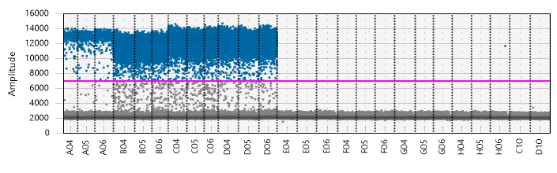
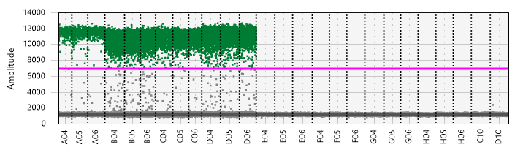
- Consistent positive droplets were observed across the replicates.
- No positive droplets shown in the no RT control, dH2O control and ddPCR supermix only control (no probe)
- Both shows distinct band of positive droplets and distinct band of negative droplets.
- Minimal ‘rain’ effect is desirable.
- Copy number graph: Using copies per 20uL well value from the exported csv file, generate bar group illustrating transcripts copies in pg of input RNA. Note that the transcripts expression of ACTB gene is not included in the graph.
- 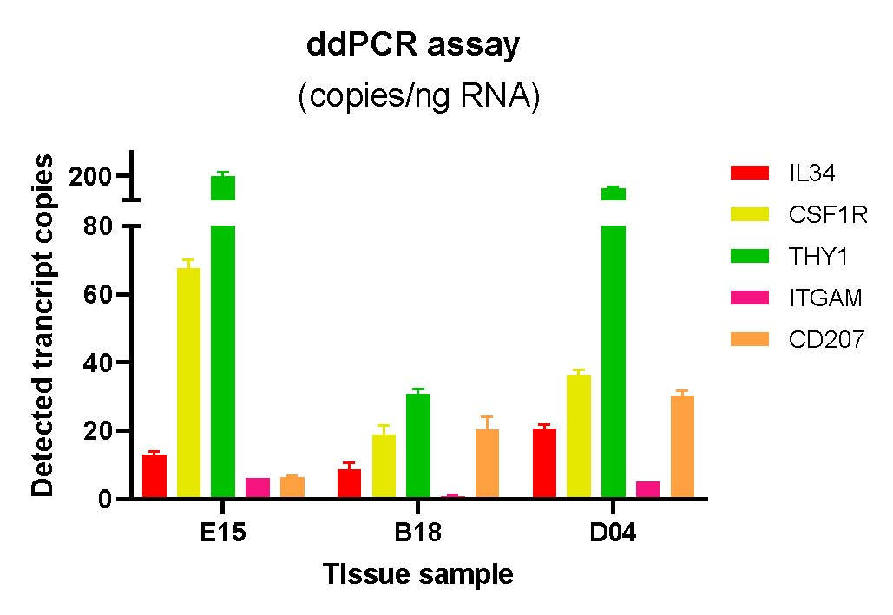

N SOP Validation Details
The SOP for ddPCR analysis using probes has been developed and validated according to the manufacturer's instructions. The validation process involved utilizing human skin cancer samples and was part of the GIHEX19SPA project, contributing to the research on measuring ligand-receptor expression in skin cancer. The results of the validation experiment have been published in the article titled 'A robust experimental and computational analysis framework at multiple resolutions, modalities and coverages' in Frontiers in Immunology.

O Troubleshooting
The common issues encountered in droplet digital PCR (ddPCR) experiments are listed below. For more detailed information, please refer to the 'Droplet Digital PCR Application Guide'.
Step | Issue | Recommendations
Step 1 | No droplets generated or no distinguishable layers seen | - Ensure to check the expiry date of the oil used in the experiment  - Use Bio-rad 96 well plates and Ranin tips to prevent any plastic contamination that could potentially shear the droplets.
Step 5 (analysis) | No positive partitions | - Perform an annealing/extension temperature gradient to determine  the optimal temperature for the digital PCR protocol; adjust physical  parameters (elongation time, ramp rate, etc.)  - The ddPCR reaction mix was not assembled correctly or the probe/primers were not ordered correctly.
 | High Mean Fluorescence Amplitude intensity  (No Negative partitions) in all wells including NTC | - Polymerase independent issue: probe hydrolysis due to poor long-term storage. Reorder the probe and make probe stock solution with 10mM Tris and store at -20C  - Polymerase dependent issue: identify intra-assay interactions and redesign causative components to reduce probe binding and cleavage by the enzyme.
 | High Mean Fluorescence Amplitude intensity  (No Negative partitions) in sample wells but not in NTC | - The target concentration is too high, dilute the input appropriately.
 | Positive signal from NTC wells | - Ensure a clean and reliable environment for dPCR experiments, it is recommended to sanitize pipettes, tip boxes, and bench tops with 5-10% bleach. Additionally, performing sample preparation and dPCR in separate rooms and wearing appropriate personal protective equipment are important measures.
 | Appearance of background “rain”  (Partitions that fail to belong to the  positive or negative population) | - Non-specific binding: Do not overload primers; try increasing annealing temperature, reducing number of cycles, decreasing extension and annealing time; ensure reagents are free of impurities.  - Poor target accessibility: to address RNA secondary structures: try to change target location or perform reverse transcription at warmer temperatures
 | No concentration calls on some wells | - Manually set a threshold and QuantaSoft software will calculate a concentration, which will appear in the concentration chart.
 | No or low total droplet count  (<10,000) | - Do not exceed the recommended DNA load (66ng/well undigested DNA or 50ng of initial RNA per well)  - Use only approved plates with approved pierceable foil heat seals  - Ensure that the full volume of the generated droplets is transferred into the 96 well plate

P Waste Management and Disposal
- Microcentrifuge tubes with residual master mix, PCR plate containing ddPCR components and used cartridges are to be disposed of into clinical waste bins according to IMB waste management protocol. There are no special waste disposal requirements associated with this SOP. If the waste bin is full, place it inside of the fume hood in TC room to evaporate.
- Expired oil should be flushed down the sink using large amounts of water.

Q Data Records Management
- For data storage and backup in the ddPCR assay, it is recommended to save the ‘*.qlp’ '.csv' files containing raw data and the '.xlsx' files containing analyzed data in two locations: the project team drive for internal backup and the project Research Data Management (RDM) system for official data records.
- In both locations, it is important to adhere to a consistent file naming convention for easy organization and retrieval. The suggested format for file names is 'project code_d000_date'. For example, a file name could be 'SPA_d001_2020_01_02' to indicate GIH external project SPA, data set 001, collected or analyzed on January 2, 2020.

R Reference Documents
- Risk assessment associated with this SOP is available in the IMB Risk Management Database in WebDB:
- Risk Assessment ID #2741 “Bio-Rad's Automated Droplet Digital PCR system”

- Other referenced documents for this SOP are follows;
- GIH SOP_007_01 Optimization of automated droplet digital PCR(ddPCR) analysis using probe
- Droplet Digital PCR Application Guide
(https://www.bio-rad.com/webroot/web/pdf/lsr/literature/Bulletin_6407.pdf)
- Automated Droplet Generator Instruction Manual
(https://www.bio-rad.com/webroot/web/pdf/lsr/literature/10043138.pdf)
- QX200 Droplet Reader and QuantaSoft Software Instruction Manual (https://www.bio-rad.com/webroot/web/pdf/lsr/literature/AW16000573.pdf)

S Quality Control (QC) & Quality Assurance (QA) Section
- Instrument maintenance (Calibration): Regularly calibrate the ddPCR instrument using appropriate calibration standards to ensure accurate measurements and reliable performance.
- Positive and Negative Controls: Include positive controls, which contain known target sequences, and negative controls, which lack the target sequences, in each ddPCR run. These controls help verify the sensitivity, specificity, and reliability of the assay.
- Replicates and Repeats: Perform replicates (technical replicates) within the same ddPCR run to assess the precision and reproducibility of the assay. Additionally, repeat the entire ddPCR assay on different days (biological replicates) to evaluate the assay's robustness and consistency.
- Validation of Assay Parameters: Validate key assay parameters, such as primer and probe concentrations, annealing temperatures, and reaction volumes, to ensure optimal performance and reliable results.

- Contact details
- Stacey Andersen
- Operations Manager, Genome Innovation Hub
T +61 7 334 62607
E s.andersen2@uq.edu.au
W gih.uq.edu.au
-----------------------------------------------------------------------------------------------------------------------------------
- Collaborator name (optional)
- Collaborator title (optional)
T
E
W

CRICOS Provider 00025B

