STANDARD OPERATING PROCEDURE (SOP)

STANDARD OPERATING PROCEDURE DETAILS
SOP Title: | RNAscope® Hiplex assay with Fresh Frozen Tissue
SOP Number: | SOP0009-01
Effective Date: | 07 May 2020
Current Review Date: | 07 May 2022
Replaces SOP Number: | First Issue
Group: | GIH

DECLARATIONS
I have read this document and approve its contents.
 | Name | Team | Signature | Date
Written By: | Sohye Yoon | GIH single cell | 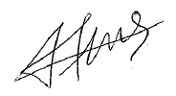 | 07 May 2020
Reviewed By: | Stacey Andersen | GIH single cell |  | 13 May 2020
Reviewed By:
Reviewed By:
Reviewed By:
Authorised By:

DOCUMENT HISTORY
SOP Number | Author | Date Originated or Revised
SOP0009-01 | Sohye Yoon | 17 APR 2020

TABLE OF CONTENTS
RD OPERATING PROCEDURE 3
A. PURPOSE AND APPLICATION 3
B. BRIEF SUMMARY OF METHOD 3
C. DEFINITIONS AND ABBREVIATIONS 3
D. OCCUPATIONAL HEALTH AND SAFETY 3
E. CAUTIONS 3
F. PERSONNEL QUALIFICATIONS, TRAINING AND RESPONSIBILITIES
G. EQUIPMENT AND MATERIALS 4
Equipment 4
Materials 4
H. PROCEDURE
Workflow
Prepare the materials 5
Prepare and pre-treat samples 6
I. WORKED EXAMPLE
J. SOP VALIDATION DETAILS
K. Troubleshooting
L. WASTE MANAGEMENT AND DISPOSAL 11
M. DATA RECORDS MANAGEMENT 11
N. REFERENCE DOCUMENTS 11
O. QUALITY CONTROL (QC) AND QUALITY ASSURANCE (QA) SECTION

RD OPERATING PROCEDURE

PURPOSE AND APPLICATION

This SOP describes the implementation of ACD RNAscope® HiPlex assay on fresh frozen tissue. The RNAscope® Assay is the most advanced RNA in situ hybridization (ISH) assay based on ACD patented technology with signal amplification and simultaneous background noise suppression which advances RNA analysis in tissues and cells. The assay as described in this SOP allows simultaneous detection of up to 8 targets per slide. With the addition of an extra reagent module, this could be increased to 12 targets per slide. It enables the user to investigate expression as well as positional relationships between multiple genes at a single cell level. The assay utilises an automated slide scanner to create high-quality virtual slides and capture fluorescence images with high throughput.
This SOP does not include any procedures on preparing the tissue sample, sectioning using a cryostat or complementary analyses such as H&E staining.

BRIEF SUMMARY OF METHOD

Properly prepared tissue slides are first fixed with freshly made fixative, and then RNA-specific probes (off-the-shelf or customized) designed for different detection tails are hybridized to multiple RNAs (up to 8 targets). After a series of highly effective and specific signal amplification steps, single RNA transcripts for up to four targets genes at a time can be visualised as punctate dots in four distinct fluorescence channels using the cleavable versions of the fluorophores AF488, Atto550, Atto647, and AF750. These dots are visible with an epifluorescence microscope and the appropriate filters. After imaging, the fluorophores from the first four targets are cleaved off and the next four targets are labelled and imaged. Images from each round can be merged to produce a single image containing spatially-resolved gene expression data for multiple genes at single cell resolution.

DEFINITIONS AND ABBREVIATIONS
ACD – Advanced Cell Diagnostics
H&E – hematoxylin and eosin

OCCUPATIONAL HEALTH AND SAFETY

Users must read, understand, and sign on to Risk Assessment ID #2739 “RNAscope HiPlex Assay on fresh frozen/fixed frozen tissue” in the IMB Risk Management database.
If you are using a cryostat in the SBMS Histology facility, you must get trained beforehand by facility staff and read, understand and sign on to Risk Assessment ID #1535, #2916 and #1365 in the UQ Risk Assessment database.
If you are using a cryostat in IMB level 4, you must get trained beforehand by the floor manager (Jill Bradley) and read, understand and sign on to Risk Assessment ID #1514 and #1543 in the IMB Risk Management Database.

CAUTIONS

- Use Fisher Scientific SuperFrost Plus Slides for all tissue types to avoid tissue loss.
- It is recommended to always perform initial positive and negative control tests with your particular tissue, to assess sample RNA quality and optimal permeabilization.
- Flick or tap the slides to remove residual reagents, but do not let the slides dry out at any time.
- We have noted significant autofluorescence detection in the green channel used with AF488 fluorophores (T1 and T5). This background fluorescence makes it difficult to determine true signal for these probes. If possible, avoid use of this channel. If use of this channel can not be avoided, make sure to assign these to genes expected to show the highest expression.
- RNA in tissue sections is easily degraded, which can result in poor detection of transcripts. Ensure your workplace and all materials used are clean and free of RNases. It is recommended that all measuring cylinders, bottles, forceps etc that are used throughout the procedure are baked before use to destroy any RNases.
- Using sample types other than fresh-frozen tissue for RNAScope HiPlex assay is possible, however the protocol for tissue digestion may be different. Please refer to the ACD RNAscope HiPlex Assay with sample preparation and pretreatment manual (document No. 324100-UM) for more information.

PERSONNEL QUALIFICATIONS, TRAINING AND RESPONSIBILITIES

Training Requirements:
X Read and Understand Document X Training Required

EQUIPMENT AND MATERIALS

Equipment
- HybEZ™ II Oven (ACD Cat. No. 321720)
- ZEISS Axio Scan.Z1 slide scanner microscopy (SBMS imaging facility)

Materials
- RNAscope® HiPlex 50X Probes (user-specified)
- RNAscope® HiPlex 12 Positive Control Probe-Hs (ACD Cat. No. 324321)
- RNAscope® HiPlex 12 Negative Control Probe (ACD Cat. No. 324341)
- RNAscope® HiPlex Protease IV (ACD Cat. No. 322340)
- RNAscope® HiPlex8 Detection Kit (ACD Cat. No. 324110)
- Wash Buffer Reagents (ACD Cat. No. 310091)
- Cleaving Reagents (ACD Cat. No. 324130)
- HybEZ™ Humidity Control Tray (with lid) (ACD Cat. No. 310012)
- ACD EZ-Batch™ Wash Tray (ACD Cat. No. 321717)
- ACD EZ-Batch™ Slide Holder (ACD Cat. No. 321716)
- HybEZ™ Humidifying paper (ACD Cat. No. 310015)
- ProLong Gold Antifade Mountant (Fisher Scientific Cat. No. P36930)
- 10X PBS (Fisher Scientific Cat. No. BP3991)
- 10% Tween-20 (Fisher Scientific Cat. No. PI85115)
- 20X SSC (Fisher Scientific Cat. No. BP1325)
- Carboy
- Distilled water
- Tubes (50ml, 15ml, 1.5ml, various sizes)
- Paper towel
- Serological pipets (25ml, 10ml, 5ml)
- 100% ethanol (molecular Grade)
- 4% paraformaldehyde (PFA)
- ImmEdge™ Hydrophobic Barrier Pen (Vector Laboratories, H-4000)
- Coverslip #1.5 high performance (Carl Zeiss, 474030-9000-000)

PROCEDURE

Workflow
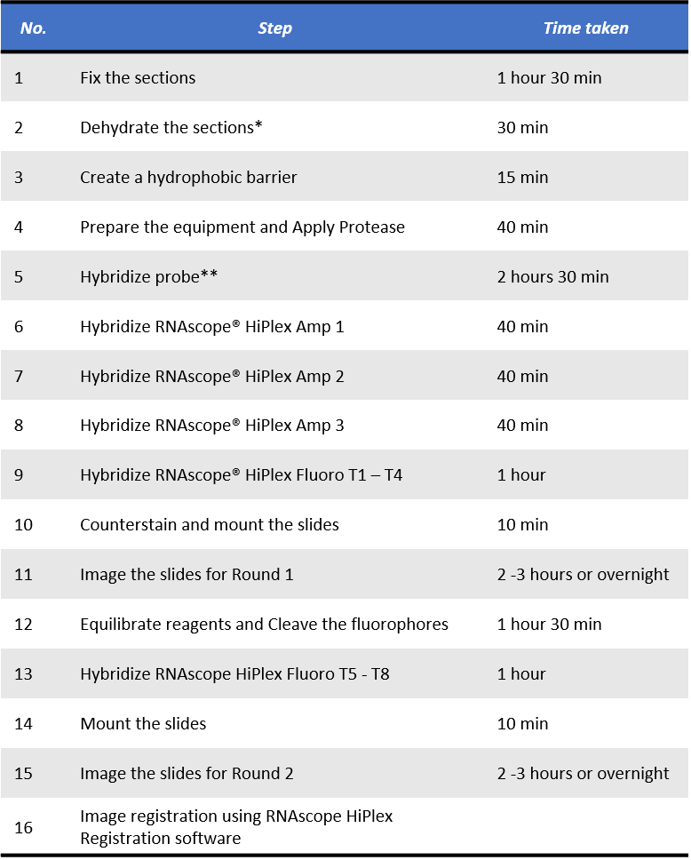

*, optional stopping point (1): Slides may be stored in 100 % ethanol at -20 °C for up to 1 week. Prolonged storage may degrade sample RNA.

**, optional stopping point (2): You can store the slides in 5X SSC overnight at RT. Before continuing with the assay, wash the slides twice with 1X Wash Buffer for 2 min at RT.

Prepare the materials
• Prepare 1X Wash Buffer : Prepare 3 L of 1X Wash Buffer by adding 2.94 L distilled water to 1 bottle of
50X Wash Buffer (60ml) in a large carboy. Mix well.
Note: If precipitation occurs in the 50X Wash Buffer, warm it up at 40 °C for 10 – 20 min before making
the 1X Wash Buffer. 1X Wash Buffer may be prepared ahead of time and stored at room temperature.

• Prepare 4X SSC
- To prepare 4X SSC, dilute 20X SSC with distilled water by pipetting one volume of 20X SSC with four
volumes of distilled water. (i.e. 20 ml of 20 X SSC + 80 ml of D.W.)
- Mix thoroughly by inverting the container at least ten times.

• Prepare PBST (0.5 % Tween)
- To make 1 liter PBST (0.5 % Tween), add 100 ml 10X PBS, 850 ml distilled water, and 50 ml of 10 % Tween in a container. Scale up or down as needed.
- Mix thoroughly by inverting the container at least ten times.

• Prepare probes
- Warm RNAscope® HiPlex probe stocks at 40 °C in a HybEZ™ II Oven for about 10 min.
- Warm RNAscope® HiPlex Probe diluent at 40 °C in a HybEZ™ II Oven for about 10 min.
- Briefly spin down all 50X Probes stocks to collect the liquid at the bottom of the tubes.
- Mix each unique target probe set by diluting 50X probe stocks with RNAscope® HiPlex probe diluent. For example, to make 200 µl of solution containing 5 probes , use 4 µl of each probe stocks and add 180 µl of RNAscope® HiPlex Probe diluent.
- Mix well by vortexing or invert the tube several times.
Note: The mixed probes can be stored at 2 – 8 °C for up to six months.

• Equilibrate reagents
- Place RNAscope® HiPlex Amp 1 – 3 and RNAscope® HiPlex Fluoro T1 – T4 reagents at RT.
- Ensure that the HybEZ™ II Oven and prepared Humidity Control Tray are at 40 °C.

Prepare and pre-treat samples
- Freeze the specimen in cryomolds on dry ice or liquid nitrogen within 5 min of tissue harvest.
- Embed frozen tissue in OCT medium and store the frozen block in an air-tight container at -80°C prior to sectioning.
- Equilibrate block to -20°C in a cryostat ~ 1 hour.
- Cut 10 µm sections and mount onto Superfrost® plus slides.
- Store the section in slide boxes wrapped air-tight with aluminium foil at -80°C until use.
Note: Training may be required for cryostat use (SBMS Histology Facility).
Option: H&E staining on a consecutive slide is recommended for annotation. For this purpose, 5 µm
thickness is optimal.
Optional Stopping Point (1) Use sectioned tissue within three months.

Step 1. Fix the sections (1 hour 30 min)
- Prepare 4% PFA in 1X PBS in a 50 ml conical tube. Use FRESH fixatives. Do NOT reuse.
- Remove the slides from -80°C and place in the fixative.
- Fix for 60 min at RT.
- Wash slides with 1X PBS by moving the slide up and down 3 – 5 times with forceps and repeat with 1X PBS.

Step 2. Dehydrate the sections (30 min)
- Prepare 40 ml 50 % ethanol, 40 ml 70 % ethanol and 2 of 40 ml 100 % ethanol in 50 ml tubes.
- Place the slides in 50 % ethanol for 5 min at RT.
- Place the slides in 70 % ethanol for 5 min at RT.
- Place the slides in 100 % ethanol for 5 min at RT.
- Repeat step 4 with fresh 100 % ethanol.
Optional Stopping Point (2) Slides may be stored in 100 % ethanol at -20 °C for up to 1 week. Prolonged
storage may degrade sample RNA.

Step 3. Create a hydrophobic barrier (15 min)
- Take the slides out of 100 % ethanol and place on absorbent paper with the section face-up. Air dry for 5 min at RT.
- Draw a barrier 2 – 4 times around each section with the Immedge™ hydrophobic barrier pen. Refer to the Table 1 to determine the recommended size of barrier per slide.

Table 1. Determining reagent volume.
Size of hydrophobic barrier (inch) | Recommended number of drops per slide | Recommended volume per slide (µl)
0.75” x 0.75” | 4 | 120
0.75” x 1.0” | 5 | 150
0.75” x 1.25” | 6 | 180

- Let the barrier dry completely ~ 1 min.

Step 4. Prepare the equipment and Apply Protease IV (40 min)
- Turn on the HybEZ™ Oven and set the temperature to 40 °C.
- Place a Humidifying Paper in the Humidity Control Tray and wet completely with distilled water.
- Load the dried slides into the RNAscope® EZ-Batch™ Slide Holder and add ~ 5 drops of Protease IV to entirely cover each section.
- Incubate for 30 min at RT.
- Remove excess liquid from the slides by decanting and shaking the locked slides in the EZ-Batch™ Slide Holder. Immediately place the slide holder in the transparent EZ-Batch™ Wash Tray filled with 1X PBS.
- Wash slides in 1X PBS with slight agitation and repeat with fresh 1X PBS.
(Slide should not stay in 1X PBS for longer than 5 min)

Step 5. Hybridize probe (2 hours 30 min)
- Ensure that the probes are prewarmed and cooled to RT prior to use.
- Remove excess liquid from the slides while keeping the slides locked in the RNAscope® EZ-Batch™ Slide Holder. Insert the slide holder into HybEZ™ Humidity Control Tray.
- Add ~ 4 drops of the appropriate probe to entirely cover each section. Refer Table 1. To determine the recommended number of drops needed per slide.
- Close the tray and insert into the over for 2 hours at 40 °C.
- Pour at least 200 ml 1X Wash Buffer into the transparent RNAscope® EZ-Batch™ Wash Tray.
- Remove the HybEZ™ Humidity Control Tray from the oven. Remove the slide holder from the tray. Place the tray back into the oven.
- Place the RNAscope EZ-Batch™ Slide Holders into the wash tray, and wash the slides for 2 min at RT. Repeat the wash step with fresh buffer.
Optional Stopping Point (3) You can store the slides in 5X SSC overnight at RT. Before continuing with
the assay, wash the slides twice with 1X Wash Buffer for 2 min at RT.

Step 6. Hybridize RNAscope® HiPlex Amp 1 (40 min)
- Remove excess liquid from the slides while keeping the slides locked in the RNAscope® EZ-Batch™ Slide Holder. Insert the slide holder into the HybEZ™ Humidity Control Tray.
- Add ~4 drops of RNAscope® HiPlex Amp 1 to entirely cover each section.
- Close the tray and insert into the HybEZ Oven for 30 min at 40 °C.
- Remove the HybEZ Humidity Control Tray from the oven. Remove the slide holder from the tray. Place the tray back into the oven.
- Pour at least 200 ml 1X Wash Buffer into the transparent RNAscope EZ-Batch Wash Tray.
- Place the RNAscope EZ-Batch Slide Holder into the wash tray, and wash the slides for 2 min at RT. Repeat the wash step with fresh buffer.

Step 7. Hybridize RNAscope® HiPlix Amp 2 (40 min)
- Remove excess liquid from the slides while keeping the slides locked in the RNAscope® EZ-Batch™ Slide Holder. Insert the slide holder into the HybEZ™ Humidity Control Tray.
- Add ~4 drops of RNAscope® HiPlex Amp 2 to entirely cover each section.
- Close the tray and insert into the HybEZ Oven for 30 min at 40 °C.
- Remove the HybEZ Humidity Control Tray from the oven. Remove the slide holder from the tray. Place the tray back into the oven.
- Pour at least 200 ml 1X Wash Buffer into the transparent RNAscope EZ-Batch Wash Tray.
- Place the RNAscope EZ-Batch Slide Holder into the wash tray, and wash the slides for 2 min at RT. Repeat the wash step with fresh buffer.

Step 8. Hybridize RNAscope® HiPlix Amp 3 (40 min)
- Remove excess liquid from the slides while keeping the slides locked in the RNAscope® EZ-Batch™ Slide Holder. Insert the slide holder into the HybEZ™ Humidity Control Tray.
- Add ~4 drops of RNAscope® HiPlex Amp 3 to entirely cover each section.
- Close the tray and insert into the HybEZ Oven for 30 min at 40 °C.
- Remove the HybEZ Humidity Control Tray from the oven. Remove the slide holder from the tray. Place the tray back into the oven.
- Pour at least 200 ml 1X Wash Buffer into the transparent RNAscope EZ-Batch Wash Tray.
- Place the RNAscope EZ-Batch Slide Holder into the wash tray, and wash the slides for 2 min at RT. Repeat the wash step with fresh buffer.

Step 9. Hybridize RNAscope® HiPlix Fluoro T1 – T4 (1 hour)
- Remove excess liquid from the slides while keeping the slides locked in the RNAscope® EZ-Batch™ Slide Holder. Insert the slide holder into the HybEZ™ Humidity Control Tray.
- Add ~4 drops of RNAscope® HiPlex Fluoro T1 – T4 to entirely cover each section.
- Close the tray and insert into the HybEZ Oven for 15 min at 40 °C.
- Remove the HybEZ Humidity Control Tray from the oven. Remove the slide holder from the tray. Place the tray back into the oven.
- Pour at least 200 ml 1X Wash Buffer into the transparent RNAscope EZ-Batch Wash Tray.
- Place the RNAscope EZ-Batch Slide Holder into the wash tray, and wash the slides for 2 min at RT. Repeat the wash step with fresh buffer.

Step 10. Counterstain and mount the slides (10 min)
Note: Do this procedure with no more than five slides at a time.
- Remove excess liquid from the slides, and add ~4 drops of DAPI to each section.
- Incubate for 30 sec at RT.
- Remove DAPI from slides and immediately place 1-2 drops of the ProLong Gold Antifade Mountant onto each section.
- Carefully place a coverslip over each tissue section. Avoid trapping air bubbles. Store slides in the dart at 2 – 8 °C before imaging.
Note: Do not leave slides at RT for more than 30 min. Preventing the slides from completely drying will
save time when you remove the coverslips.

Step 11. Image the slides for Round 1 (2 -3 hours or overnight – depending on slice interval set up)
- Image the slides under ZEISS Axio Scan.Z1 slide scanner microscopy in SBMS imaging facility. You are required to have a training for the microscopy by staff in the facility.
- Log in to the PC that is connected with the slide scanner.
- Double click “Zen” software icon you the desktop and select ‘Zen slidescan’.
- Load slide in a slide frame (four standard slides are held in a single frame)
- Press the open button on the slide scanner, load the frame on an empty tray and close the door.
- Go to the “Default Scan Profile” on the software and select “GIH RNAscope-40x Fast” from the list.
- Change “storage Location” to “GIH” folder in Voltage drive (if the drive is not mapped on your account, select “GIH” folder in D drive or a project RDM drive.
- Tick a small box next to the image of slide in “Magazine” field and click “Start Preview Scan”.
- Open the advanced wizard (click ‘’) after the preview has been captured.
- Step 4 – 6 of the wizard should be checked. Step 1 – 3 normally do not have to be modified for standard slides.
- Step 4 Tissue detection setting :
  - For RNAscope slide which is fluorescence samples, it might be necessary to define the ROIs manually as the tissue sections have low contrast. Improve the visibility of samples that are very faint by adjusting the display curve of the histogram (the histogram is in the middle panel -> Display).
  - Draw regions manually. The “Draw Spline Contour” (arrow) drawing tool is especially helpful to surround tissues sections.
- Step 5 Focus Map settings :
- Make sure that “Coarse” is active.
- Expand the "Channels" drop down menu and set the reference channel for the autofocus. Per default DAPI is selected.
- Check the initial x-y position is per default in the centre of the ROI.
- Click on “LIVE” in order to switch on the camera.
- Click on “Find Focus”.
- Check image for focus quality at different positions of the sample: click inside the slide shown in the "Navigation" tab to move the specimen to the selected position.
(The focus position is set from the profile so do not change it)
- Select “Fine”.
- Expand the “Channels” drop down menu and set the reference channel for the Fine autofocus. Per default DAPI is selected.
- Click on “Find Focus”
- Click on "LIVE" in order to switch on the camera.
- Click on "Find Focus".
- Step 6 Define Scan settings :
- Expand the “Channels” drop down menu.
- Activate the channels you need (DAPI, FITC for T1/T5 channel, Cy3 for T2/T6 channel, Cy5 for T3/T7 channel, Cy7 for T4/T8 channel). The appropriate exposure time for each channel is already set up in the profile.
- Set the reference channel for stitching - Highlight an appropriate channel and click on "Stitching Ref.". Per default DAPI is selected as reference channel.
Note: An appropriate stitching channel is one in which the dye covers the specimen evenly.
- By clicking on "Snap" a single preview picture with all the channels can be captured.
- Expand the “Z-stack Configuration” and check “Z Stack”
- "Z stack configuration": Tick “Z-Stack” → Set 10 µm in “Range” or Set 1.5 µm in “Interval” to lead 9 slices.
Note: 10 µm thickness section
- Once all parameters are adjusted, save adapted scan profile.
- Select the slide to run by ticking a box in “Process” next to each slide.
- Press "Start Scan".
- Once the imaging is completed, press open button on the scanner and remove the slides carefully.
- Store the slides in the dark at 2 – 8 °C for up to three days, or proceed immediately to the fluorophore cleaving step. Overnight imaging process may be possible.

Step 12. Equilibrate reagents and Cleave the fluorophores (1 hour and 30 min)
- Place RNAscope® HiPlex Fluoro T5 -T8 reagent at RT.
- Ensure that the HybEZ Oven is at 40 °C.
- Soak the slides in 4X SSC at RT for at least 30 min or until the coverslips fall off the slides easily.
- Gently remove each coverslips by pushing it horizontally.
Note: Do not use any buffer other than 4X SSC. To reduce tissue damage, do not remove the coverslips by force. Soak the slides in 4X SSC until the coverslips can be moved easily. If the slides have been dried completely, you may need to soak the slides in 4X SSC overnight.
- Briefly wash the slides once in 4X SSC.
- Break open a FRESH glass ampule of provided cleaving stock solution.
- Prepare a 10% cleaving solution by diluting with 4X SSC.
Note: Due to oxidation, do not use the cleaving stock solution more than once. Do not use any buffer other than 4X SSC to make 10% cleaving solution.
- Load the slides in the RNAscope EZ-Batch Slides Holder.
- Remove excess liquid from the slides when keeping them locked in the RNAscope EZ-Batch Slide Holder. Insert the slide holder into the HybEZ Humidity Control Tray.
- Apply ~ 4 drops of freshly prepared 10% cleaving to entirely cover each section.
- Close the tray and incubate for 15 min at RT. Remove the slide holder from the tray.
- Pour at least 200 ml PBST (0.5% Tween) into the transparent RNAscope EZ-Batch Wash Tray.
- Place the RNAscope EZ-Batch Slide Holder into the wash tray, and wash the slides for 2 min at RT. Repeat the wash step with fresh buffer.
Note: Do not use any other buffer than PBST (0.5% Tween) for this step.
- Repeat Steps 9-13 (10% cleaving solution incubation and PBST wash step). When repeating Step 11, place the HybEZ Humidity Control Tray into the HybEZ Oven to warm the tray back up to 40 °C.

Step 13. Hybridize RNAscope® HiPlex Fluoro T5 - T8 (1 hour)
- Remove excess liquid from the slides while keeping them locked in the RNAscope EZ-Batch Slide Holder. Insert the slide holder into the HybEZ Humidity Control Tray.
- Add ~ 4 drops of RNAscope® HiPlex Fluoro T5 – T8 to entirely cover each section.
- Close the tray and insert into the HybEZ Over for 15 min at 40 °C.
- Remover the tray from the oven, and remove the slide holder from the tray.
- Pour at least 200 ml 1X Wash Buffer into the transparent RNAscope EZ-Batch Wash Tray.
- Place the RNAscope EZ-Batch Slide Holder into the wash tray, and wash the slides for 2 min at RT. Repeat the wash step with fresh buffer.

Step 14. Mount the slides (10 min)
Note: Do this procedure with no more than five slides at a time.
- Remove excess liquid from the slides, immediately place 1 – 2 drops of the ProLong Gold Antifade Mountant onto each section.
- Carefully place a coverslip over each tissue section. Avoid trapping air bubbles. Store the slides in the dark at 2 – 8 °C.

Step 15. Image the slides for Round 2 (2 -3 hours or overnight – depending on slice interval set up)
- Repeat Step 11.

Step 16. Image registration using RNAscope HiPlex Registration software
- Register the images generated from Round 1 and Round 2 using the single channel exposure.
- To ensure accuracy, make sure that the DAPI channel images are similarly exposed.
- Refer to the RNAscope HiPlex® Registration Software User Manual (300065-USM). A step by step guide for how to use the software is also available in the installer package of the software.

WORKED EXAMPLE

Four of human BCC (Basal Carcinoma Cell) skin tissues in OTC (optimal cutting temperature) media were provided by Ian Fraser group and were cryosectioned in 10 µm thickness for the assay.
For the imaging, ZEISS Axio Scan.Z1 slide scanner microscopy at SBMS imaging facility was used with the optimal parameters. A merged image from two rounds is as follows;
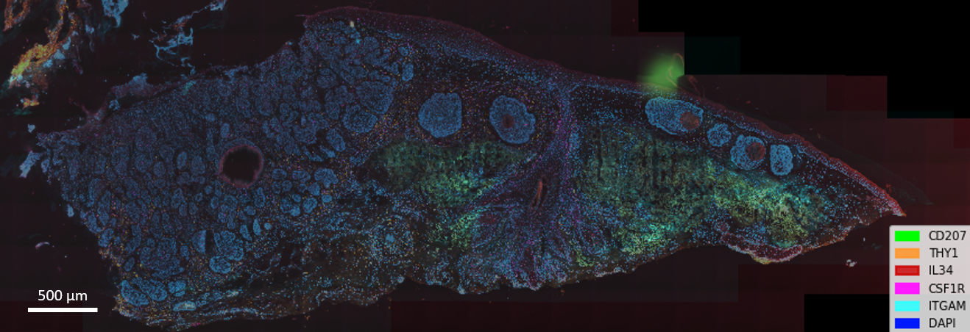

SOP VALIDATION DETAILS

This SOP has been written based on the manufacturer’s protocol (ACD RNAscope® HiPlex Assay User Manual) with minor modifications (ie reagent volume, imaging time). The image generated using this protocol has been analysed by Dr. Quan Nguyen and his PhD student Minh Tran and has been validated to be a decent quality.

Troubleshooting

- Weak/no signal with excellent morphology: This may be due to over-fixed tissue but under digested with Protease, leading poor probe accessibility.
- Poor tissue morphology with high background or non-uniform strong/weak signal: This may be due to under-fixed but over digested tissue, leading loss of RNA due to protease over digestion.
- Failing to register and overlay images using RNAScope® HiPlex Registration Software: This may be cause of the location of the same region are not matched between two image rounds. This can be resolved by using a microscope with a precise stage recorder. You may wish to develop and run template matching algorithm to merge images manually.

WASTE MANAGEMENT AND DISPOSAL

Solid and low-volume liquid waste generated through performing this protocol are to be disposed of into clinical waste bins according to IMB waste management protocol. Sharps are to be disposed of into puncture-resistant clinical sharps bins. There are no special waste disposal requirements associated with this SOP.

DATA RECORDS MANAGEMENT

All generated image files (.czi) are saved in GIHEX19SPA-UQRDM.

REFERENCE DOCUMENTS

ACD RNAscope HiPlex Assay with sample preparation and pretreatment manual (document No. 324100-UM)
ACD RNAscope HiPlex Image registration software manual (document No. 300065-UM)
Risk Assessments associated with this SOP are available in the IMB Risk Assessment Database in WebDB:
- Risk Assessment ID #2739 “RNAscope HiPlex Assay on fresh frozen/fixed frozen tissue”

Other references Risk Assessments are available in the IMB Risk Assessment Database or UQSafe-Risk system.
- IMB Risk Assessment ID #1514 “Cryostat (Leica) usage”
- IMB Risk Assessment ID #1543 “Installation and use of disposable blades in LIECA Cryostat”
- UQ Risk Assessment ID #1535 “SBMS Histology – Cryostat Use”
- UQ Risk Assessment ID #2916 “SBMS Histology – Disposal of Waste”
- UQ Risk Assessment ID #1365 “SBMS Histology – Use of Sharps/Blades”

QUALITY CONTROL (QC) AND QUALITY ASSURANCE (QA) SECTION

- Recommend running both positive and negative control. If not practical, run negative control with your test slide at least.
- Perform H&E staining on a consecutive tissue section to check the morphology of the tissue.
- Before starting imaging, confirm that nuclei are stained with DAPI properly.

